

Projectiles

Thomas Laryea



Peter Symonds College

Contents

Analysis 2

Background to Project 2

Description of the Current System 2

Evidence of Analysis 2

Identification of the end-user/supervisor 6

Prospective users 6

Questionnaire 6

Proposed Solution Details 8

Objectives 8

Modelling 10

Prototyping 11

Prototype 1 11

Equations 12

Design 12

Overview 12

User Interface 15

Algorithms 22

Database 23

Testing 26

Testing Evidence 43

Test 1.1 43

Test 1.2 44

Test 1.3 45

Test 1.4.1 45

Test 1.4.2 46

Test 1.4.3 47

Test 1.4.4 48

Test 1.5.1 49

Test 1.5.2 50

Test 1.5.3 51

Test 1.5.4 52

Test 1.5.5 53

Test 1.5.6 54

Test 2.1.1 55

Test 2.1.2 56

Test 2.2 56

Test 2.3 58

Test 2.4 59

Test 2.5 60

Test 2.6 61

Test 2.7 62

Test 3.1 63

Test 3.2 63

Test 3.3.1 64

Test 3.3.2 64

Test 3.3.3 65

Test 3.4.1 65

Test 3.4.2 66

Test 3.4.3 66

Test 3.4.4 67

Test 3.4.5 67

Test 3.4.6 68

Test 5.1 68

Test 5.1.2 69

Test 5.1.3 70

Test 5.1.4 70

Test 5.2.1 71

Test 5.2.2 71

Test 5.2.3 72

Test 5.2.4 73

Test 6.1.1 73

Test 6.1.2 74

Test 6.1.3 74

Test 6.1.4 74

Test 6.1.5 75

Test 7.3.1 76

Test 7.3.2 76

Test 7.3.3 77

Test 7.3.4 77

Test 7.3.5 78

Test 7.3.6 78

Test 7.4.1 79

Test 7.4.2 79

Test 7.4.3 80

Test 7.4.4 80

Test 7.4.5 81

Test 7.4.6 81

Test 7.5.1 82

Test 7.5.2 82

Test 7.5.3 83

Test 7.5.4 83

Test 7.5.5 84

Test 7.5.6 84

Test 7.6.1 85

Test 7.6.2 86

Test 7.6.3 86

Test 7.6.4 87

Test 7.7.1 87

Test 7.7.2 88

Test 7.7.3 88

Test 7.8.1 89

Test 7.8.2 89

Test 7.8.3 90

Test 7.9.1 90

Test 7.9.2 91

Test 7.9.3 92

Test 7.11.2 92

Test 7.12 93

Amendments 96

# Analysis

## Background to Project

Peter Symonds College is a sixth form college in Winchester, Hampshire, in the south of England. The college offers some higher education degrees and accommodation for boarding students. The college has around 4000 students with almost 1000 students studying A-Level Maths and 25 members of staff in the mathematics department. With the use of technology, the Mathematics department think they could improve teaching and learning in A-Level maths and further maths.

Further Maths revision and class exercises mainly consists of completing past paper questions or questions from the Mei (exam board) text books. This can make revision become repetitive for the students, since there are a limited number of past paper questions for each topic. These past papers usually consist of questions that are indistinguishable from other past exam papers, which can lead to some students simply remembering how to answer a certain type question and not actually understand how to solve it.

A specific topic that lacks unique question is projectiles (a topic in the mechanics 1 module). The mathematics department feel that they could use technology to simulate and create projectile problems to help mechanics students with their revision on projectiles.

## Description of the Current System

The current system the maths department use for studying projectiles is answering questions from past mechanics 1 exam papers or the mechanics 1 textbook. In class, the teacher will handout sheets the students with projectile questions taken from multiple past papers or an exercise to complete within the mechanics textbook which contains 5 – 10 questions. The teacher will then give the students around 30 minutes to answer as many questions as they can. After the 30 minutes, the teacher will briefly go through each question and give the answer to them however, the teacher does not always have enough time to go through all the questions and only keeps track of their students’ progress twice an academic year, so it is not clear which students need the most support. If the students wish to see answer to the questions outside of class they can access the mathematics intranet which covers all past paper questions and exercises from the textbook. The college has hundreds of computers spread across the site and free internet access too, this allows students to easily access the Maths intranet for worked solutions. In the maths classroom their only 1 computer for the teacher, this is used with the interactive whiteboards to draw projectile diagrams when providing a worked solution to the questions answered by the students in class.

The main problems of this system are…

* Not many projectile questions.
* Some worked solutions are outdated and lack information.
* Questions are can be very indistinguishable.
* Teachers don’t always have enough time go through questions in class.
* A lot of class time is spent on drawing diagrams.
* Progress of the students is only recorded twice a year.

Evidence of Analysis

The current system only utilises computers to look at worked solution to questions from past mechanics 1 papers and the worked solutions to the mechanics 1 textbook which can be found on the college intranet. Other than that, the students answer questions from past papers and the mechanics 1 textbook.

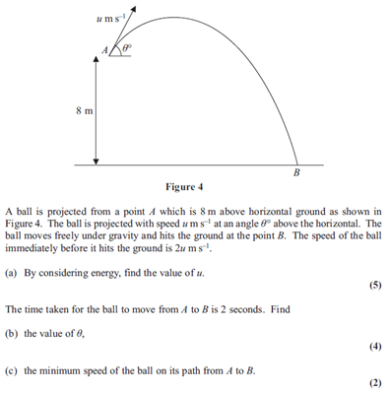

Mechanics 1 textbook.

Projectile question from M1 Past exam paper

The worked solution on the college intranet are useful to an extent. The main problem is that some of the worked solutions lack details and an explanation to some of the projectile questions. They are also hand written, photographed and saved as a portable document file which must be all redone if there is a mistake in the worked solution which may take a while.

Worked solution from mathematics intranet.

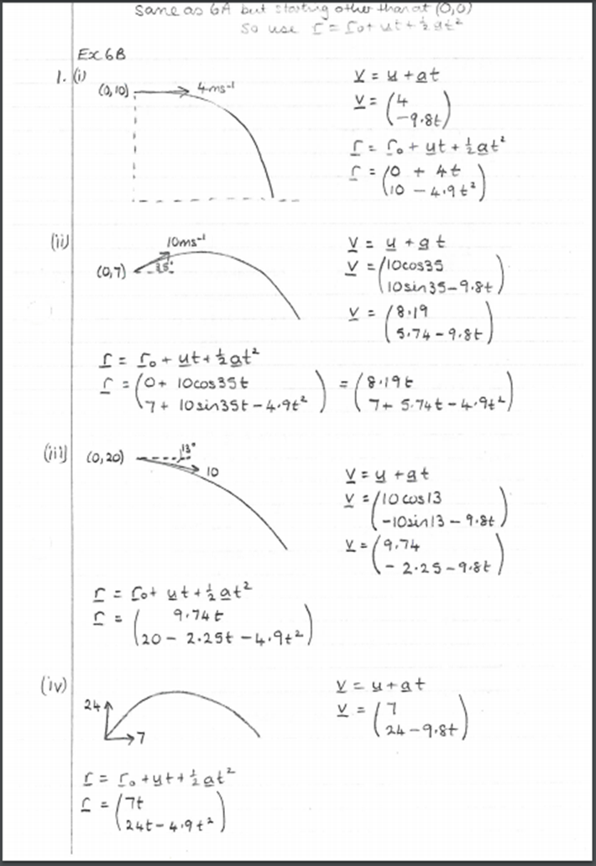

Exercise number.

Question number.

Equation used.

Answers.

There are many existing projectile simulators such as this one “http://www.physicsclassroom.com/Physics-Interactives/Vectors-and-Projectiles/Projectile-Simulator/Projectile-Simulator-Interactives” on the world wide web which run from adobe flash player, however it lacks many features to help teach projectiles such as finding the maximum height of the projectile and notes to show the working out instead giving just the time and distance of the projectile. It’s also not aimed at students doing MEI (Exam Board) Mechanics.

My Maths is another Maths learning tool used by many schools. For projectiles, it has 2 online quizzes with randomly generated questions which teachers can set for a class to complete and keep track of their scores too. The online quizzes also include a quick lesson on projectiles with a worksheet, however this only has 4 questions and doesn’t have worked solutions.

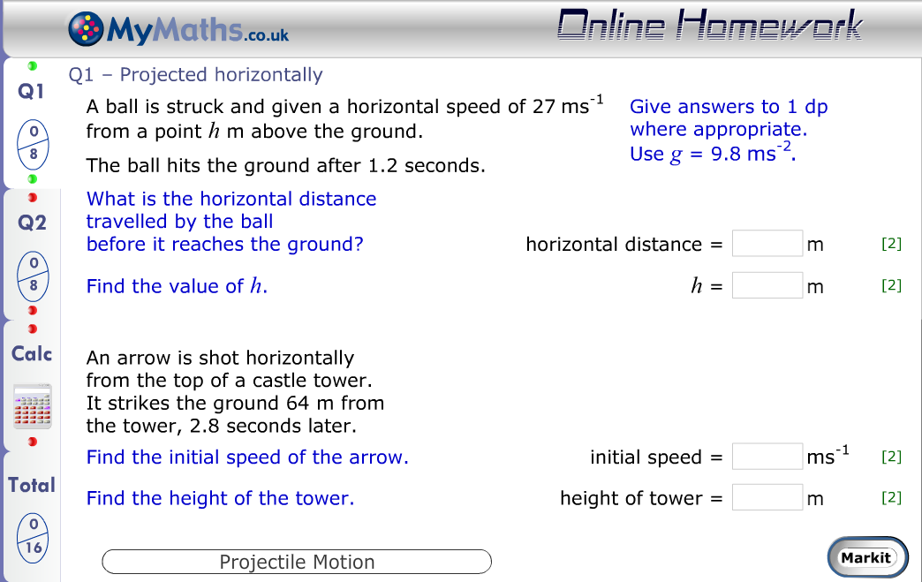

Edit box to enter answer.

Button to check answers.

The maths intranet provides links to YouTube videos on projectiles from Khan academy and the FMSP. The Khan academy have multiple videos on projectiles for multiple situations such as projectiles at an angle, horizontal projectiles and projectile motion. Each video shows what calculations need to be done to solve similar problems. The FMSP video states the requirements from the exam board then works through a couple of projectile questions from past papers based on different situations. After completing each question, the video goes through the mark scheme with a lot of detail to show how each mark is awarded. Unlike the other online resources, this is specific to the exam board the college uses.

## Identification of the end-user/supervisor

Gordon Hunt a further mathematics teacher at peter Symonds college, will be the main user of the system. He needs to be able to create projectile questions such as finding the maximum height, the time it takes for the projectile to land and the distance travelled by the projectile. He also needs the system to be able calculate the projectile problems with a step by step solution and a textbox to add extra notes and he needs to be able to send the created questions to his class and have the option to hide or show the answers.

## Prospective users

The users of this system will be the mathematics teachers and the students at Peter Symonds college studying mechanics.

## Questionnaire

1. What is the current system for teaching projectiles?

We mainly work through chapter 6 in the Mei mechanics 1 textbook during class. Other methods I personally use for teaching projectiles are booklets with multiple past paper questions which students can work through inside and outside of class. At the end module the students have a test to see their strengths and weaknesses in the module.

1. What problems does this current system have?

Yes, there are a few problems…

* Some of the worked solutions are taken from other sites, so some of them are difficult to understand or use different methods that we don’t teach because they are inefficient.
* I currently hand draw diagrams in class on an interactive which is not always reliable since the stylus can stop working sometimes or the board requires recalibration. This can waste valuable time.
* Apart from a test at the end of the projectile module, there is no other way the progress of each student is kept track off. My maths does have a system that keeps track of scores and shows which question the student answered incorrectly, however the questions doesn’t test different aspects of projectiles and the question are different for each student.
* Past paper questions are used a lot for practicing projectiles. However, both teachers and students must search through lots of past papers to find these questions. Students also don’t remember which questions they have answered and end up answering past paper questions they have already done.

1. Does the current system have a login system?

Yes, both teachers and students have login to access the intranet.

1. Can you think of any possible solutions to these problems?

Possible solution to these problems would be to create projectile simulator that displays the trajectory path (this will solve the problem of drawing diagrams.).

Another possible solution is to allow teachers to add past paper questions or create their own projectile questions for students to answer. The system could possibly store data on how each student performed on each question for teachers to track their progress.

1. Are there any calculations that need to be made?

Yes, the system will need to calculate…

* The maximum height of the projectile(meters)
* Time of the flight(seconds)
* Distance travelled (meters)

1. Should there be limits to areas of the system for different users?

Yes, the teachers should only be able to add or create questions for students and view the scores of each student.

1. What type of input is there?

Input for the projectile Simulator

* Initial velocity (meters per second)
* Angle of projection (degrees)

Input for questions

* Edit box to input answers

Input for creating questions

* Edit box to input question
* Edit box to input answer
* Edit box to input question title

Input for login screen

* Edit box to input username
* Edit box to input password

1. How are errors/exceptions handled?

The system should not crash when the wrong input is entered and instead ask the user try again. E.g. if a user enters the letter ‘A’ for initial velocity the program should display a message such as ‘Invalid input, please try again.’

1. Will any personal data be entered into the system?

Yes, the names of each student and teacher using the system.

1. Should the users have passwords?

Yes.

## Proposed Solution Details

A possible solution to the Symonds mathematics department’s problem is to create a windows application that can simulate a projectile trajectory path so the teacher is not required to the draw diagrams (this can be used by both teachers and students). The teachers will be able to add projectile questions from past papers or their own created questions for students to answer which can be accessed on school computers. The system will require login details for both teachers and students to limit access for students. The teachers account will be able to create accounts for students and create projectile questions, the teachers will be able track each student’s progress by showing which questions they have answered and their total score on the question. The student accounts will be able to view questions created or added by their teachers as well as using the projectile simulator.

## Objectives

1. Create a log in System for teachers and students that automatically redirects users to the correct home page.
2. Create a system that identifies if the user is a teacher or student.
3. Create a way to store the login details of each users.
4. Create a home page for students which has the options to answer questions from their teacher or just use the projectile simulator.
5. Home page for teachers which has the option to create projectile question and add them to the system or just use the projectile simulator.
6. Register system where teachers can create multiple accounts at once for student in their class.
7. Create a way for teachers to add past paper question to system or create their own questions for students to answer.
8. Implement a way for teachers to add worked solution to the added question.
9. Implement an option for teachers to add questions with or without worked solutions.
10. Create a way for students to view and answer questions on the system.
11. Allow the user to enter answers to each question with an edit box.
12. Create a system that calculates the distance travelled, maximum height and time using inputs from the user which are the angle of projection, initial velocity and height.
13. Create a way for the user to input the initial velocity.
14. Limit the users input to any integer number greater than 0.
15. Create a way for the user to input the angle of projection.
16. Limit the users input to a maximum of 90 degrees.
17. Create a way for the user to input the initial height.
18. Limit the users input to any integer greater than 0.
19. Create a button labelled ‘Draw’ that shows a live animation of a projectile motion and starts the calculation of the projectile.
20. Create a system that creates a live trajectory path on a drawing canvas.
21. Create a live timer which starts once the projectile animation is started and stops once the projectile animation ends
22. Create an option for the user to skip animations.
23. Create a GUI that looks and feels responsive
    1. Add sounds to button clicks.
    2. Add animations for screen transitions.
24. Create a normalised database that stores the past paper questions and questions created by teachers. This should store…
25. The question
26. The answer
27. Worked solution if available.
28. Students who have answered the question with their score
29. Create a way for teachers to view the scores of each student on each question using a table to show this data.
30. Create a way for students to view which questions they have answered and their score on each question using a table to show this data.

## Modelling

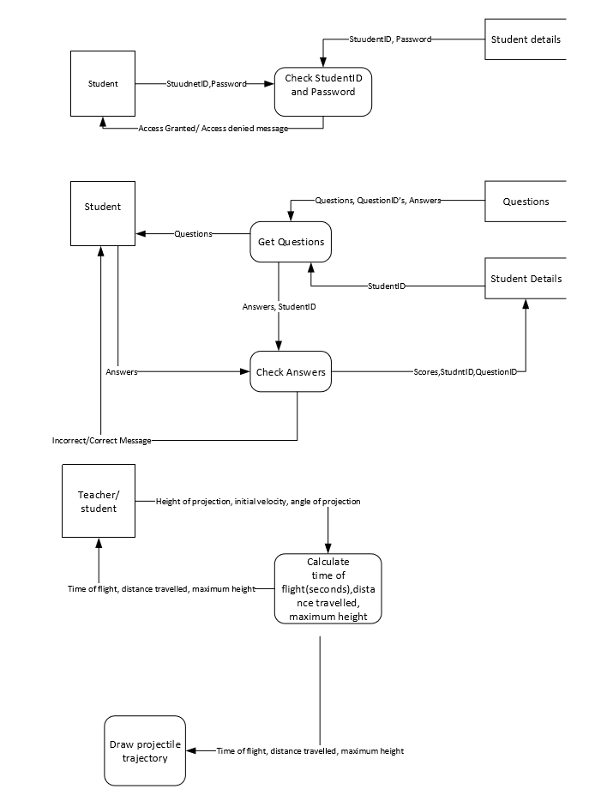Data Flow Diagram (proposed solution)

## Prototyping

### Prototype 1

My main priority of the program is to create trajectory path animation of the projectile.

The most suitable way to output this on Delphi is to use a blank image canvas and use the ‘lineTo()’ function which takes a x and a y coordinate. I will also use the ‘moveTo()’ function which starts the line at a certain coordinate.

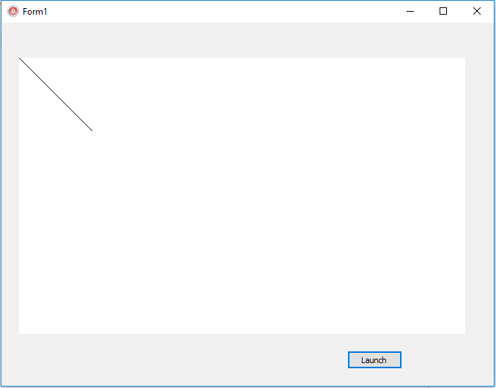

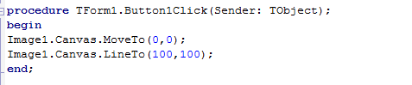

Clicking ‘launch’ button draws a line to the coordinates (100,100) from the origin however the placement of the origin is in the top left corner when it needs to be in the bottom left corner. With some research I found out there is no way of changing the origin location, so I will have to subtract the y coordinate from the height of the image canvas.

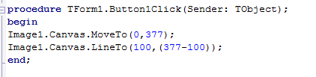

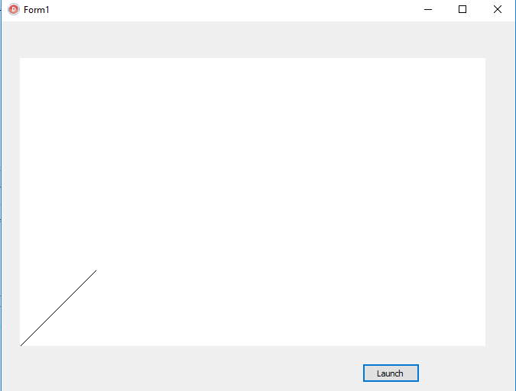

## Equations

|  |
| --- |
|  |

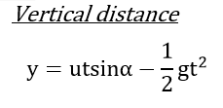

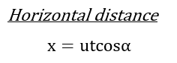

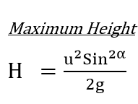

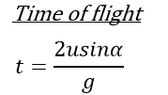

# Design

## Overview

### IPSO Chart

|  |  |
| --- | --- |
| **Input**  Username(string)  Password(string)  Initial velocity(integer)  Angle of projection(integer)  Initial height(integer)  Answer(string) | **Processes**  Check Username and password.  Calculate maximum height  Calculate time of flight  Calculate final Velocity (velocity the projectile hits the ground at)  Check Answer |
| **Storage**  Data Storage tables:  Username  Password  Data Storage tables:  Question ID  Question  Answer  Solution  Date added | **Output**  Time of flight  Maximum height  Final velocity  Correct answer message  Incorrect answer message  Trajectory path animation |

### Hierarchy Diagram

**Key\***

1: Initial velocity

2: Angle

3: Height

4: Time of flight

5: Maximum height

6: X velocity

7: Y velocity

8: instructions to draw trajectory

**Data flow directions**

Red Font: going down the diagram

Blue Font: going up the diagram

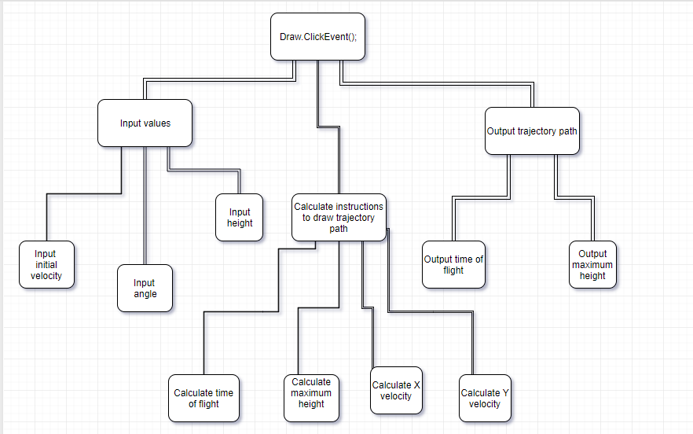

1

2

7

1,2,3

3

4

7,3

1,2,3

5

6

1,2

4

4,5,8

7

1,2

5

## User Interface

### Login screen design

These edit boxes will take input of the user’s password and id number

Image canvas used as a background

Title of program

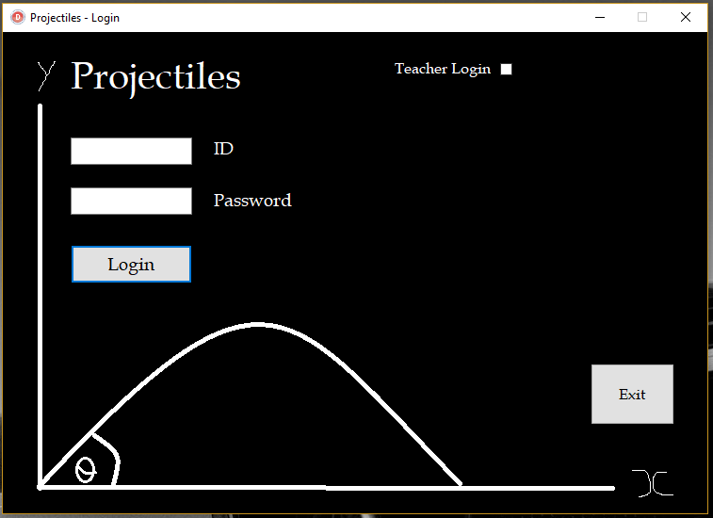

The check box will tell the program if the user is a teacher or student. When the box is checked and the login button is clicked the program will the teacher table in the database for a matching Id and password instead of the student table.

The login in button will run an algorithm to check user id and password entered with the database.

End application

### Main Menu(Student) design

This is the main menu a student will be presented with after logging in. Each of these buttons will open another form apart from the exit button.

Welcome message

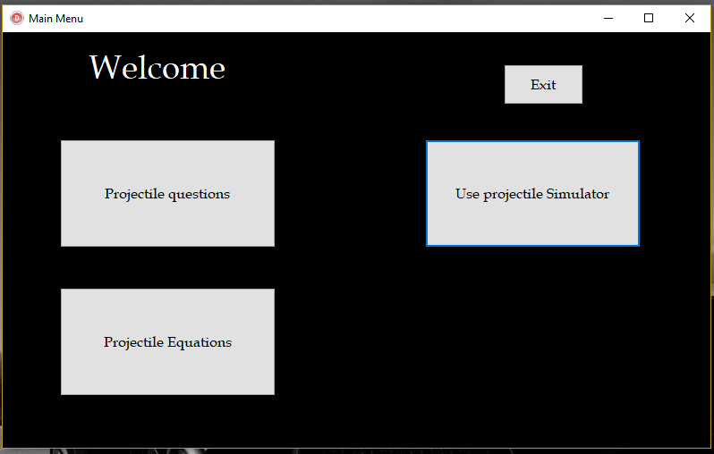

This button will take the user to the projectile simulator

This button will open a form that shows basic projectile equations commonly used in the mechanics 1 exam.

Clicking this button will load the form where students can answer projectile questions added or created by their teachers.

### Main menu (Teacher) design

This form will be identical to student’s main menu except from the extra admin settings button and view student details button which will open a menu for teachers to add students, other teachers, classes, questions and open a menu to view student scores and details.

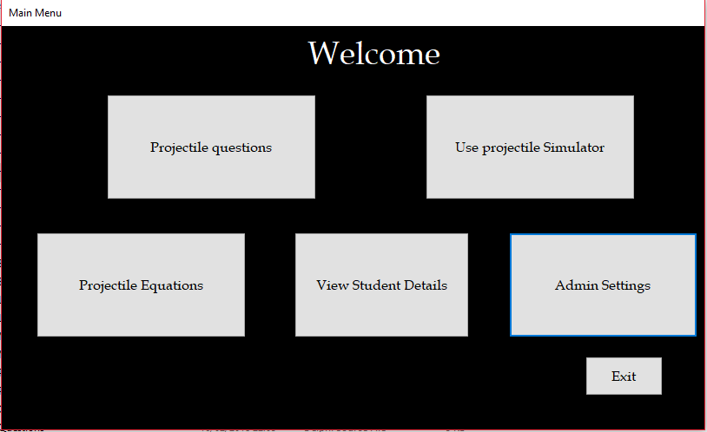

### Answer questions design

The user will enter the questions id number into the edit box and click load which query the database for the question and load it onto the memo box.

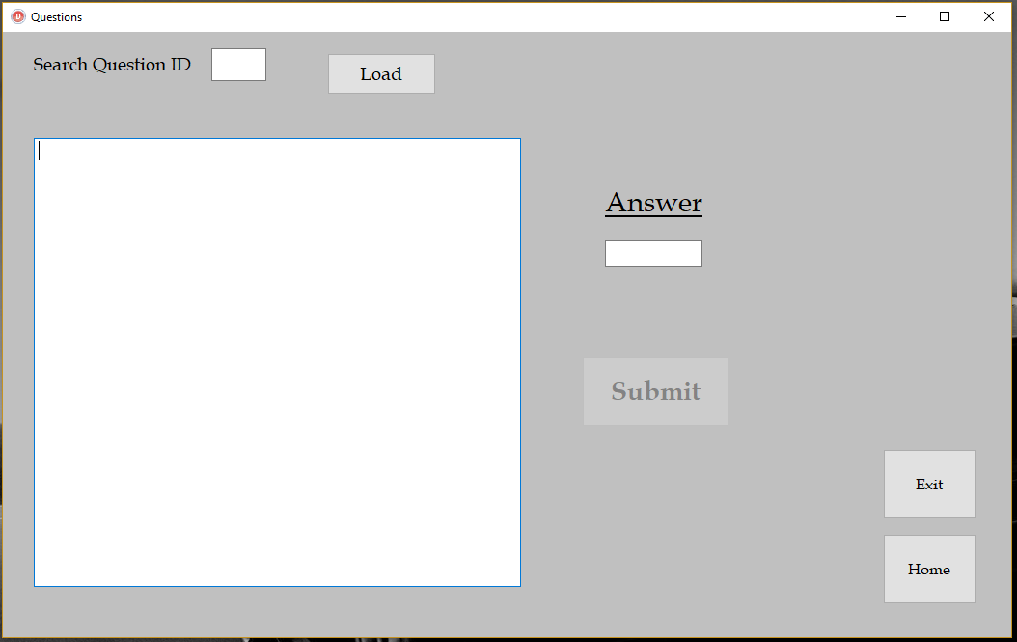

The user will enter their answer into the answer box and click submit which query the data base to check their answer. A new record will be created using the student’s ID and the question ID and give them a score based on their answer.

### Projectile simulator design

Image canvas that draws the trajectory path of the projectile (appears when the draw button is clicked)

Clicking ‘Draw’ will calculate the path of the projectile then start the timer and start drawing the path.

Ball of type ‘tshape’. This follow the trajectory path created by the image canvas.

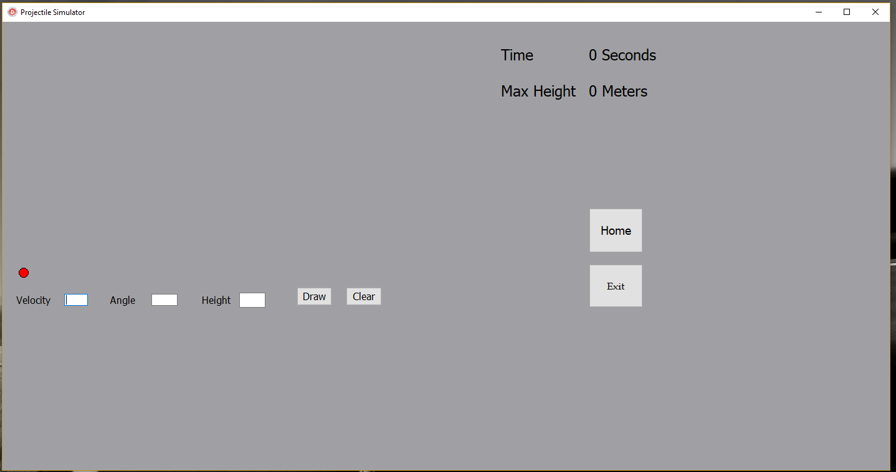

Displays the calculated maximum height of the projectile.

Live timer of the projectile from launch to landing

Resets the form to its initial sate.

Inputs for the angle of projection, initial velocity and initial height from ground level.

### Adding data to the database (admin settings) design

This form will allow teachers to add questions, students, teachers and classes to the database. The form will use tabs to separate the data being added. Each tab will have edit boxes for any required data that is needed to create a record in the database.

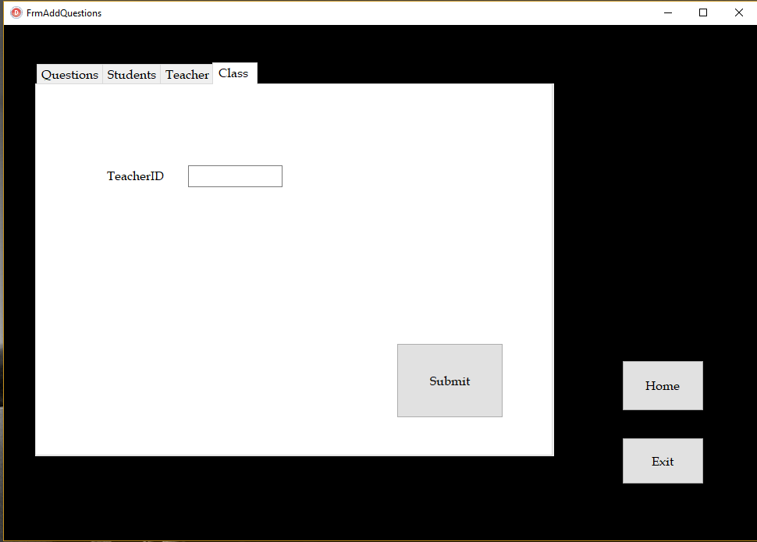

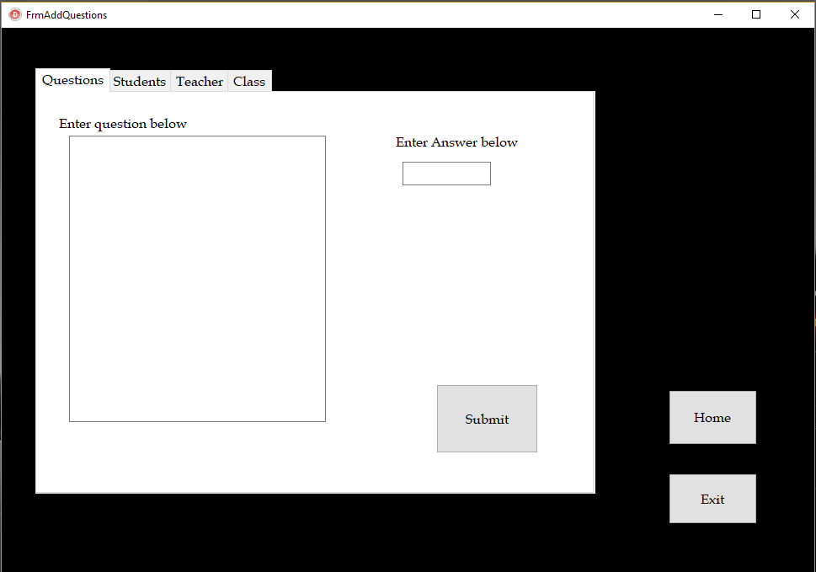

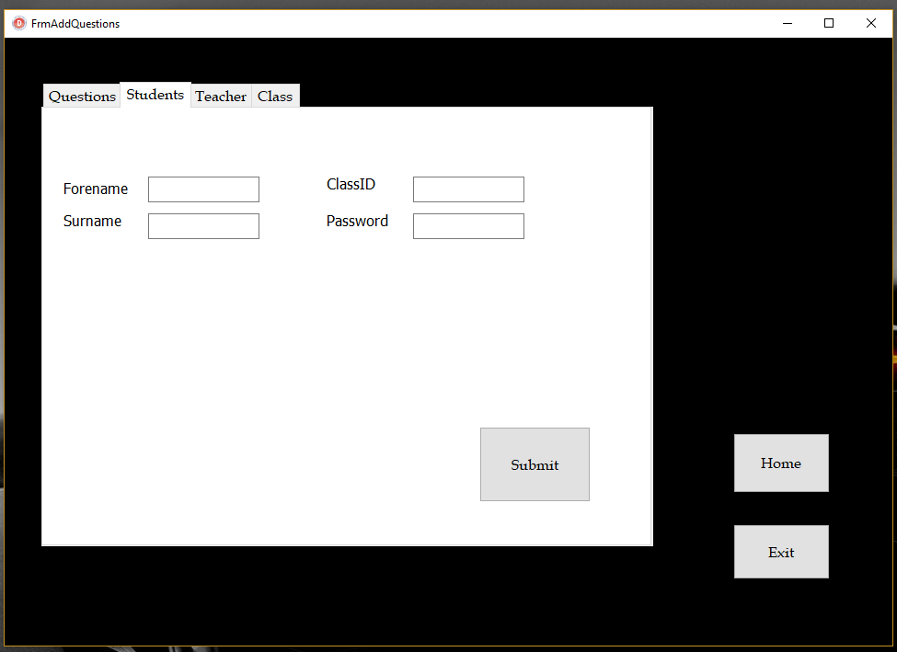

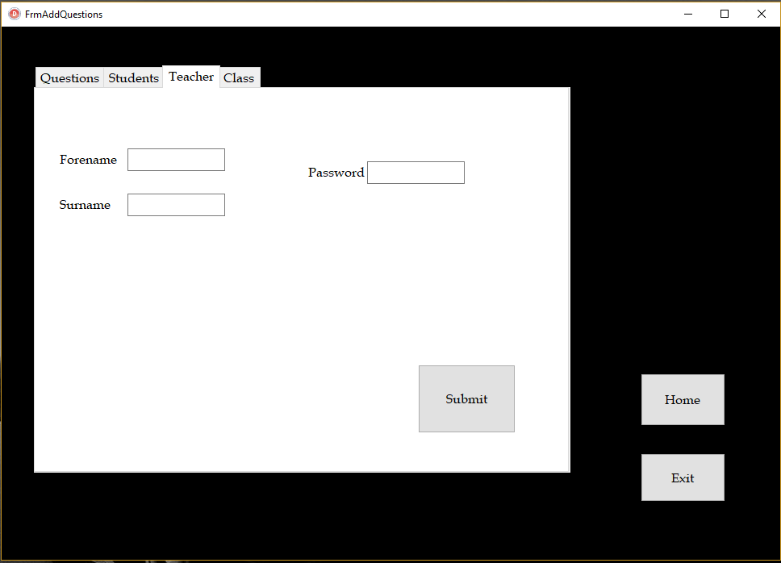

## Algorithms

### Algorithm for drawing a trajectory path

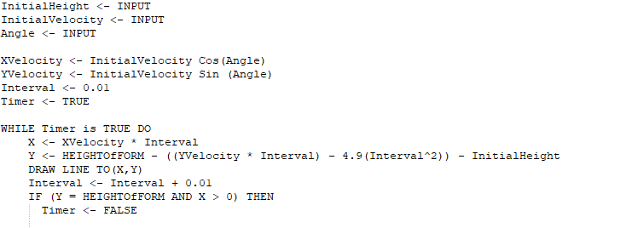

User Input for the initial velocity, Angle of projection and the initial height from ground level.

While the timer is running the horizontal and vertical distance are calculated at the time of the interval value. The interval is then incremented by 0.01 and X and Y are recalculated then another is drawn from the previously calculated coordinates. Once Y has returned to the height of the form, the timer is set to false so no more lines are drawn more lines are drawn.

The horizontal velocity and the vertical velocity are calculated using the initial velocity and angle. Interval is used to replaced time in the equations for calculating horizontal and vertical distance. So, the program will draw a line every 0.01 seconds.

If an object is created to follow this trajectory path, I simply need set the values of its coordinates to X Y in the while loop.

## Database

### Entity Relationship Diagram

Question

Score

Class

Teacher

Student

### Creating Database tables with Data Definition Language

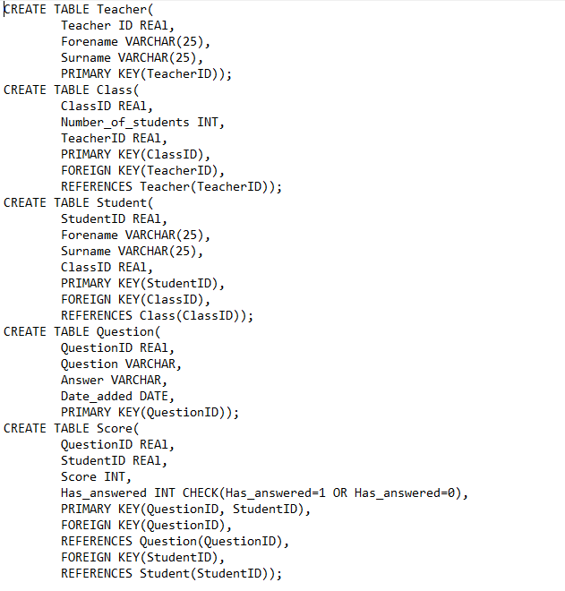

### SQL Queries

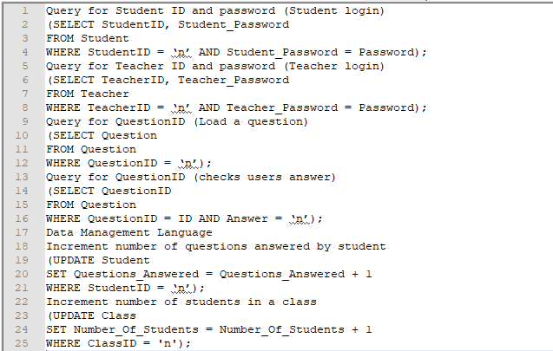

# Testing

## Test plan

|  |  |
| --- | --- |
| Test series | Purpose |
| 1: Login form testing. | This test series will test to flow of control (exiting the application and returning to the main menu form) and correctly validating the user input (username and password validation). |
| 2: Main menu form testing. | This test series will test to flow of control (exiting the application and switching to the correct forms.) |
| 3: Questions form testing | This test series will test to flow of control (exiting the application and returning to the main menu form) and whether the correct data is loaded onto the form (Questions from the database). |
| 4: Equations form testing | This test series will test to flow of control (exiting the application and returning to the main menu form) and whether the correct data is loaded onto the form (image files). |
| 5: Admin settings form testing. | This test series will test to flow of control (exiting the application and returning to the main menu form), whether the correct data is saved to the database and correctly validating the user input (data entered by the user to be added to the database). |
| 6: Student details form testing. | This test series will test to flow of control (exiting the application and returning to the main menu form), whether the correct data is saved to the database and correctly validating the user input (data entered by the user to be added to the database). |
| 7: Projectile simulator form testing. | This test series is to check that the validation of user input is correct for the projectile simulator, the correct calculations are made (e.g. horizontal displacement and time.) and to test the flow of control (exiting the application and returning to the main menu form). |
| 8: objective based testing (some maybe already completed in other tests these will be marked with an asterisk). | This test series will test the applications objectives to see whether they have been met sufficiently. |

## Testing

|  |  |  |  |  |  |  |
| --- | --- | --- | --- | --- | --- | --- |
| Test | Unit | Purpose | Input/Test data | Expected  outcome | Actual  Outcome | Pass? |
| 1.1 | Ulogin | Test to check if the login form is opened when the application starts. | Double click ‘Projectiles.exe’. | The application is started and the user is presented with the login screen. | The application is started and the user is presented with the login screen. | y |
| 1.2 | Ulogin | Test to check if the application is terminated without errors. | Left click ‘BtnExit’. | The application is terminated with no errors. | The application is terminated with no errors. | y |
| 1.3 | Ulogin | Test to check if the user can input their id and password. | ‘Admin’ and ‘Admin’. | ‘Admin’  And ‘Admin’ | ‘Admin’  And ‘Admin’. | y |
| 1.4.1 | Ulogin | Test to check If access is denied for incorrect login details. | ‘1234’ and ‘qwerty’,  left click ‘Login’. | Pop up message: ‘Access denied’. | Pop up message: ‘Access denied’. | y |
| 1.4.2 | Ulogin | Test to check if access is granted for correct login details. | ‘1’ and ‘Dunk’,  left click ‘Login’. | Pop up message: ‘Access granted’. | Pop up message: ‘Access granted’. | y |
| 1.4.3 | Ulogin | Test to check if access is denied for incorrect password. | ‘1’ and ‘qwerty’,  left click ‘Login’. | Pop up message: ‘Access denied’. | Pop up message: ‘Access denied’. | y |
| 1.4.4 | Ulogin | Test to check if access is denied for incorrect ID. | ‘123’ and ‘Dunk’,  left click ‘Login’. | Pop up message: ‘Access denied’. | Pop up message: ‘Access denied’. | y |
| 1.5.1 | Ulogin | Test to check if correct student login is denied when ‘Teacher/admin’ is checked. | ‘1’ and ‘dunk’  ,’Teacher/admin’ is checked,  left click ‘Login’. | Pop up message: ‘Access denied’. | Pop up message: ‘Access denied’. | y |
| 1.5.2 | Ulogin | Test to check if correct teacher login is denied when ‘Teacher/admin’ is not checked. | ‘1’ and ‘Kobe’,  left click ‘Login’. | Pop up message: ‘Access denied’. | Pop up message: ‘Access denied’. | y |
| 1.5.3 | Ulogin | Test to check if access Is granted for correct id and password. (Teacher/Admin checked). | ‘2’ and ‘900’,  left click ‘Login’. | Pop up message: ‘Access granted’. | Pop up message: ‘Access granted’. | y |
| 1.5.4 | Ulogin | Test to check if access is denied for incorrect password (Teacher/Admin checked). | ‘2’ and ‘qwerty’,  left click ‘Login’. | Pop up message: ‘Access denied’. | Pop up message: ‘Access denied’. | y |
| 1.5.5 | Ulogin | Test to check if access is denied for incorrect ID (Teacher/Admin checked). | ‘32’ and ‘900’,  left click ‘Login’. | Pop up message: ‘Access denied’. | Pop up message: ‘Access denied’. | y |
| 1.5.6 | Ulogin | Test to check if the Main menu form is opened with a successful login | ‘Admin’ and ‘Admin’,  left click ‘Login’,  left click ‘ok’. | The user is presented with the main menu form. | The user is presented with the main menu form. | y |
| 2.1.1 | Ulogin and UmainMenu | Test to check if the admin settings and student details buttons are hidden if the user logged in without ‘Teacher/Admin’ checked. | ‘2’ and ‘fade’,  left click ‘Login’,  left click ‘ok’. | Main menu form with 3 buttons (‘Use projectile simulator’, ’Projectile questions’ and ‘Projectile equations’). | Pop up message: ‘Access granted’, left click ‘ok’ and the main menu form with 3 buttons (‘Use projectile simulator’, ’Projectile questions’, ‘Projectile equations’). | y |
| 2.1.2 | Ulogin and UmainMenu | Test to check if the admin settings and student details buttons are visible if the user logged in with ‘Teacher/Admin’ checked | ‘1’ and ‘Kobe’,  left click ‘Login’,  left click ‘ok’. | Main menu form with the same 3 buttons as before and 2 additional buttons (‘Admin settings’ and ‘Student details’). | Main menu form with the same 3 buttons as before and 2 additional buttons (‘Admin settings’ and ‘Student details’). | y |
| 2.2 | UmainMenu | Test to check if the application is terminated without errors. | Left click ‘BtnExit’. | The application is terminated with no errors. | The application is terminated with no errors. | y |
| 2.3 | UmainMenu | Test to check if the questions form is opened and the main menu is closed. | Left click ‘BtnQuestions’. | ‘UQuestions.pas’ is opened and ‘UMainMenu.pas’ is closed. | ‘UQuestions.pas’ is opened and ‘UMainMenu.pas’ is closed. | y |
| 2.4 | UMainMenu | Test to check if the projectile simulator form is opened and the main menu is closed. | Left click ‘BtnSimulator’. | ‘UProjectileSim.pas’ is opened and ‘UMainMenu.pas’ is closed. | ‘‘UProjectileSim.pas’ is opened and ‘UMainMenu.pas’ is closed. | y |
| 2.5 | UMainMenu | Test to check if equations form is opened and the main menu is closed. | Left click ‘BtnEquations’ | ‘UEquations.pas’ is opened and ‘UMainMenu.pas’ is closed. | ‘UEquations.pas’ is opened and ‘UmainMenu.pas’ is closed. | y |
| 2.6 | UMainMenu | Test to check if the student details form is opened and the main menu is closed. | Left click ‘BtnDetails’ | ‘UshowScores.pas’ is opened and ‘UMainMenu.pas’ is closed. | ‘UshowScores.pas’ is opened and ‘UMainMenu.pas’ is closed. | y |
| 2.7 | UMainMenu | Test to check if Admin settings form is opened and the main menu is closed. | Left click ‘BtnAdminSettings’ | ‘AddQuestionsAndUsers.pas’ is opened and ‘UmainMenu.pas’ is closed. | ‘AddQuestionsAndUsers.pas’ is opened and ‘UMainMenu.pas’ is closed. | y |

|  |  |  |  |  |  |  |
| --- | --- | --- | --- | --- | --- | --- |
| 3.1 | UQuestions | Test to check if an invalid error is displayed when the user loads a non-existent question. | QuestionID = ‘a’,  left click ‘BtnLoad’ | Pop up message: 'Question not valid, please try a different ID.' | Pop up message: 'Question not valid, please try a different ID.' | y |
| 3.2 | UQuestions | Test to check if the correct question is loaded without any errors. | QuestionID = ‘2’,  left click ‘BtnLoad’. | MmoQuestion =’ A football is kicked with speed 31 m s−1  at an angle of 20° to the horizontal. It travels towards the goal which….’ | MmoQuestion =’ A football is kicked with speed 31 m s−1  at an angle of 20° to the horizontal. It travels towards the goal which….’ | y |
| 3.3.1 | UQuestions | Test to check if the solution is loaded if the user is a teacher/admin without any errors. | Left click ‘BtnSolution’. | MmoSolution = ‘Both components of initial speed  Horiz 31cos20 (29.1) Vert 31sin 20 (10.6…. | MmoSolution = ‘Both components of initial speed  Horiz 31cos20 (29.1) Vert 31sin 20 (10.6…. | y |
| 3.3.2 | UQuestions | Test to check if the solution is loaded if the user is a student without any errors. | Left click ‘BtnSolution’. | MmoSolution = ‘Both components of initial speed  Horiz 31cos20 (29.1) Vert 31sin 20 (10.6…. | MmoSolution = ‘Both components of initial speed  Horiz 31cos20 (29.1) Vert 31sin 20 (10.6…. | y |
| 3.3.3 | UQuestions | Test to check if the students record is updated correctly when they obtain solutions. | Left click ‘BtnSolution’. | Record in score table: StudentID = ‘2’, QuestionID = ‘2’, ‘Has_Answered’ = ‘1’,  Score = ‘0’.  Record in Student table: StudentID = ‘2’, Questions_Answered = ‘1’. | Where StudentID = ‘2’  And QuestionID = ‘2’ in the score table ‘Has_Answered’ = 1 and score = ‘0’.  In the student table where the StudentID = ‘2’, Questions_Answered = ‘1’. | y |
| 3.4.1 | UQuestions | Test to check if the answer is checked correctly if the user is a teacher/admin. | Left click ‘BtnSubmit’,  Answer = ‘yes/3.76m’. | Pop up message: ‘Correct!’. | Pop up message: ‘Correct!’. | y |
| 3.4.2 | UQuestions | Test to check if the answer is checked correctly if the user is a student. | Left click ‘BtnSubmit’,  Answer = ‘yes/3.76m’. | Pop up message: ‘Correct!’. | Pop up message: ‘Correct!’. | y |
| 3.4.3 | UQuestions | Test to check if the students record is updated correctly when they submit a correct answer. | Left click ‘BtnSubmit’,  Answer = ‘yes/3.76m’. | Record in score table: StudentID = ‘6’, QuestionID = ‘2’, ‘Has_Answered’ = ‘1’,  Score = ‘1’.  Record in Student table: StudentID = ‘6’, Questions_Answered = ‘1’. | Record in score table: StudentID = ‘6’, QuestionID = ‘2’, ‘Has_Answered’ = ‘1’,  Score = ‘0’.  Record in Student table: StudentID = ‘6’, Questions_Answered = ‘1’. | n |
| 3.4.4 | UQuestions | Test to check if an incorrect answer is differentiated from the correct answer if the user is a teacher/admin. | Left click ‘BtnSubmit’,  Answer = ‘n/1.98m’. | Pop up message: ‘Incorrect!’. | Pop up message: ‘Incorrect!’. | y |
| 3.4.5 | UQuestions | Test to check if an incorrect answer is differentiated from the correct answer if the user is a student. | Left click ‘BtnSubmit’,  Answer = ‘n/1.98m’. | Pop up message: ‘Incorrect!’. | Pop up message: ‘Incorrect!’. | y |
| 3.4.6 | UQuestions | Test to check if the students record is updated correctly when they submit an incorrect answer. | Left click ‘BtnSubmit’,  Answer = ‘n/1.98m’. | Record in score table: StudentID = ‘5’, QuestionID = ‘2’, ‘Has_Answered’ = ‘1’,  Score = ‘1’.  Record in Student table: StudentID = ‘5’, Questions_Answered = ‘1’. | Record in score table: StudentID = ‘5’, QuestionID = ‘2’, ‘Has_Answered’ = ‘1’,  Score = ‘1’.  Record in Student table: StudentID = ‘5’, Questions_Answered = ‘1’. | y |
| 3.7 | UQuestions | Test to check if the application is terminated without errors. | Left click ‘BtnExit’. | The application is terminated with no errors. | The application is terminated with no errors. | y |
| 3.8 | UQuestions | Test to check if the questions form is closed and the main menu is opened without any errors. | Left click ‘BtnHome’. | ‘UQuestions.pas’ is closed and ‘UMainMenu.pas’ is opened without any errors. | ‘UQuestions.pas’ is closed and ‘UMainMenu.pas’ is opened without any errors. | y |
| 4.1 | UEquations | Test to check if the images of the projectile equations are loaded correctly. | Left click ‘BtnEquations’. | The user is presented with 4 images of projectile equations. | The user is presented with 4 images of projectile equations. | y |
| 4.2 | UEquations | Test to check if the application is terminated. | Left click ‘BtnExit’. | The application is terminated with no errors. | The application is terminated with no errors. | y |
| 5.1 | AddQuestionAndUsers | Test to check if connecting to the database reveals the tab sheets to add records to the user. | Left click ‘BtnConnect’ | The user is presented with a tab sheet with 4 pages labelled ‘Class’, ‘Teacher’, ‘Student’ and Questions’. | The user is presented with a tab sheet with 4 pages labelled ‘Class’, ‘Teacher’, ‘Student’ and Questions’. | y |
| 5.1.1 | AddQuestionAndUsers | Test to check if the correct components are loaded onto the ‘Questions’ tab page. | Left click ‘Questions’ (tab sheet page control). | The user is presented with 2 memo boxes to enter a question and a solution and an edit box to enter an answer. | The user is presented with 2 memo boxes to enter a question and a solution and an edit box to enter an answer. | y |
| 5.1.2 | AddQuestionAndUsers | Test to check if the correct components are loaded onto the ‘Students’ tab page. | Left click ‘Students’ (tab sheet page control) | The user is presented with 4 edit boxes to enter their forename, surname, password and class id. | The user is presented with 4 edit boxes to enter their forename, surname, password and class id. | y |
| 5.1.3 | AddQuestionAndUsers | Test to check if the correct components are loaded onto the ‘Teacher’ tab page. | Left click ‘Teacher’ (tab sheet page control) | The user is presented with 3 edit boxes to enter their forename, surname and password. | The user is presented with 3 edit boxes to enter their forename, surname and password. | y |
| 5.1.4 | AddQuestionAndUsers | Test to check if the correct components are loaded onto the ‘Class’ tab page. | Left click ‘Class’ (tab sheet page control) | The user is presented with 1 edit box to enter a teacher id. | The user is presented with 1 edit box to enter a teacher id. | y |
| 5.2.1 | AddQuestionAndUsers | Test to check if a teacher is added to the database correctly. | Forename = ‘John’,  surname = ‘Smith’, password = ’abc123’,  left click ‘BtnTeacherSubmit’. | Record in teacher table: TeacherID = ‘3’, Teacher_forename = ‘John’, ‘Teacher_surname’ = ‘Smith’,  ‘Password’ = ‘abc123’. | Record in teacher table: TeacherID = ‘3’, Teacher_forename = ‘John’, ‘Teacher_surname’ = ‘Smith’,  ‘Password’ = ‘abc123’. | y |
| 5.2.2 | AddQuestionAndUsers | Test to check if a class is added to the database correctly. | Teacher id = ‘3’,  left click ‘BtnClassSubmit’. | Record in the class table: ClassID = ’3’, Number_Of_Students = ’0’,  TeacherID = ‘3’. | Record in the class table: ClassID = ’3’, Number_Of_Students = ’0’,  TeacherID = ‘3’. | y |
| 5.2.3 | AddQuestionAndUsers | Test to check if a student is added to the database correctly | Forename = ‘Harry’, Surname = ‘Wilson’, Password = ’apple’, ClassID = ‘3’,  left click ‘BtnStudentSubmit’. | Record in the student table:  StudentID = ‘7’,  Student_Forename = ‘Harry’,  Student_Surname = ‘Wilson’, Student_password = ‘apple’, Questions_Answered = ‘0’,  ClassID = ‘3’. | In the Student table in the projectile data base there is a record with StudentID = ‘7’, Student_Forename = ‘Harry’, Student_Surname = ‘Wilson’, Student_password = ‘apple’, Questions_Answered = ‘0’, ClassID = ‘3’. | y |
| 5.2.4 | AddQuestionAndUsers | Test to check if a question is added to the database correctly | MmoQuestion = ‘A golfer practising on a range with an elevated tee 4.9 m above the fairway…’,  MmoSolution = ‘x = ut + 0.5a(t^2) then 4.9 m = 0 + 0.5(9.8) …’,  Answer = ‘1s’,  left click ‘BtnQuestionSubmit’. | Record in the question table: QuestionID = ’3’,  Question =’ A golfer practising on a range with an elevated tee 4.9 m above the fairway…’, solution = ‘x = ut + 0.5a(t^2) then 4.9 m = 0 + 0.5(9.8) …’,  Answer = ‘1s’,  Date_added = ‘’. | Record in the question table: QuestionID = ’3’,  Question =’ A golfer practising on a range with an elevated tee 4.9 m above the fairway…’, solution = ‘x = ut + 0.5a(t^2) then 4.9 m = 0 + 0.5(9.8) …’,  Answer = ‘1s’,  Date_added = ‘’. | y |
| 5.3 | AddQuestionAndUsers | Test to check if the admin settings form is closed and the main menu is opened without any errors. | Left click ‘BtnHome’. | ‘AddQuestionsAndUsers.pas’ is closed and ‘UMainMenu.pas’ is opened without any errors. | ‘AddQuestionsAndUsers.pas’ is closed and ‘UMainMenu.pas’ is opened without any errors. | y |
| 5.4 | AddQuestionAndUsers | Test to check if the application is terminated without errors. | Left click ‘BtnExit’. | The application is terminated with no errors. | The application is terminated with no errors. | y |
| 6.1.1 | UshowScores | Test to check correct data is loaded onto the grid with index 0 selected in the table options. | Item index = ‘0’, QuestionID = ‘1’,  left click ‘BtnLoad’. | All scores on question 1 only. | All scores on question 1 only. | y |
| 6.1.2 | UshowScores | Test to check correct data is loaded onto the grid with index 1 selected in the table options. | Item index = ‘1’,  ClassID = ‘2’,  left click ‘BtnLoad’. | A table with the correct the values (all scores from class 2 only). | Incorrect data loaded. | n |
| 6.1.3 | UshowScores | Test to check correct data is loaded onto the grid with index 2 selected in the table options. | Item index = ‘2’,  StudentID = ‘2’,  left click ‘BtnLoad’. | All scores of student number 2 only. | All scores of student number 2 only. | y |
| 6.1.4 | UshowScores | Test to check correct data is loaded onto the grid with index 3 selected in the table options. | Item index = ‘3’,  ClassID = ‘2’,  QuestionID = ‘3',  left click ‘BtnLoad’. | All scores from class 2 on question 3 only (empty since nobody has answered question 3). | All scores from class 2 on question 3 only (empty since nobody has answered question 3). | y |
| 6.1.5 | UshowScores | Test to check correct data is loaded onto the grid with index 4 selected in the table options. | Item index = ‘4’,  StudentID = ‘2’,  left click ‘BtnLoad’. | All details of student number 2 except password. | All details of student number 2 except password. | y |
| 6.2 | UshowScores | Test to check if the Student details form is closed and the main menu is opened without any errors. | Left click ‘BtnHome’. | ‘UshowScores.pas’ is closed and ‘UMainMenu.pas’ is opened without any errors. | ‘UshowScores.pas’ is closed and ‘UMainMenu.pas’ is opened without any errors. | y |
| 6.3 | UshowScores | Test to check if the application is terminated without errors. | Left click ‘BtnExit’. | The application is terminated with no errors. | The application is terminated with no errors. | y |
| 7.1 | UProjectileSim | Test to check if the projectile simulator form is closed and the main menu is opened without any errors. | Left click ‘BtnHome’. | ‘UProjectileSim.pas’ is closed and ‘UMainMenu.pas’ is opened without any errors. | ‘‘UProjectileSim.pas’ is closed and ‘UMainMenu.pas’ is opened without any errors. | y |
| 7.2 | UProjectileSim | Test to check if the application is terminated without errors. | Left click ‘BtnExit’. | The application is terminated with no errors. | The application is terminated with no errors. | y |
| 7.3.1 | UProjectileSim | Test to check if inputs are rejected for ‘Velocity’ (erroneous data). | Velocity = ’a’,  Angle = ‘45’,  Height = ‘5’,  left click ‘BtnDraw’. | Pop up message: ‘‘a’ is an invalid integer value’ and the draw function is not started. | Pop up message: ‘‘a’ is an invalid integer value’ and the draw function is not started. | y |
| 7.3.2 | UProjectileSim | Test to check if inputs are accepted for ‘Velocity’ (extreme data). | Velocity = ’100’,  Angle = ‘45’,  Height = ‘10’,  left click ‘BtnDraw’. | The draw function is started and a trajectory line is drawn on the image canvas. | The draw function is started and a trajectory line is drawn on the image canvas. | y |
| 7.3.3 | UProjectileSim | Test to check if inputs are rejected for ‘Velocity’  (erroneous data). | Velocity = ’101’,  Angle = ‘45’,  Height = ‘5’,  left click ‘BtnDraw’. | Pop up message: ‘Invalid input please try again’  and the draw function is not started. | Pop up message: ‘Invalid input please try again’  and the draw function is not started. | y |
| 7.3.4 | UProjectileSim | Test to check if inputs are accepted for ‘Velocity’ (typical data). | Velocity = ’50’,  Angle = ‘45’,  Height = ‘5’,  left click ‘BtnDraw’. | The draw function is started and a trajectory line is drawn on the image canvas. | The draw function is started and a trajectory line is drawn on the image canvas. | y |
| 7.3.5 | UProjectileSim | Test to check if inputs are rejected for ‘Velocity’  (erroneous data). | Velocity =’-1’,  Angle = ‘45’,  Height = ‘5’,  left click ‘BtnDraw’. | Pop up message: ‘Invalid input please try again’  and the draw function is not started. | Pop up message: ‘Invalid input please try again’  and the draw function is not started. | y |
| 7.3.6 | UProjectileSim | Test to check Inputs are accepted for ‘Velocity’ (extreme data). | Velocity =’0’,  Angle = ‘45’,  Height = ‘5’,  left click ‘BtnDraw’. | The draw function is started and a trajectory line is drawn on the image canvas. | The draw function is started and a trajectory line is drawn on the image canvas. | y |
| 7.4.1 | UProjectileSim | Test to check if inputs are rejected for ‘Angle’ (erroneous data). | Velocity = ’50’,  Angle = ‘b’,  Height = ‘5’,  left click ‘BtnDraw’. | Pop up message: ‘‘b’ is an invalid integer value’ and the draw function is not started. | Pop up message: ‘‘b’ is an invalid integer value’ and the draw function is not started. | y |
| 7.4.2 | UProjectileSim | Test to check if inputs are accepted for ‘Angle’ (extreme data). | Velocity = ’50’,  Angle = ‘90’,  Height = ‘5’,  left click ‘BtnDraw’. | The draw function is started and a trajectory line is drawn on the image canvas. | The draw function is started and a trajectory line is drawn on the image canvas. | y |
| 7.4.3 | UProjectileSim | Test to check if inputs are rejected for ‘Angle’ (erroneous data). | Velocity = ’50’,  Angle = ‘91’,  Height = ‘5’,  left click ‘BtnDraw’. | Pop up message: ‘Invalid input please try again’  and the draw function is not started. | Pop up message: ‘Invalid input please try again’  and the draw function is not started. | y |
| 7.4.4 | UProjectileSim | Test to check if inputs are accepted for ‘Angle’ (typical data). | Velocity = ’50’,  Angle = ‘45’,  Height = ‘5’,  left click ‘BtnDraw’. | The draw function is started and a trajectory line is drawn on the image canvas. | The draw function is started and a trajectory line is drawn on the image canvas. | y |
| 7.4.5 | UProjectileSim | Test to check Inputs are accepted for ‘Angle’ (extreme data). | Velocity = ’50’,  Angle = ‘0’,  Height = ‘5’,  left click ‘BtnDraw’. | The draw function is started and a trajectory line is drawn on the image canvas. | The draw function is started and a trajectory line is drawn on the image canvas. | y |
| 7.4.6 | UProjectileSim | Test to check if inputs are rejected for ‘Angle’ (erroneous data). | Velocity = ’50’,  Angle = ‘-5’,  Height = ‘5’,  left click ‘BtnDraw’. | Pop up message: ‘Invalid input please try again’  and the draw function is not started. | Pop up message: ‘Invalid input please try again’  and the draw function is not started. | y |
| 7.5.1 | UProjectileSim | Test to check if inputs are rejected for ‘Height’ (erroneous data). | Velocity = ’50’,  Angle = ‘45’,  Height = ‘c’,  left click ‘BtnDraw’. | Pop up message: ‘‘c’ is an invalid integer value’ and the draw function is not started. | Pop up message: ‘‘c’ is an invalid integer value’ and the draw function is not started. | y |
| 7.5.2 | UProjectileSim | Test to check if inputs are accepted for ‘Height’ (extreme data). | Velocity = ’50’,  Angle = ‘45’,  Height = ‘50’,  left click ‘BtnDraw’. | The draw function is started and a trajectory line is drawn on the image canvas. | The draw function is started and a trajectory line is drawn on the image canvas. | y |
| 7.5.3 | UProjectileSim | Test to check if inputs are rejected for ‘Angle’ (erroneous data). | Velocity = ’50’,  Angle = ‘51’,  Height = ‘5’,  left click ‘BtnDraw’. | Pop up message: ‘Invalid input please try again’  and the draw function is not started. | Pop up message: ‘Invalid input please try again’  and the draw function is not started. | y |
| 7.5.4 | UProjectileSim | Test to check if inputs are accepted for ‘Height’ (typical data). | Velocity = ’50’,  Angle = ‘45’,  Height = ‘21’,  left click ‘BtnDraw’. | The draw function is started and a trajectory line is drawn on the image canvas. | The draw function is started and a trajectory line is drawn on the image canvas. | y |
| 7.5.5 | UProjectileSim | Test to check if inputs are accepted for ‘Height’ (extreme data). | Velocity = ’50’,  Angle = ‘45’,  Height = ‘0’,  left click ‘BtnDraw’. | The draw function is started and a trajectory line is drawn on the image canvas. | The draw function is started and a trajectory line is drawn on the image canvas. | y |
| 7.5.6 | UProjectileSim | Test to check if inputs are rejected for ‘Height’ (erroneous data). | Velocity = ’50’,  Angle = ‘45’,  Height = ‘-10’,  left click ‘BtnDraw’. | Pop up message: ‘Invalid input please try again’  and the draw function is not started. | Pop up message: ‘Invalid input please try again’  and the draw function is not started. | y |
| 7.6.1 | UProjectileSim | Test to check if the live timer starts with valid inputs. | Velocity = ’60’,  Angle = ‘35’,  Height = ‘18’,  left click ‘BtnDraw’. | The time in the form of a label increments. | The time in the form of a label increments. | y |
| 7.6.2 | UProjectileSim | Test to check if the timer stops when the projectile animation finishes with the correct value to 2 decimal places. | Velocity = ’60’,  Angle = ‘45’,  Height = ‘30’,  left click ‘BtnDraw’. | The time stops with a value between 9.30 and 9.32 seconds. | The time stops with a value of 9.31 seconds. | y |
| 7.6.3 | UProjectileSim | Test to check if the timer stops when the projectile animation finishes with the correct value to 2 decimal places. | Velocity = ’30’,  Angle = ‘60’,  Height = ‘40’,  left click ‘BtnDraw’. | The time stops with a value between 6.53 and 6.54 seconds. | The time stops with a value of 6.54 seconds. | y |
| 7.6.4 | UProjectileSim | Test to check if the timer stops when the projectile animation finishes with the correct value to 2 decimal places. | Velocity = ’100’,  Angle = ‘90’,  Height = ‘50’,  left click ‘BtnDraw’. | The time stops with a value between 20.87 and 20.88 seconds | The time stops with a value of 20.90 seconds. | n |
| 7.7.1 | UProjectileSim | Test to check the accuracy of the horizontal(x) displacement and maximum height. | Velocity = ’10’,  Angle = ‘20’,  Height = ‘30’,  left click ‘BtnDraw’. | X displacement = ’27 Meters’,  Max height = ‘31 Meters’. | X displacement = ’27 Meters’,  Max height = ‘31 Meters’. | y |
| 7.7.2 | ‘UProjectileSim’ | Test to check the accuracy of the horizontal(x) displacement and maximum height. | Velocity = ’100’,  Angle = ‘80’,  Height = ‘5’,  left click ‘BtnDraw’. | X displacement = ’350 Meters’,  Max height = ‘500 Meters’. | X displacement = ’350 Meters’,  Max height = ‘500 Meters’. | y |
| 7.7.3 | UProjectileSim | Test to check the accuracy of the horizontal(x) displacement and maximum height (extreme). | Velocity = ’1’,  Angle = ‘0’,  Height = ‘0’,  left click ‘BtnDraw’. | X displacement = ’0 Meters’,  Max height = ‘0 Meters’. | X displacement = ’0 Meters’,  Max height = ‘0 Meters’, however the animation never ends (broken loop). | n |
| 7.8.1 | UProjectileSim | Test to check if the time is the correct value to 2 decimal places with skip animation checked. | Velocity = ’60’,  Angle = ‘45’,  Height = ‘30’,  left click ‘BtnDraw’. | The time stops with a value between 9.30 and 9.32 seconds. | The time stops with a value of 9.32 seconds. | y |
| 7.8.2 | UProjectileSim | Test to check if the time is the correct value to 2 decimal places with skip animation checked. | Velocity = ’30’,  Angle = ‘60’,  Height = ‘40’,  left click ‘BtnDraw’. | The time stops with a value between 6.53 and 6.54 seconds. | The time stops with a value of 6.55 seconds. | n |
| 7.8.3 | UProjectileSim | Test to check if the time is the correct value to 2 decimal places with skip animation checked  (extreme). | Velocity = ’100’,  Angle = ‘90’,  Height = ‘50’,  left click ‘BtnDraw’. | The time stops with a value between 20.87 and 20.88 seconds. | The time stops with a value of 20.89 seconds. | n |
| 7.9.1 | UProjectileSim | Test to check the accuracy of the horizontal(x) displacement and maximum height with skip animation on. | Velocity = ’10’,  Angle = ‘20’,  Height = ‘30’,  left click ‘BtnDraw’. | X displacement = ’27 Meters’,  Max height = ‘31 Meters’. | X displacement = ’49 Meters’,  Max height = ‘31 Meters’. | n |
| 7.9.2 | UProjectileSim | Test to check the accuracy of the horizontal(x) displacement and maximum height with skip animation on. | Velocity = ’100’,  Angle = ‘80’,  Height = ‘5’,  left click ‘BtnDraw’. | X displacement = ’350 Meters’,  Max height = ‘500 Meters’. | X displacement = ’196 Meters’,  Max height = ‘500 Meters’. | n |
| 7.9.3 | UProjectileSim | Test to check the accuracy of the horizontal(x) displacement and maximum height with skip animation on (extreme). | Velocity = ’1’,  Angle = ‘0’,  Height = ‘0’,  left click ‘BtnDraw’. | X displacement = ’0 Meters’,  Max height = ‘0 Meters’. | Application froze then crashed (possibly broken loop). | n |
| 7.10 | UProjectileSim | Test to check the if the ball follows the trajectory path (line drawn on the image canvas) correctly. | Velocity = ’100’,  Angle = ‘80’,  Height = ‘5’,  left click ‘BtnDraw’. | The ball follows the trajectory path (line drawn on the image canvas) and stops at the bottom of the image canvas (the ball has landed). | The ball follows the trajectory path (line drawn on the image canvas) and stops at the bottom of the image canvas (the ball has landed). | y |
| 7.11.1 | UProjectileSim | Test to the check if the projectile animation stays within the screen and image canvas (Full Screen mode). | Velocity = ’100’,  Angle = ‘45’,  Height = ‘50’,  left click ‘BtnDraw’. | The trajectory animation stays within the image canvas and the screen. | The trajectory animation stays within the image canvas. | y |
| 7.11.2 | UProjectileSim | Test to the check if the projectile animation stays within the screen and image canvas (minimized mode). | Velocity = ’100’,  Angle = ‘45’,  Height = ‘50’,  left click ‘BtnDraw’. | The trajectory animation stays within the image canvas and the screen. | The trajectory animation goes off the image canvas and off the screen. | n |
| 7.12 | UProjectileSim | Test to the check if the projectile animation runs as normal after switching screen modes. | Velocity = ’100’,  Angle = ‘45’,  Height = ‘50’,  left click ‘BtnDraw’,  left click ‘BtnClear’,  switch to minimized mode,  Velocity = ’30’,  Angle = ‘45’,  Height = ‘10’,  Left click ‘BtnDraw’. | The trajectory animation is drawn without any errors. | The trajectory line is not visible and the ball is in the incorrect place in the image canvas. | n |
| 7.13 | UProjectileSim | Test to check if the image canvas is cleared, the balls position is reset to the origin and all calculated values are reset to 0 (time, max height and horizontal displacement) after clicking the ‘Clear’ button. | Velocity = ’74’,  Angle = ‘28’,  Height = ‘33’,  left click ‘BtnDraw’,  left click ‘BtnClear’. | * The image canvas is blank. * The balls position is at the origin. * The time, max height and horizontal displacement are set to 0. | * The image canvas is blank. * The balls position is at the origin. * The time, max height and horizontal displacement are set to 0. | y |

# Testing Evidence

### Test 1.1

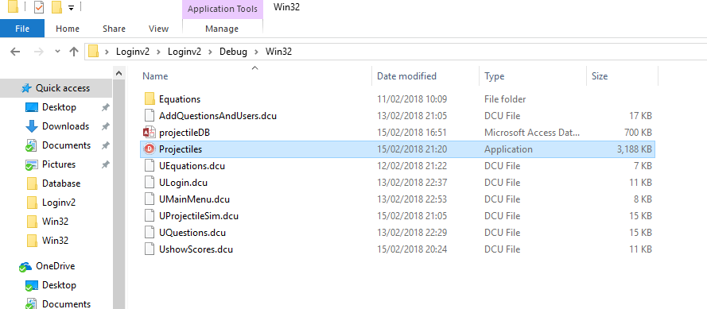

Double click ‘Projectiles.exe’.

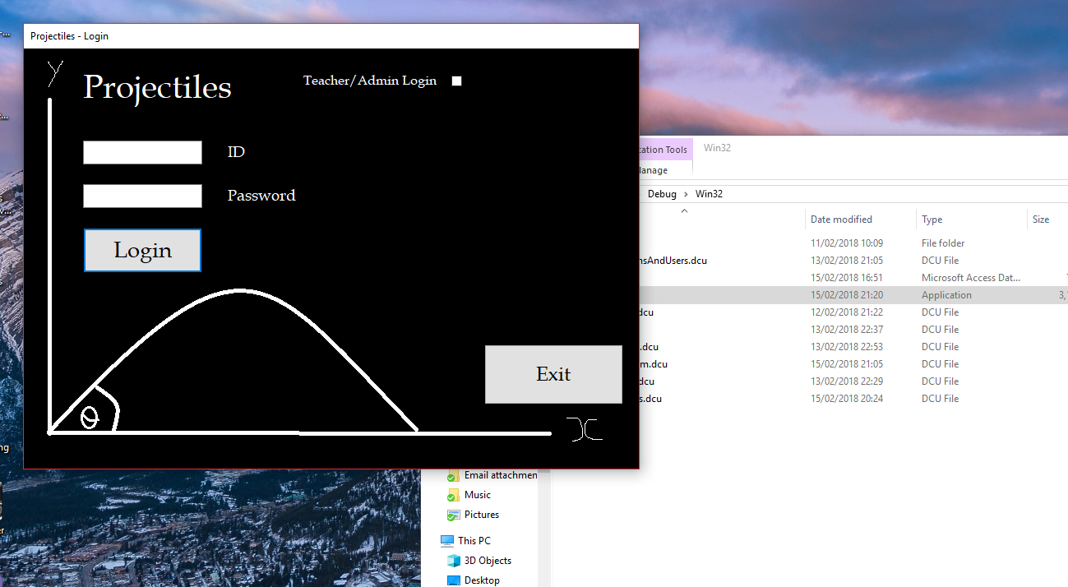

Login form is open.

### Test 1.2



Left click the exit button.

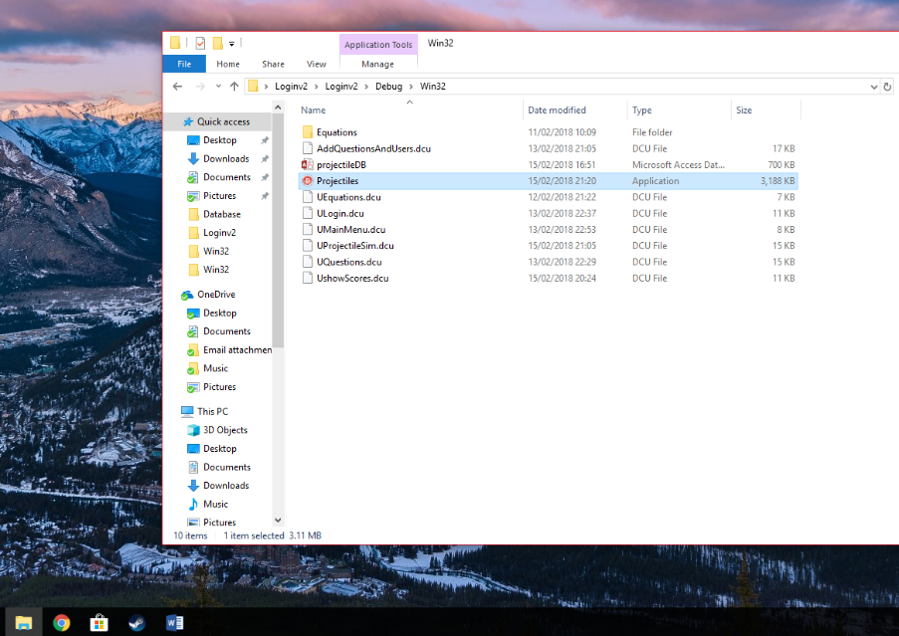

The application is terminated with no errors.

### Test 1.3

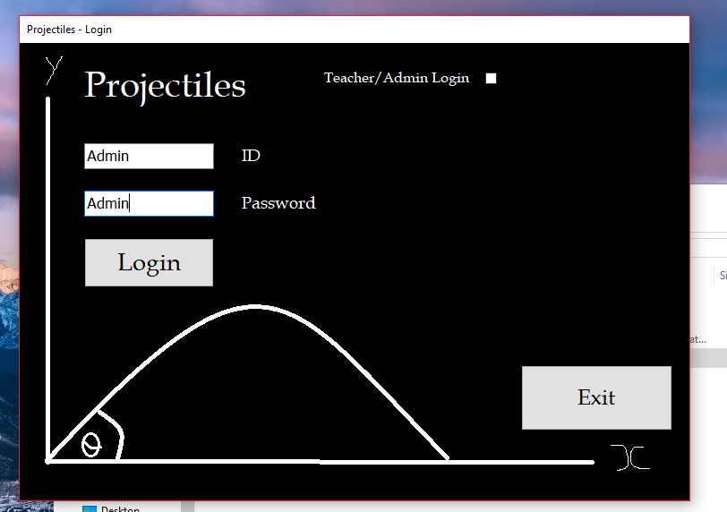

Left click the edit box and type ‘Admin’ then repeat on the edit box below.

### Test 1.4.1

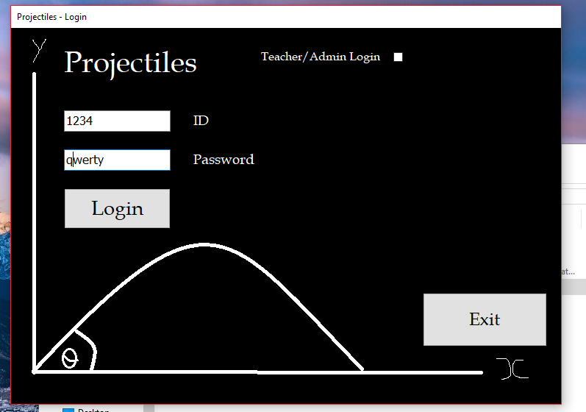

Enter ID (‘1234’) and password (‘qwerty’).

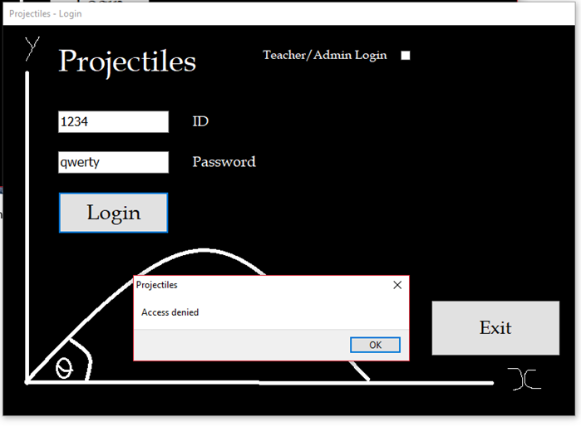

Left click the login button.

### Test 1.4.2

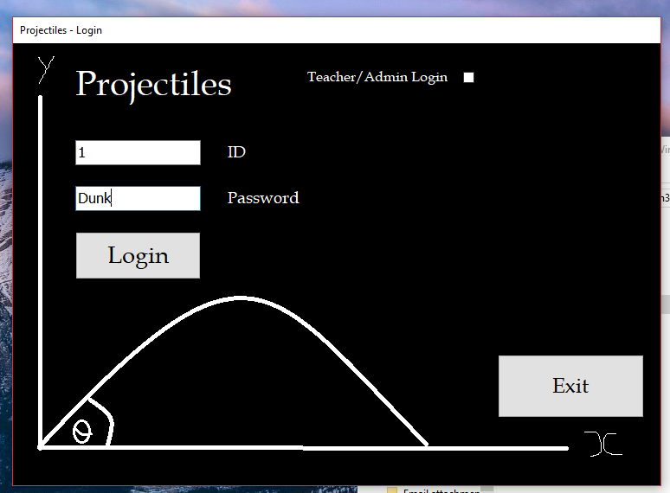

Enter ID (‘1’) and password (‘Dunk’).

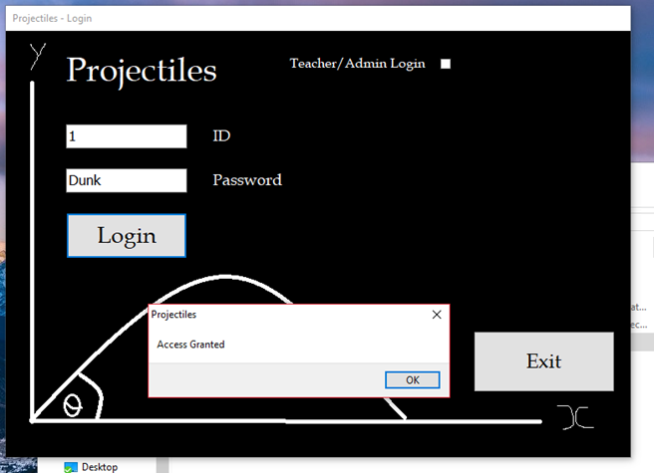

Left click the login button.

### Test 1.4.3

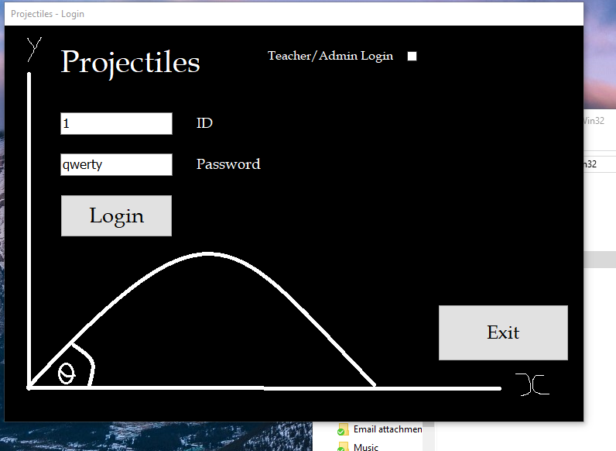

Enter ID (‘1’) and password (‘qwerty’).

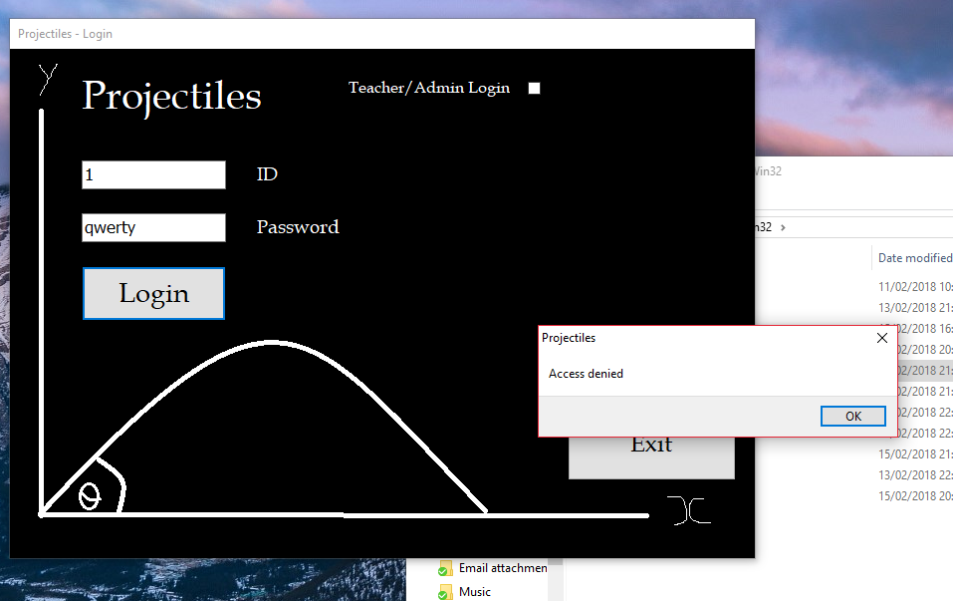

Left click the login button.

### Test 1.4.4

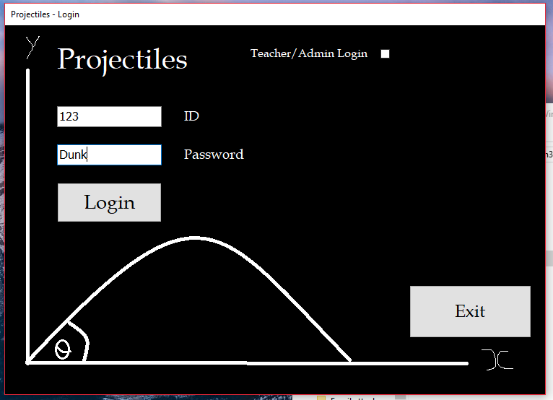

Enter ID (‘123’) and password (‘Dunk’).

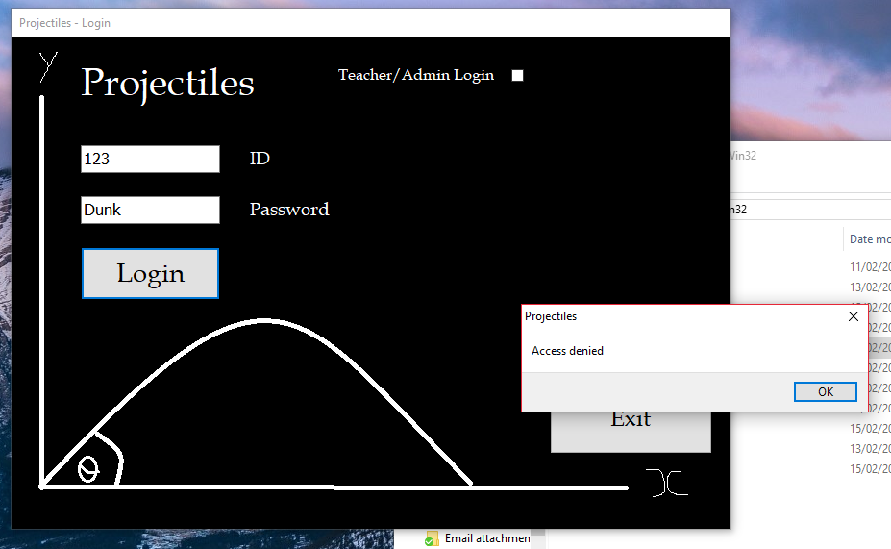

Left click the login button.

### Test 1.5.1

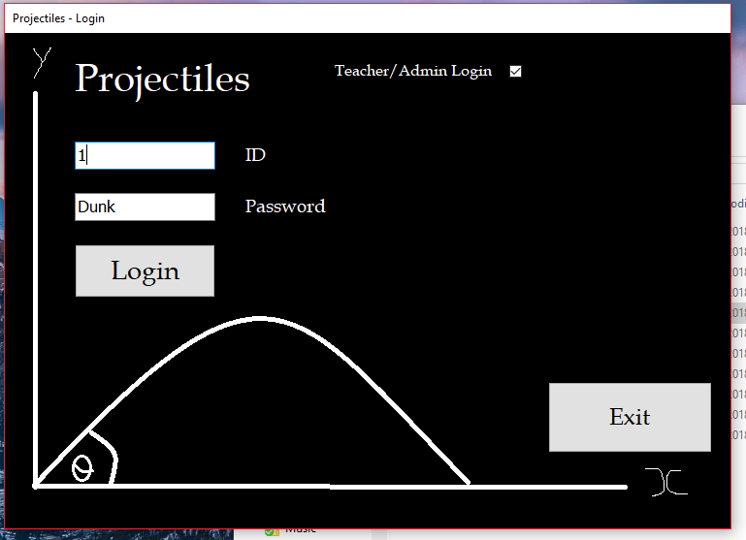

Enter ID (‘1’) and password (‘Dunk’).

Left click check box for Teacher/Admin.

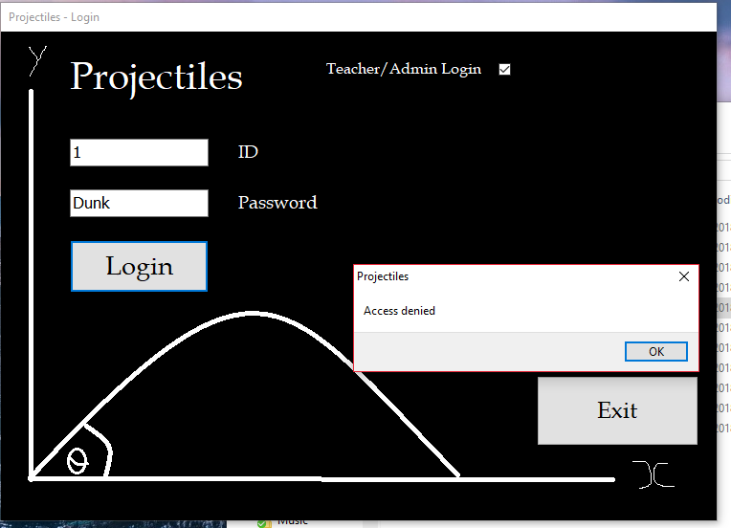

Left click the login button.

### Test 1.5.2

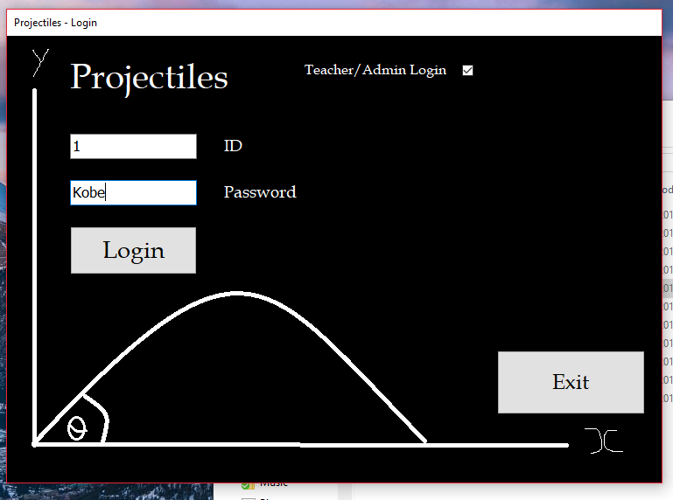

Enter ID (‘1’) and password (‘Kobe’).

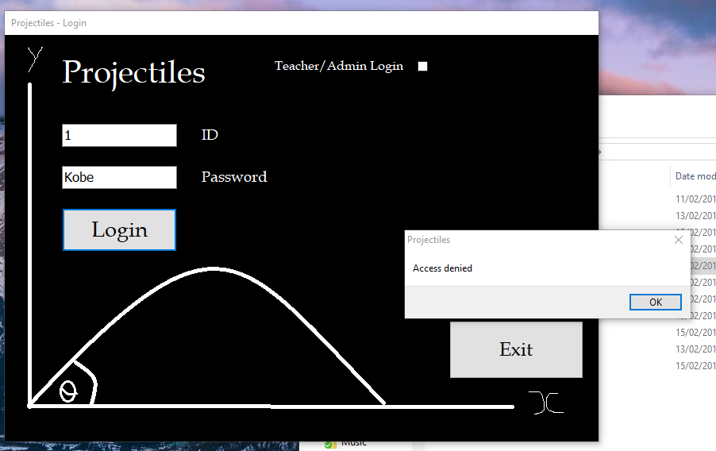

Left click the login button.

### Test 1.5.3

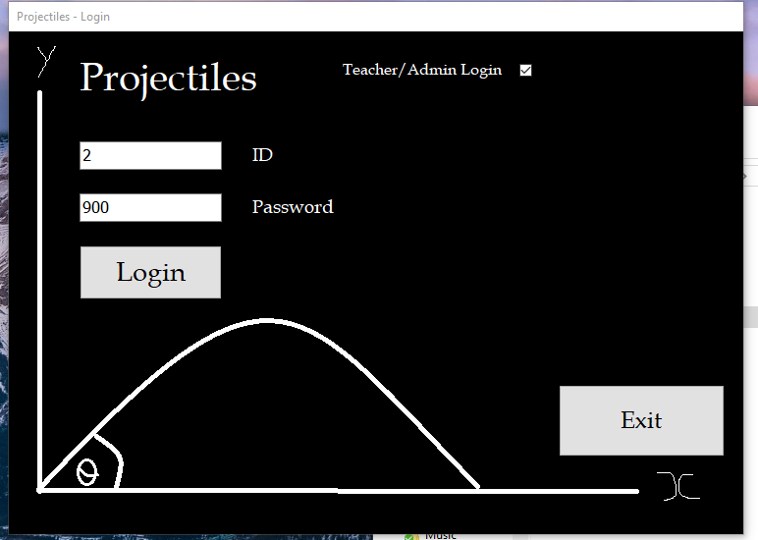

Enter ID (‘2’) and password (‘900’).

Left click check box for Teacher/Admin.

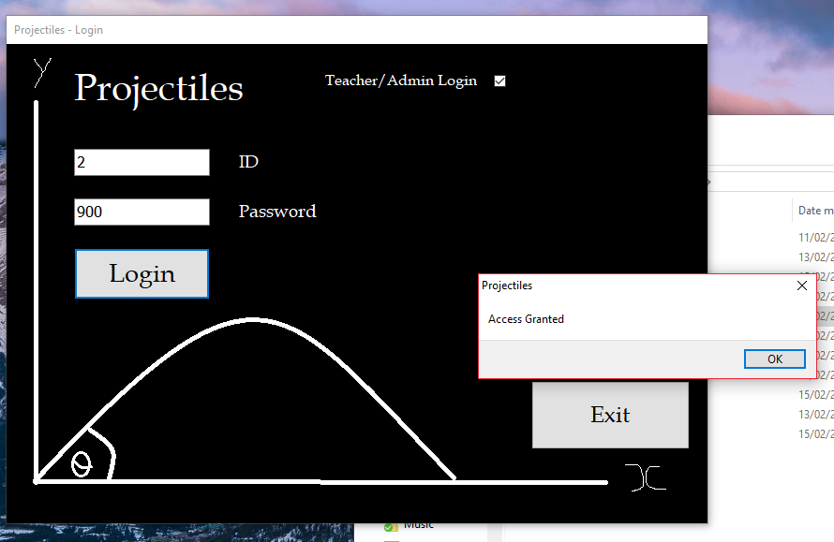

Left click the login button.

### Test 1.5.4

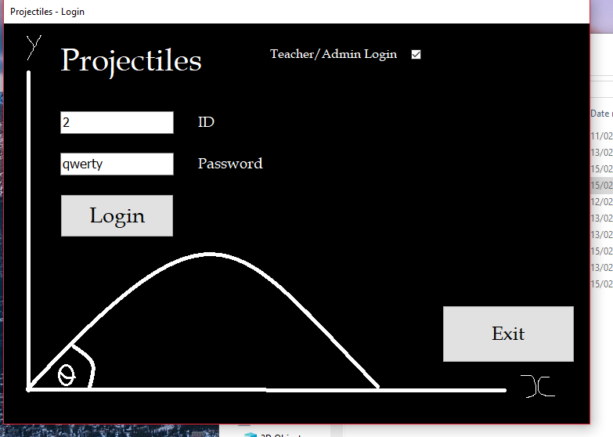

Enter ID (‘2’) and password (‘qwerty’).

Left click check box for Teacher/Admin.

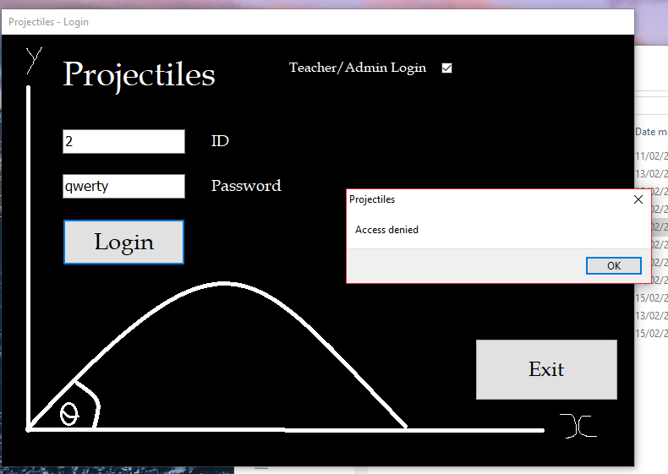

Left click the login button.

### Test 1.5.5

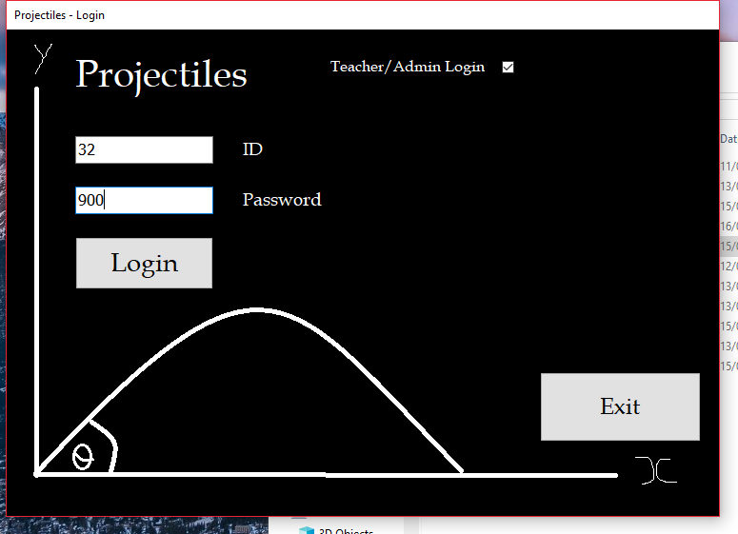

Enter ID (‘32’) and password (‘900’).

Left click check box for Teacher/Admin.

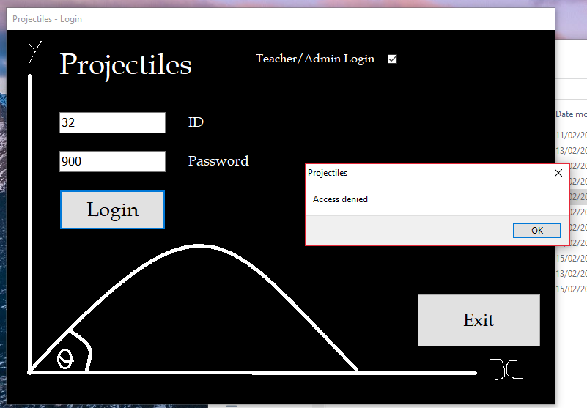

Left click the login button.

### Test 1.5.6

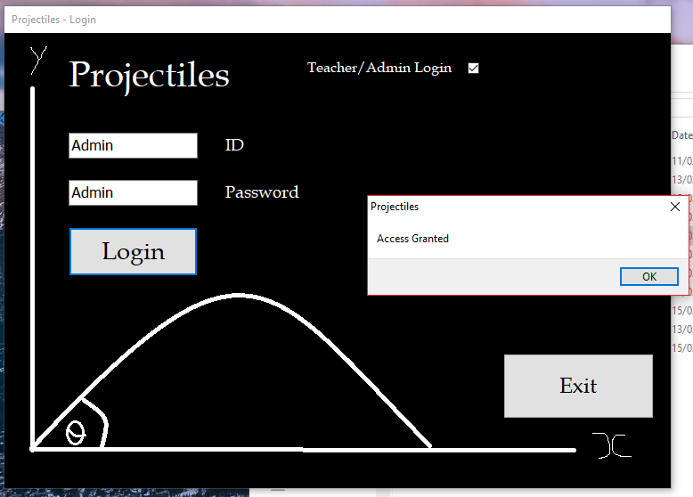

Enter ID (‘Admin’) and password (‘Admin’).

Left click check box for Teacher/Admin.

Left click the login button.

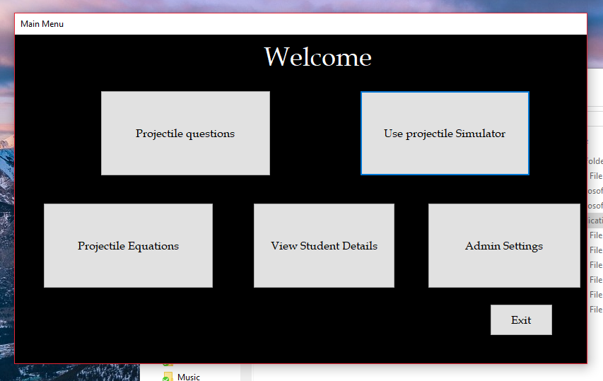

Left click ‘ok’.

### Test 2.1.1

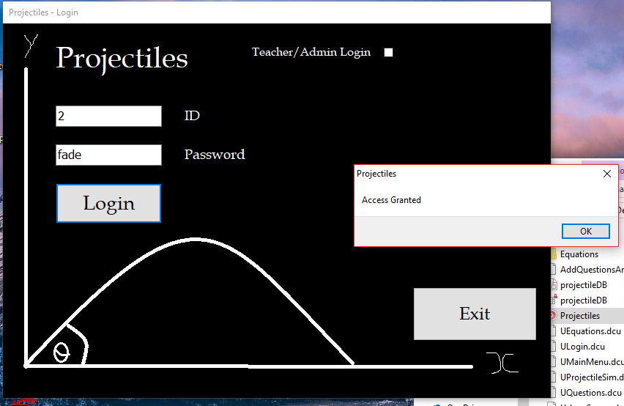

Enter ID (‘Admin’) and password (‘Admin’).

Left click check box for Teacher/Admin.

Left click the login button.

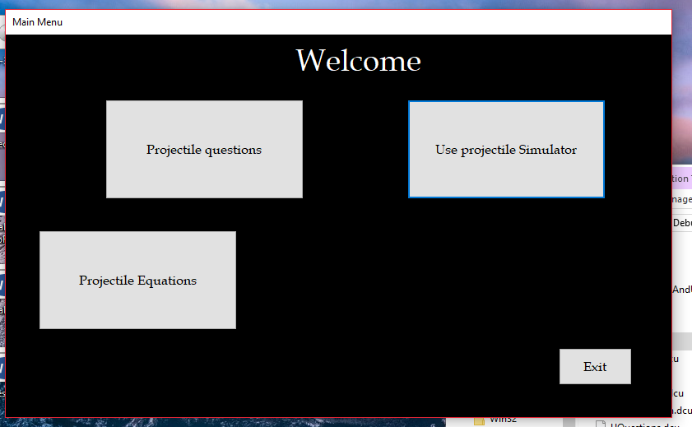

Left click ‘ok’.

### Test 2.1.2

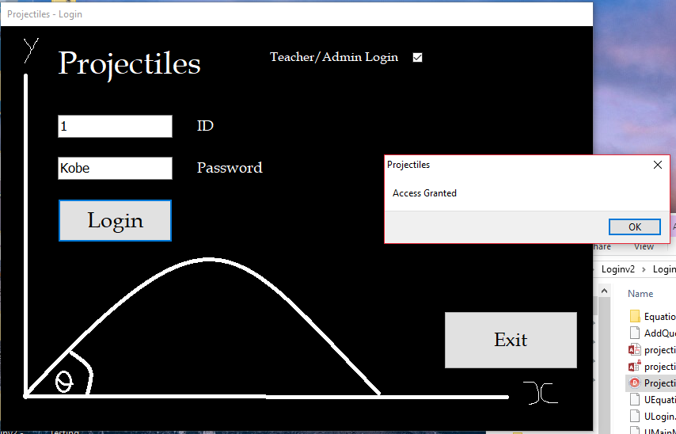

Enter ID (‘1’) and password (‘Kobe’).

Left click check box for Teacher/Admin.

Left click the login button.

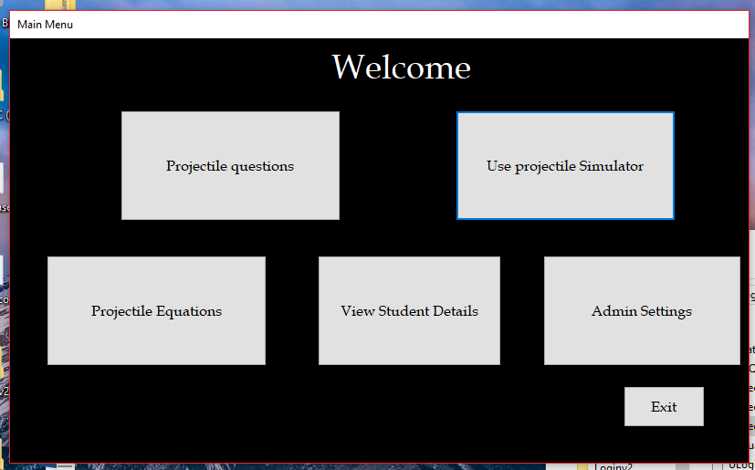

Left click ‘ok’.

### Test 2.2

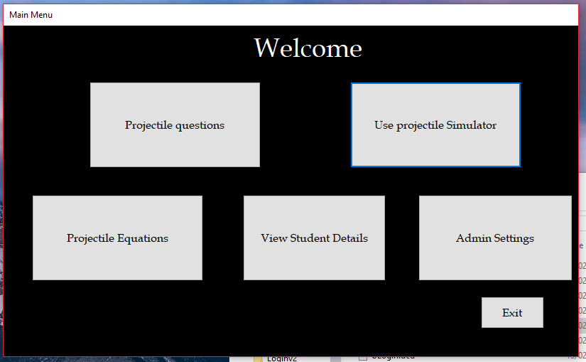

Left click the exit button.

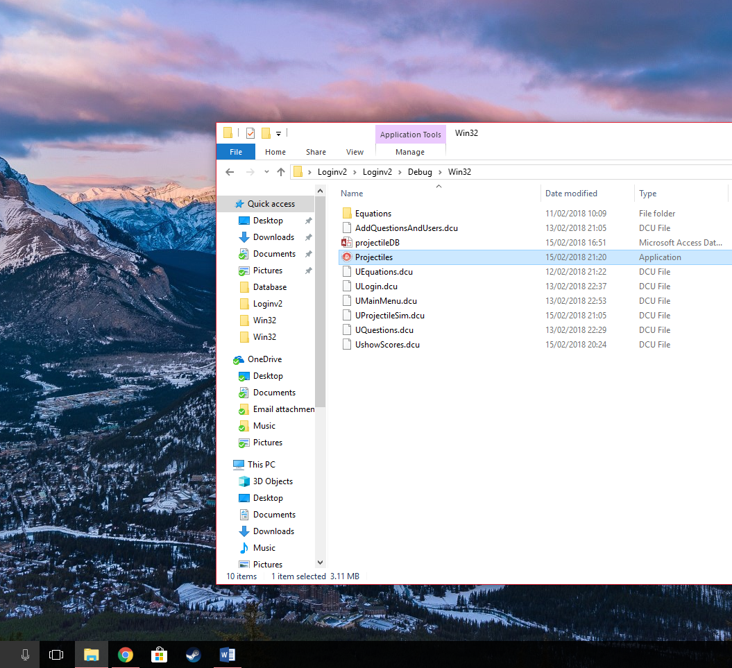  
The application is terminated with no errors.

### Test 2.3



Left click the projectile questions button.

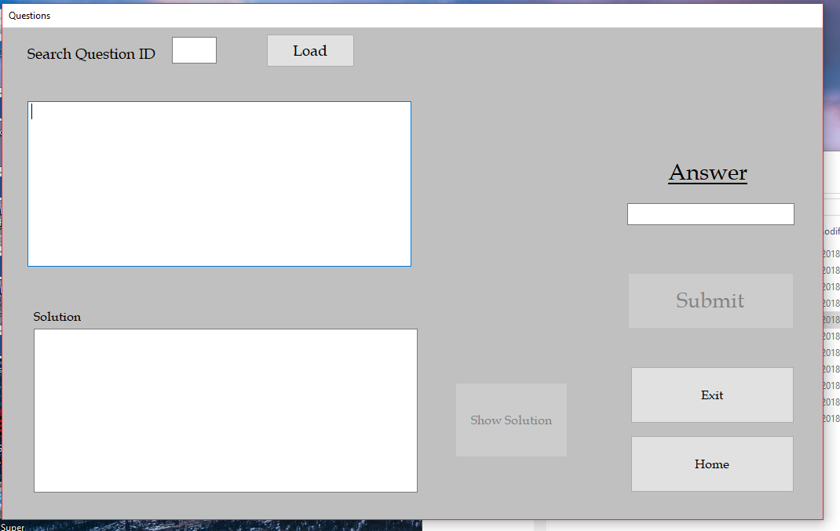

The questions form is now open and the main menu is closed.

### Test 2.4



Left click the use projectile simulator button.

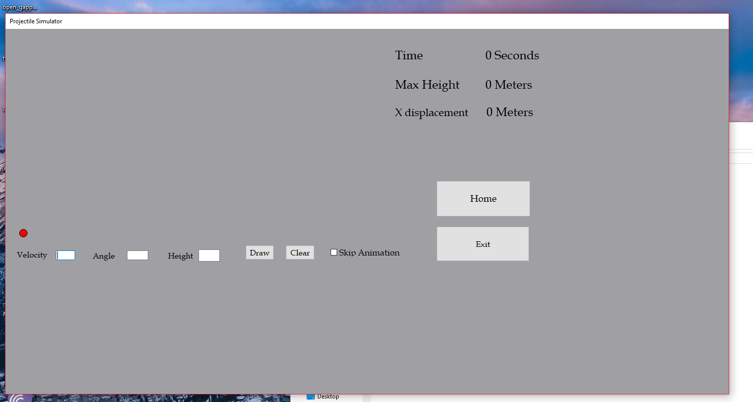

The projectile simulator form is open and the main menu is closed.

### Test 2.5



Left click the projectile equations button.

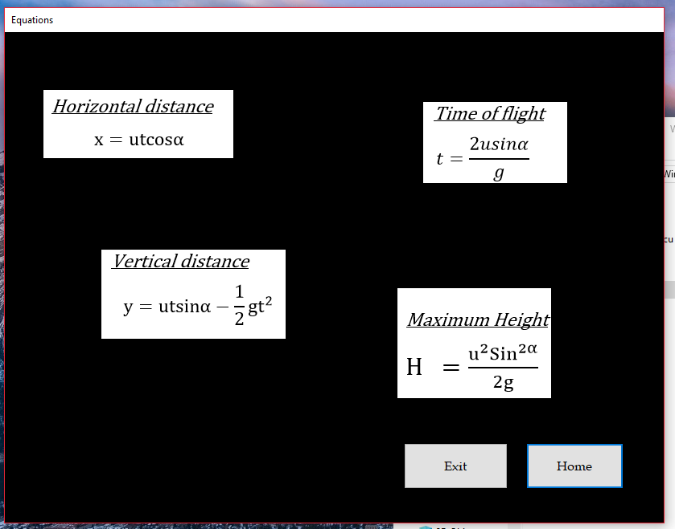

The equations form is now open and the main menu is closed.

### Test 2.6



Left click the view student details button.

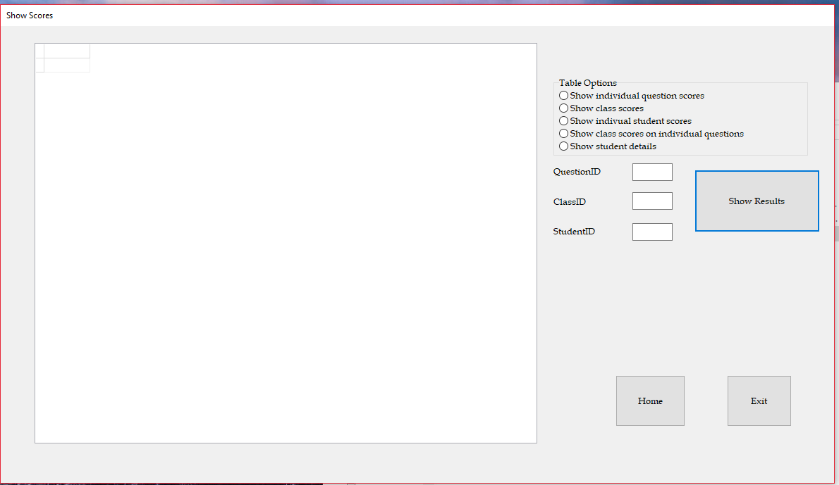

The student details form is now open and the main menu is closed.

### Test 2.7



Left click the admin settings button.

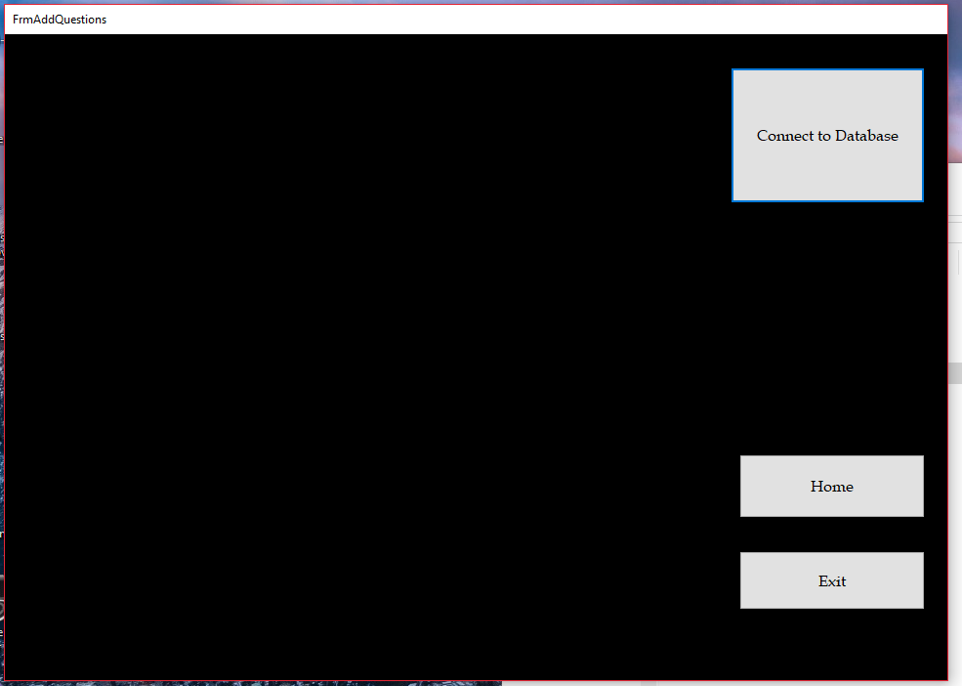

The admin settings form is now open and the main menu is closed.

### Test 3.1

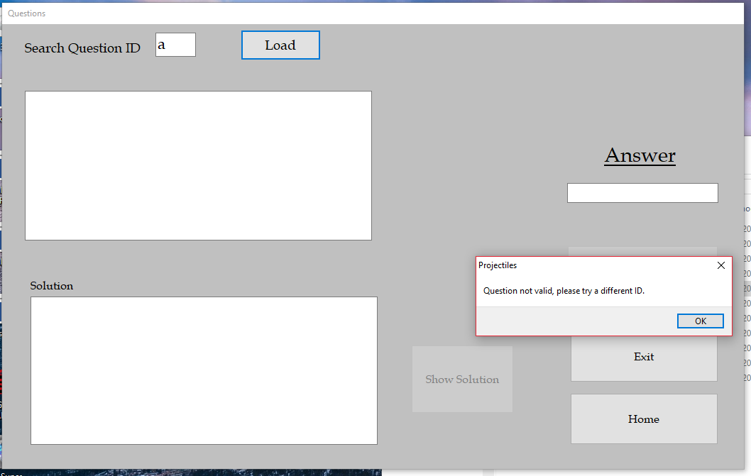

Set question id to be ‘a’.

Left click the load button.

### Test 3.2

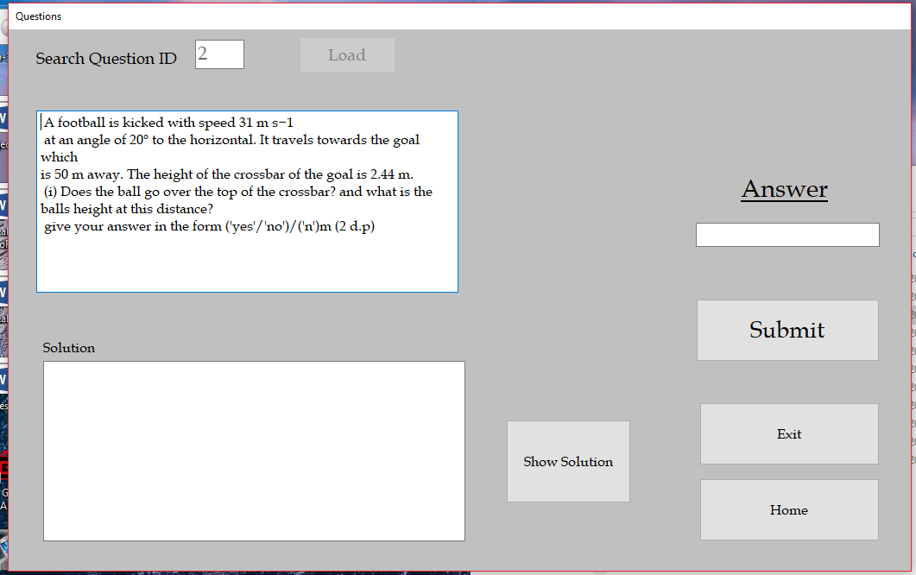

Set question id to be ‘2’.

Left click the load button. (Current user = ‘1’).

### Test 3.3.1

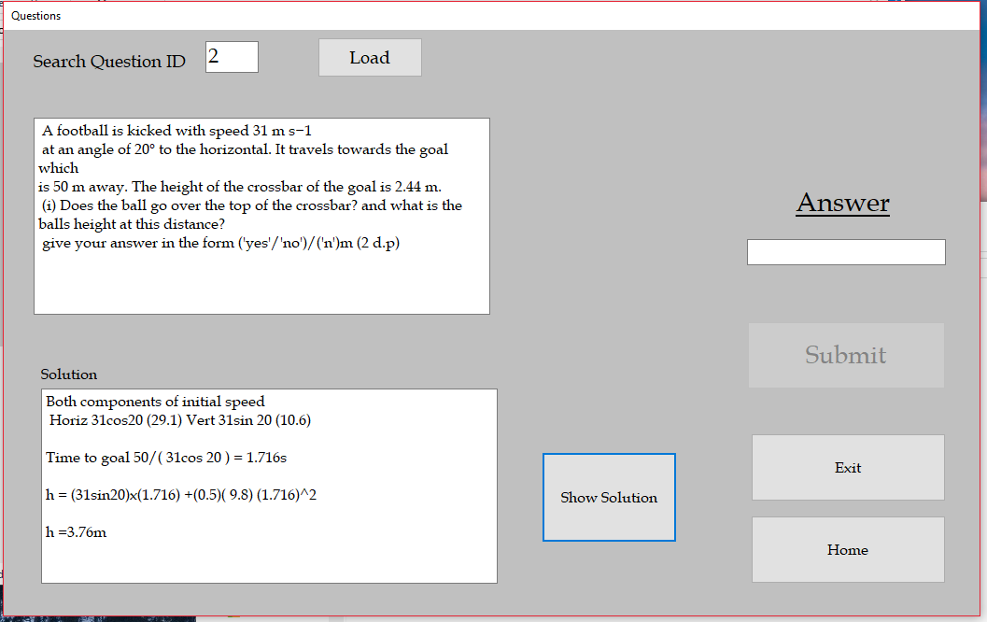

Left click the show solution button. (Current user = ‘1’ (Teacher)).

### Test 3.3.2

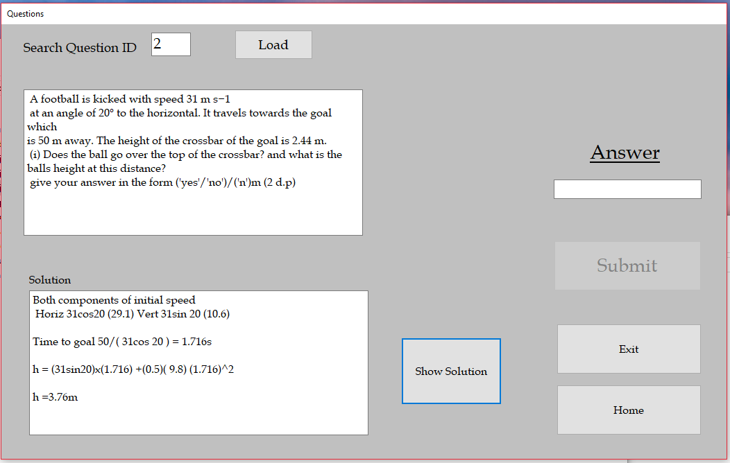

Left click the show solution button. (Current user = ‘2’ (Student)).

### Test 3.3.3

Continued from test 3.3.2

Score table

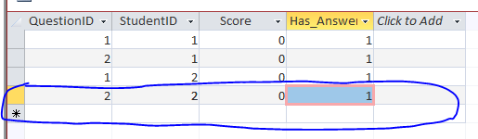

Student table

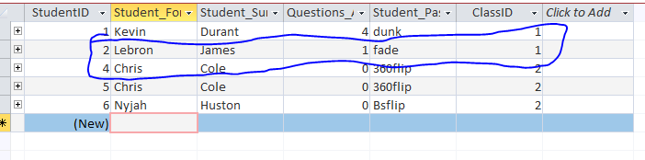

### Test 3.4.1

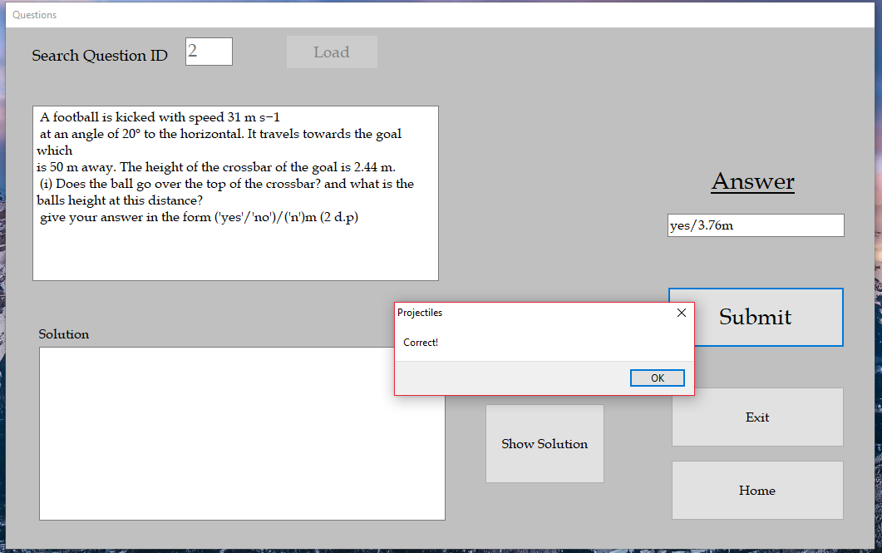

Current user = ‘2’ (Teacher).

Set answer = ‘yes/3.76m’.

Left click the submit button.

### Test 3.4.2

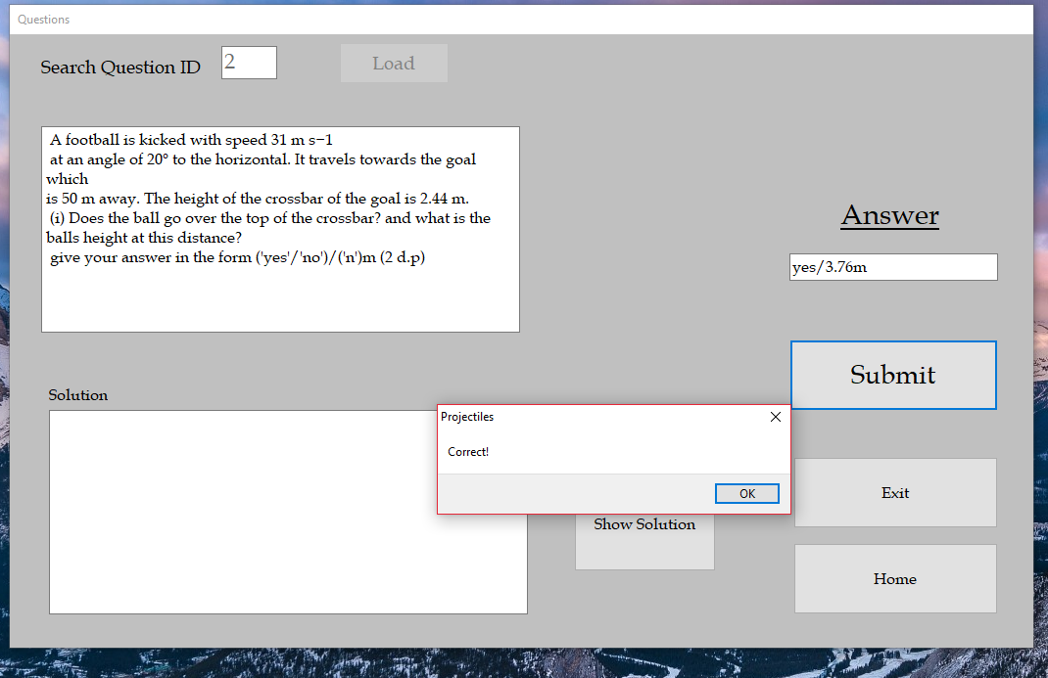

Current user = ‘6’ (Student).

Set answer = ‘yes/3.76m’.

Left click the submit button.

### Test 3.4.3

Continued from test 3.4.2

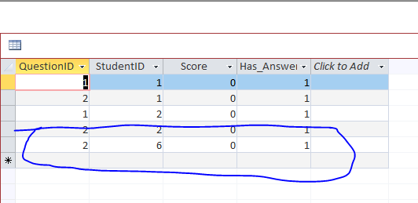

The score is set to 0 even though the question was answered correcltly.

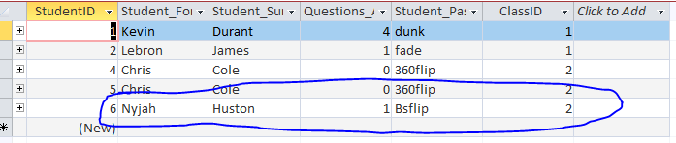

### Test 3.4.4

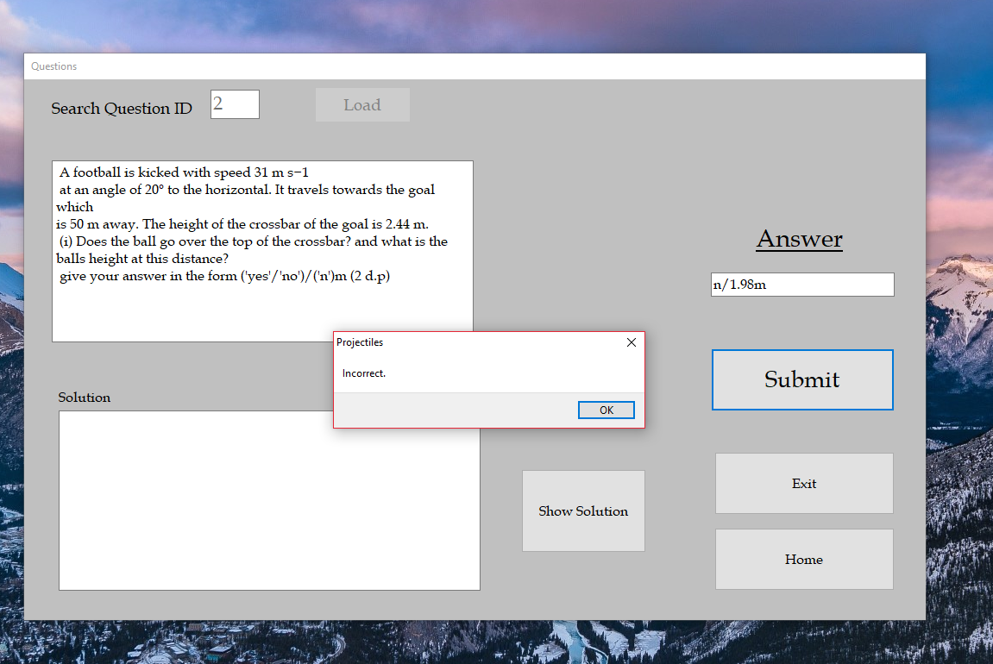

### Test 3.4.5

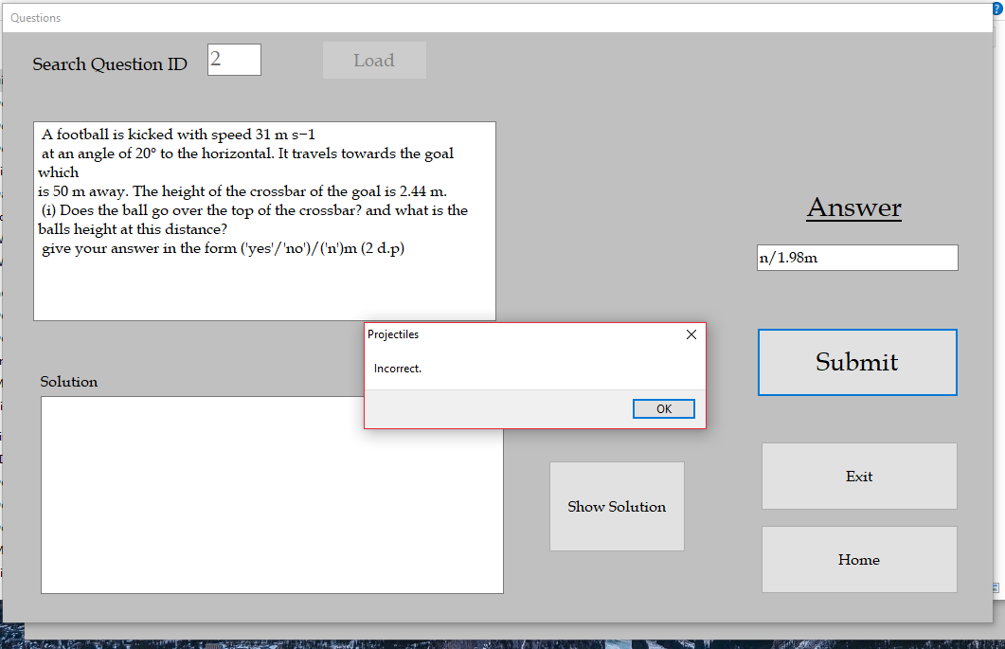

### Test 3.4.6

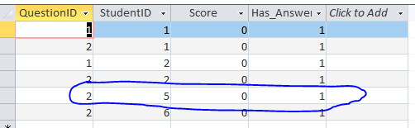

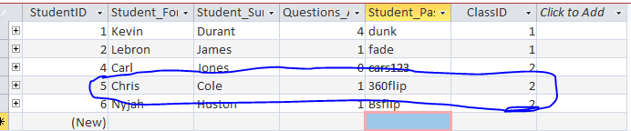

### Test 5.1

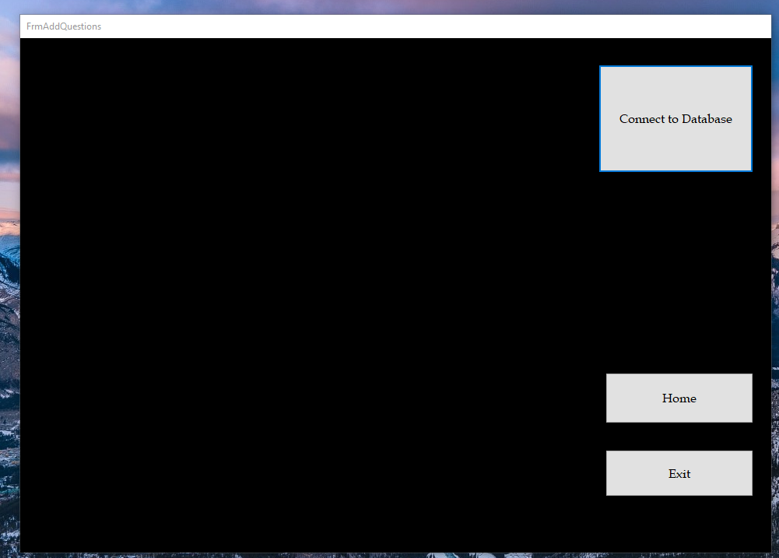

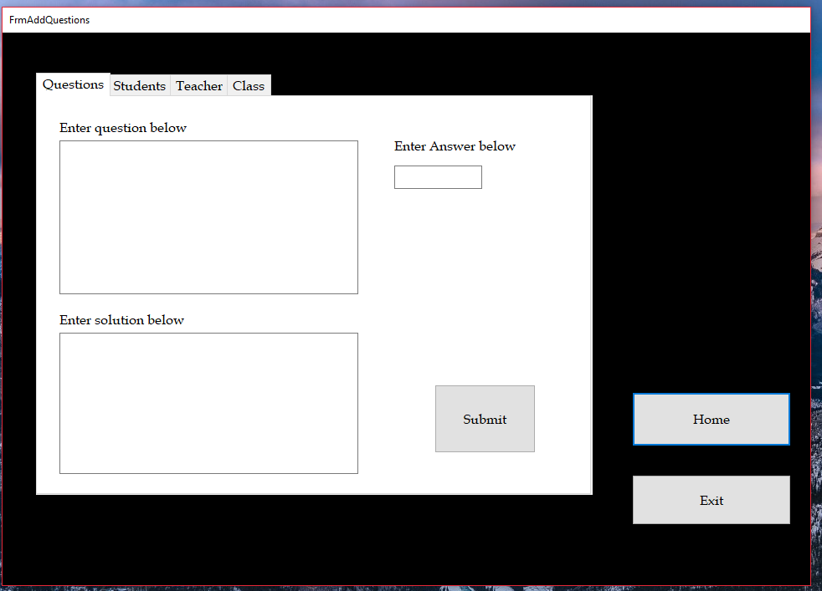

### Test 5.1.2

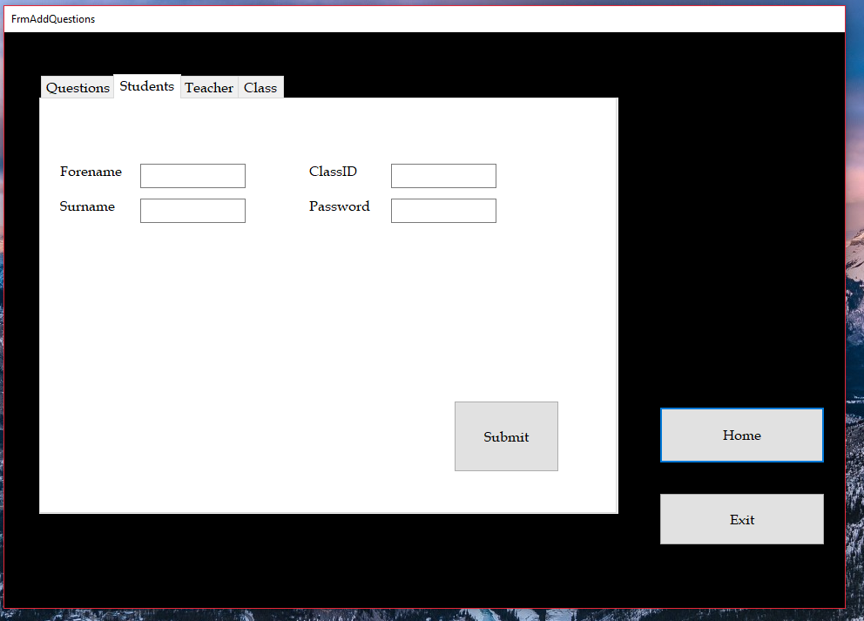

### Test 5.1.3

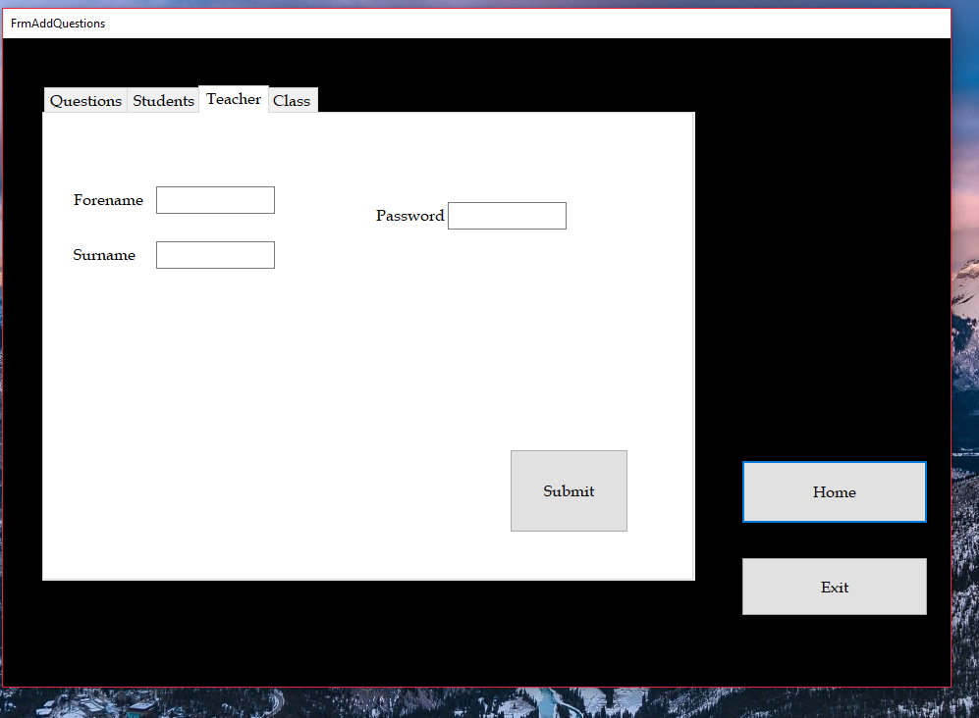

### Test 5.1.4

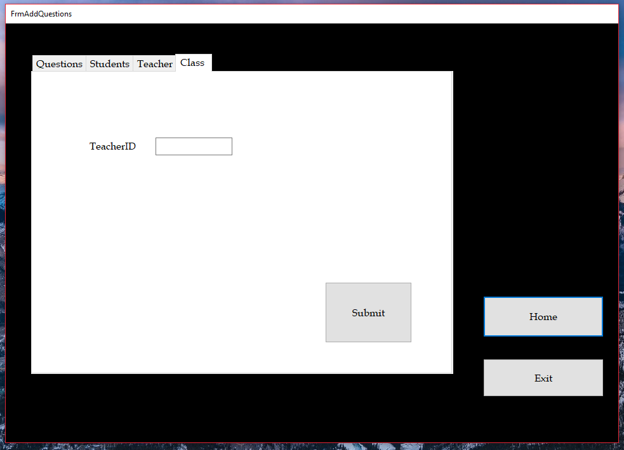

### Test 5.2.1

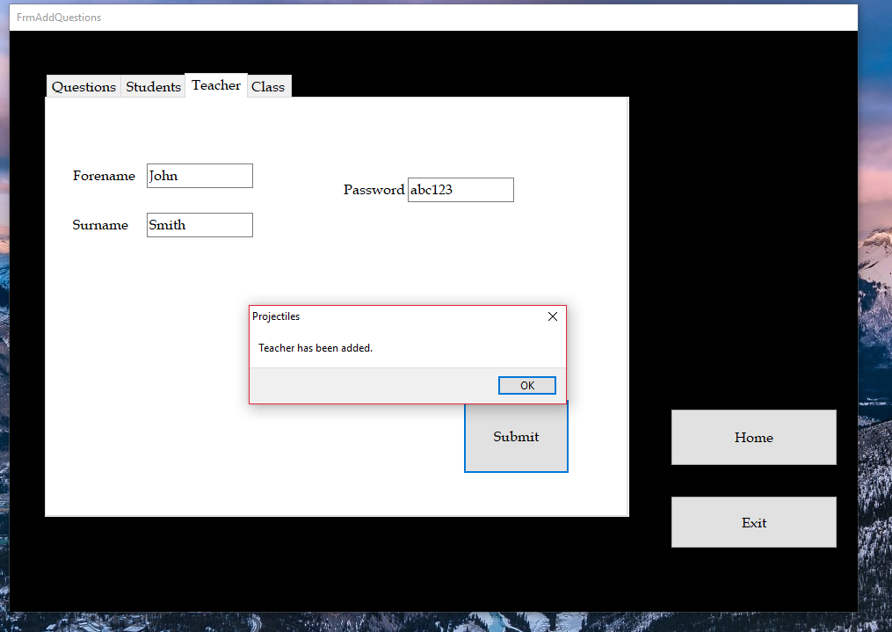

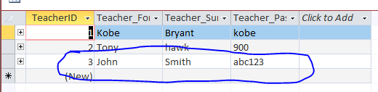

### Test 5.2.2

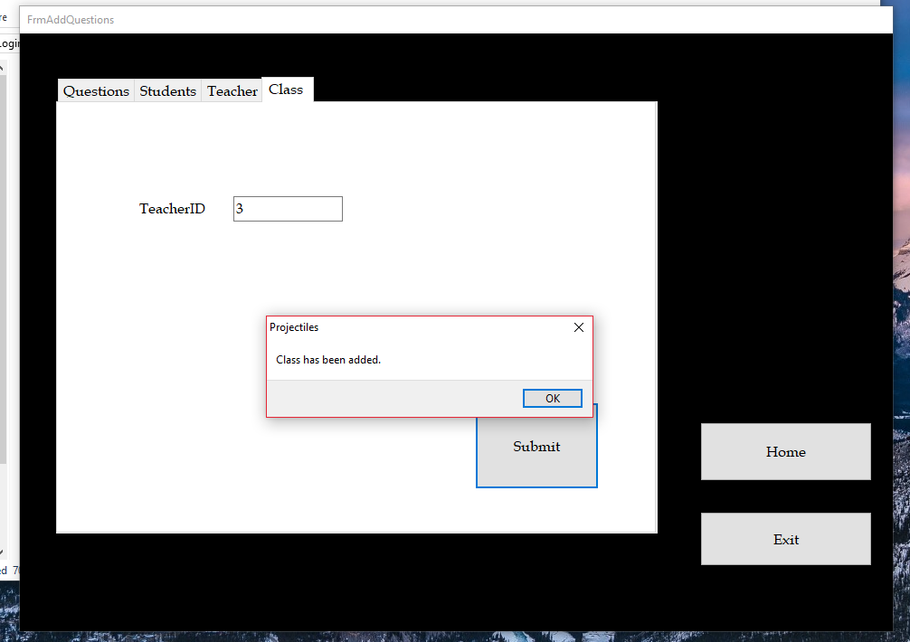

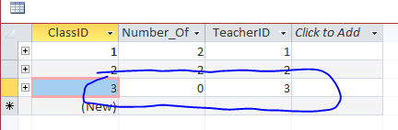

### Test 5.2.3

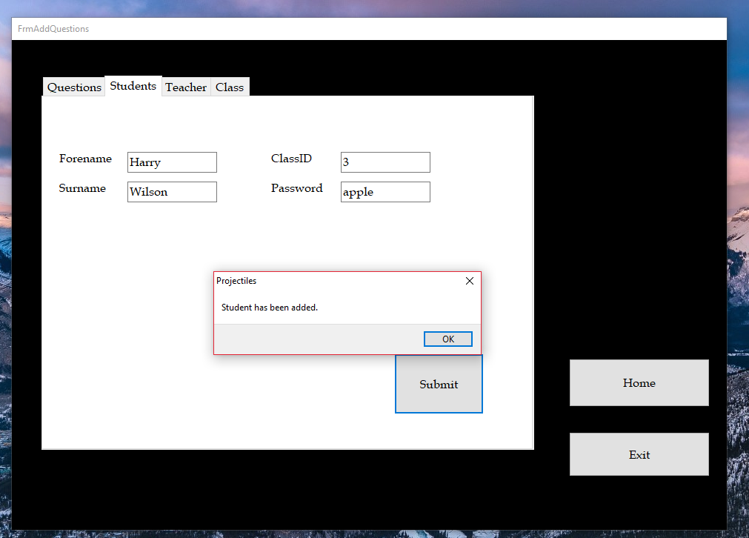

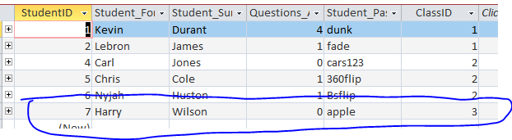

### Test 5.2.4

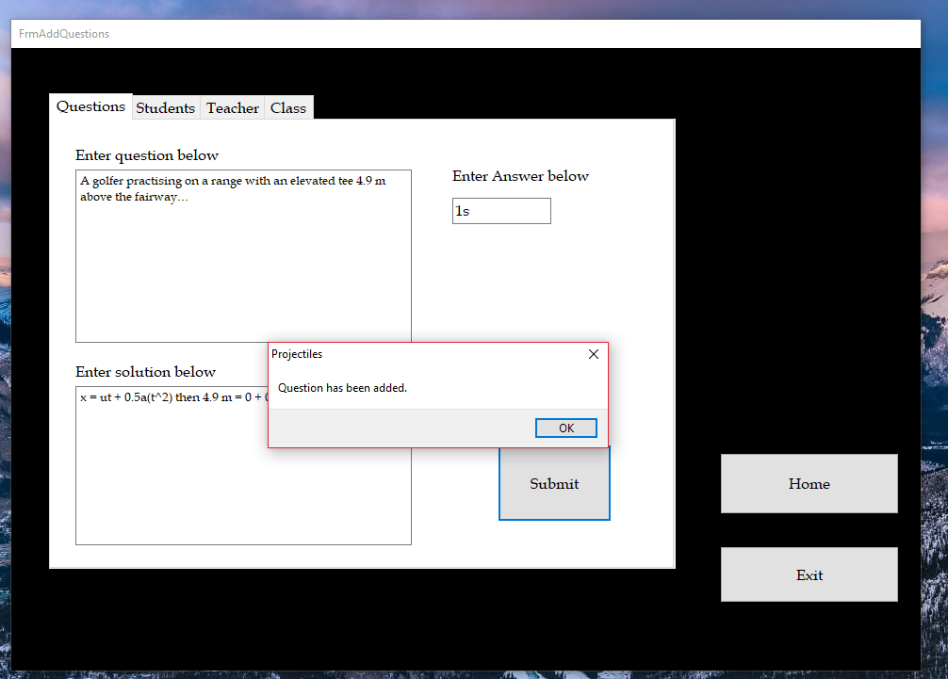

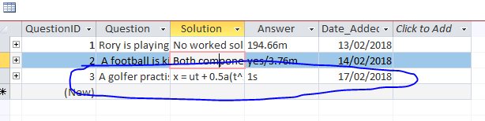

### Test 6.1.1

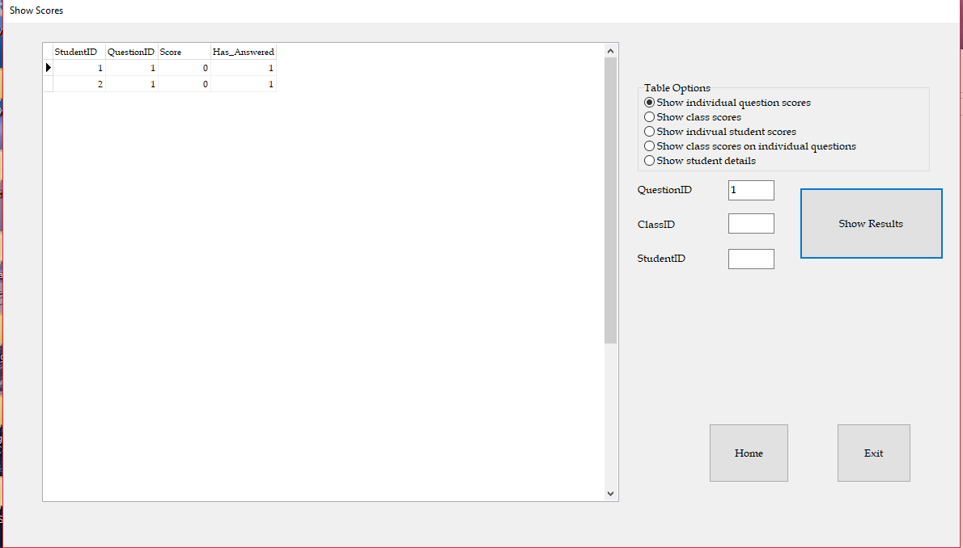

### Test 6.1.2

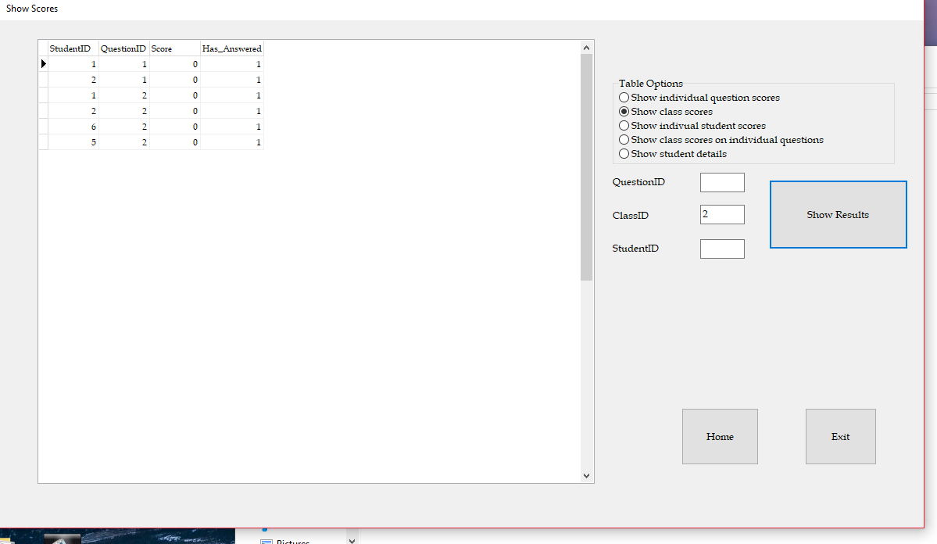

Students 1 and 2 are not in class which means there is a mistake in my SQL queries.

### Test 6.1.3

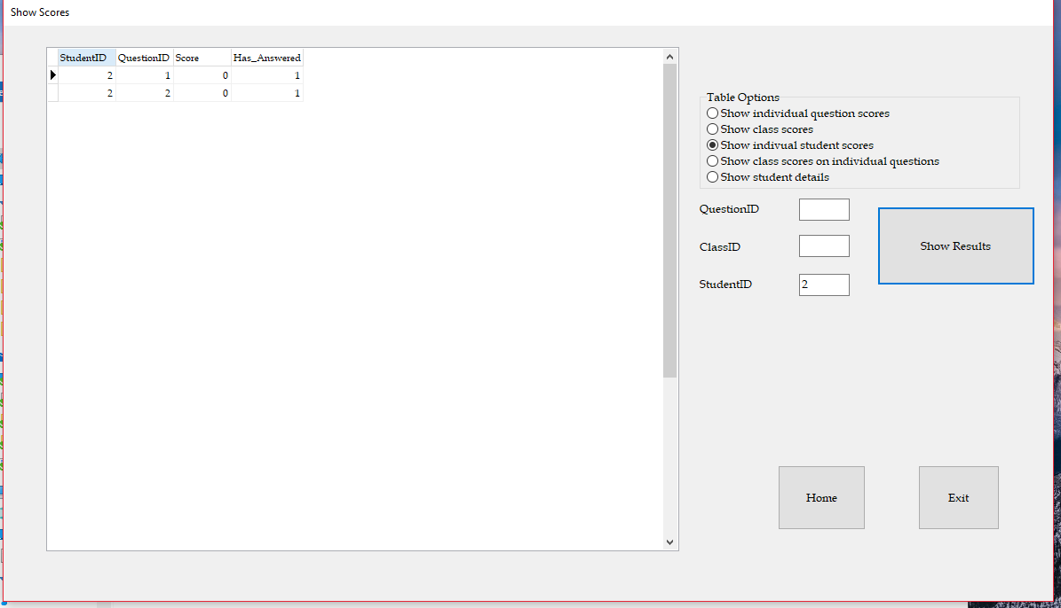

### Test 6.1.4

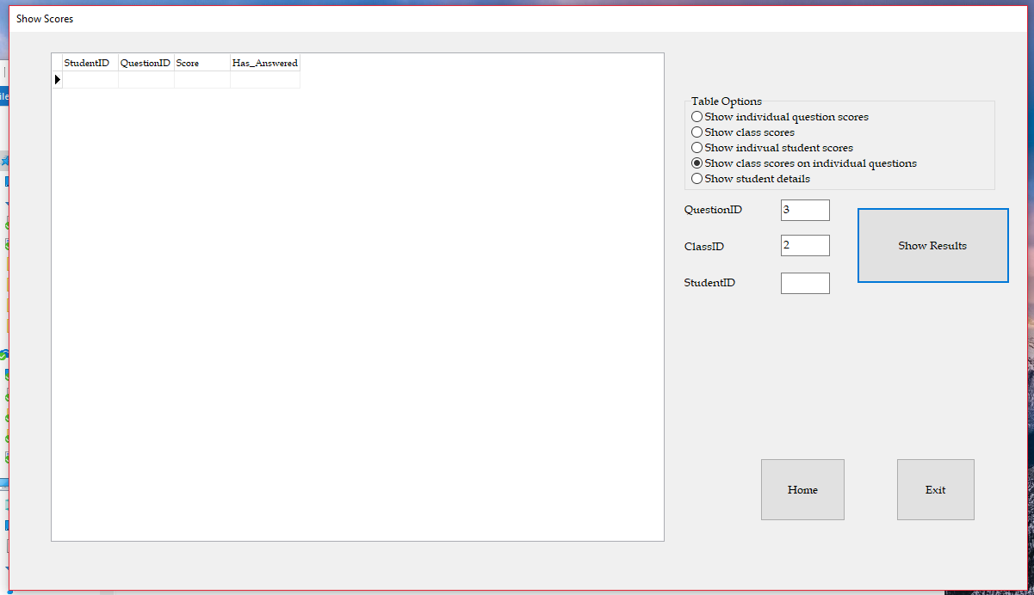

### Test 6.1.5

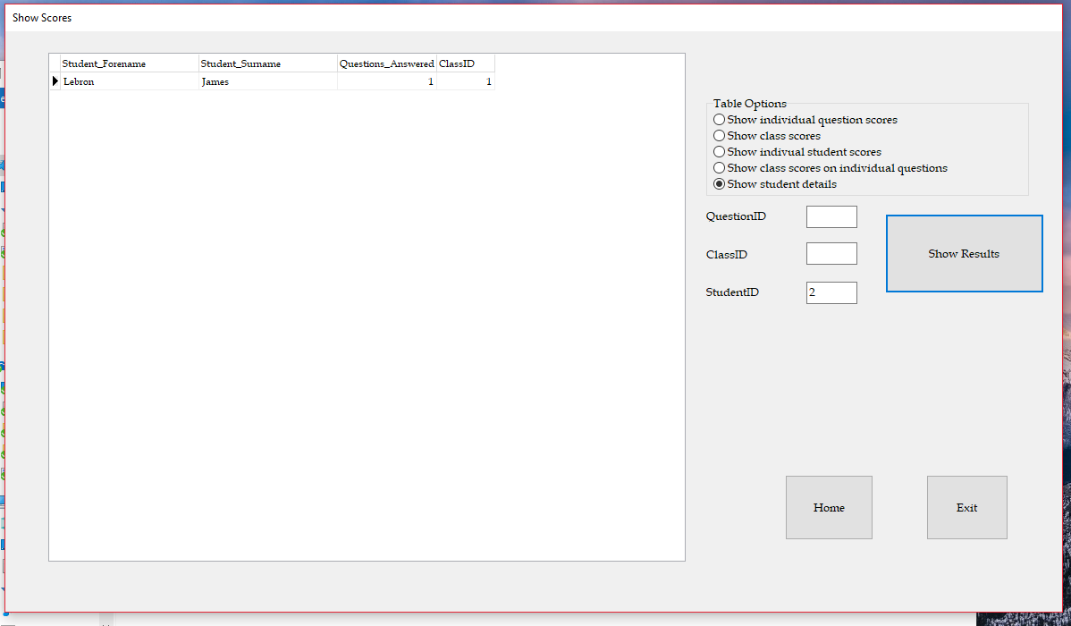

### Test 7.3.1

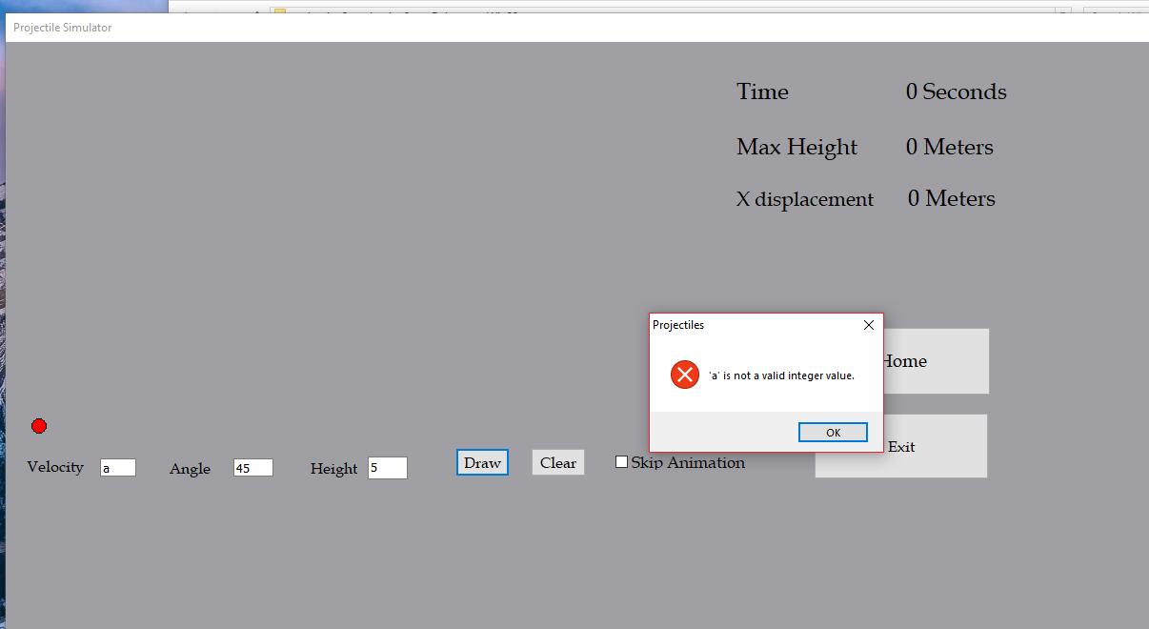

### Test 7.3.2

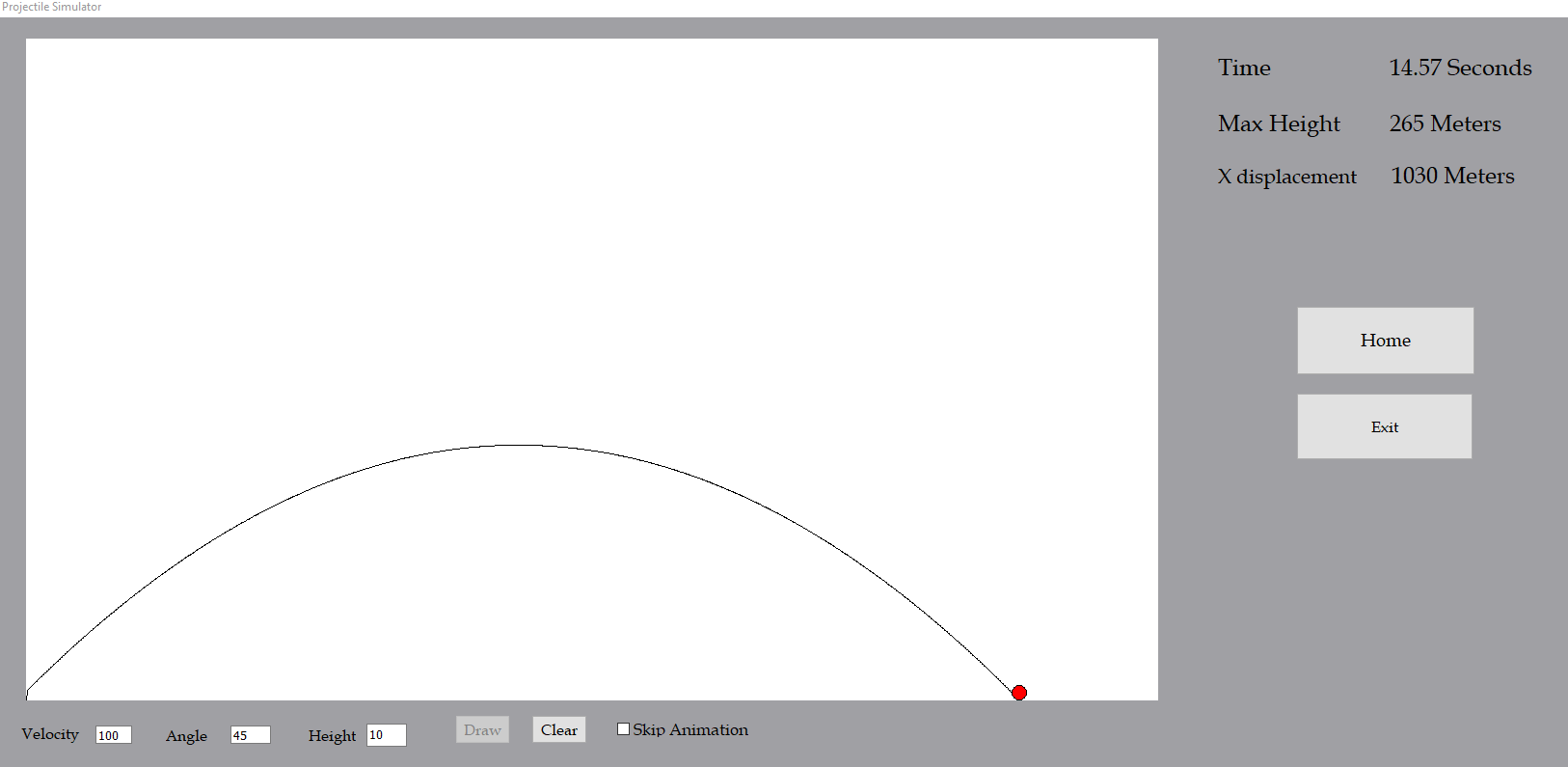

### Test 7.3.3

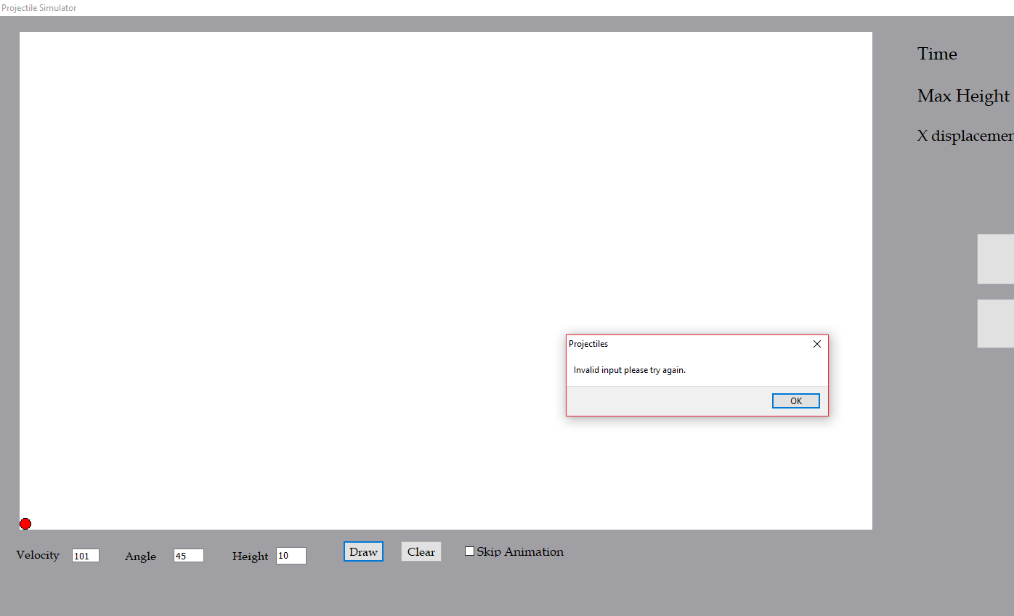

### Test 7.3.4

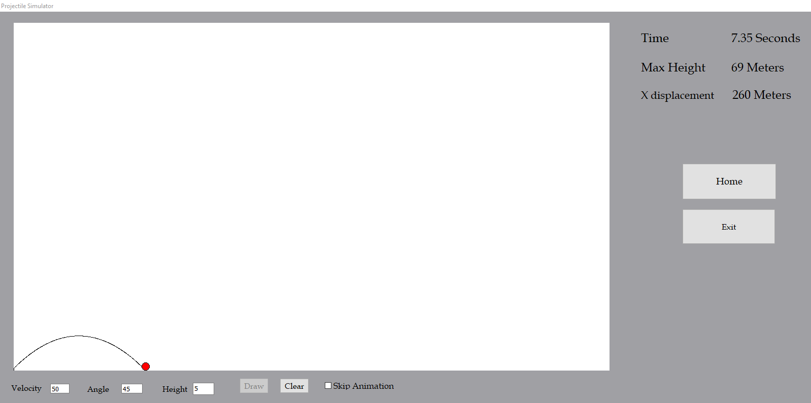

### Test 7.3.5

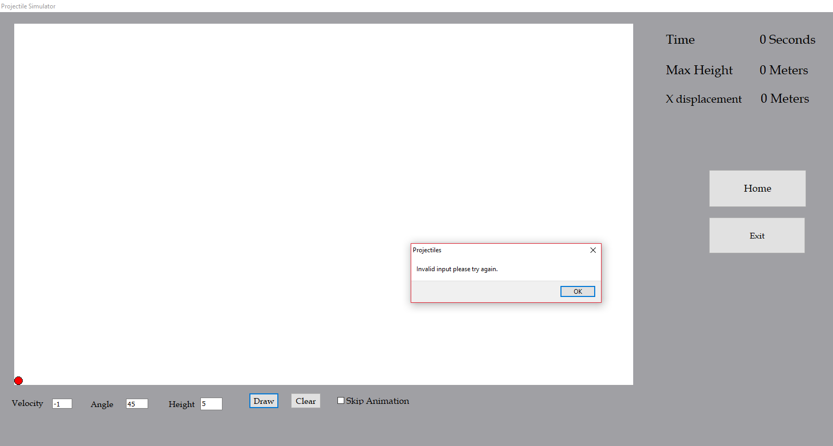

### Test 7.3.6

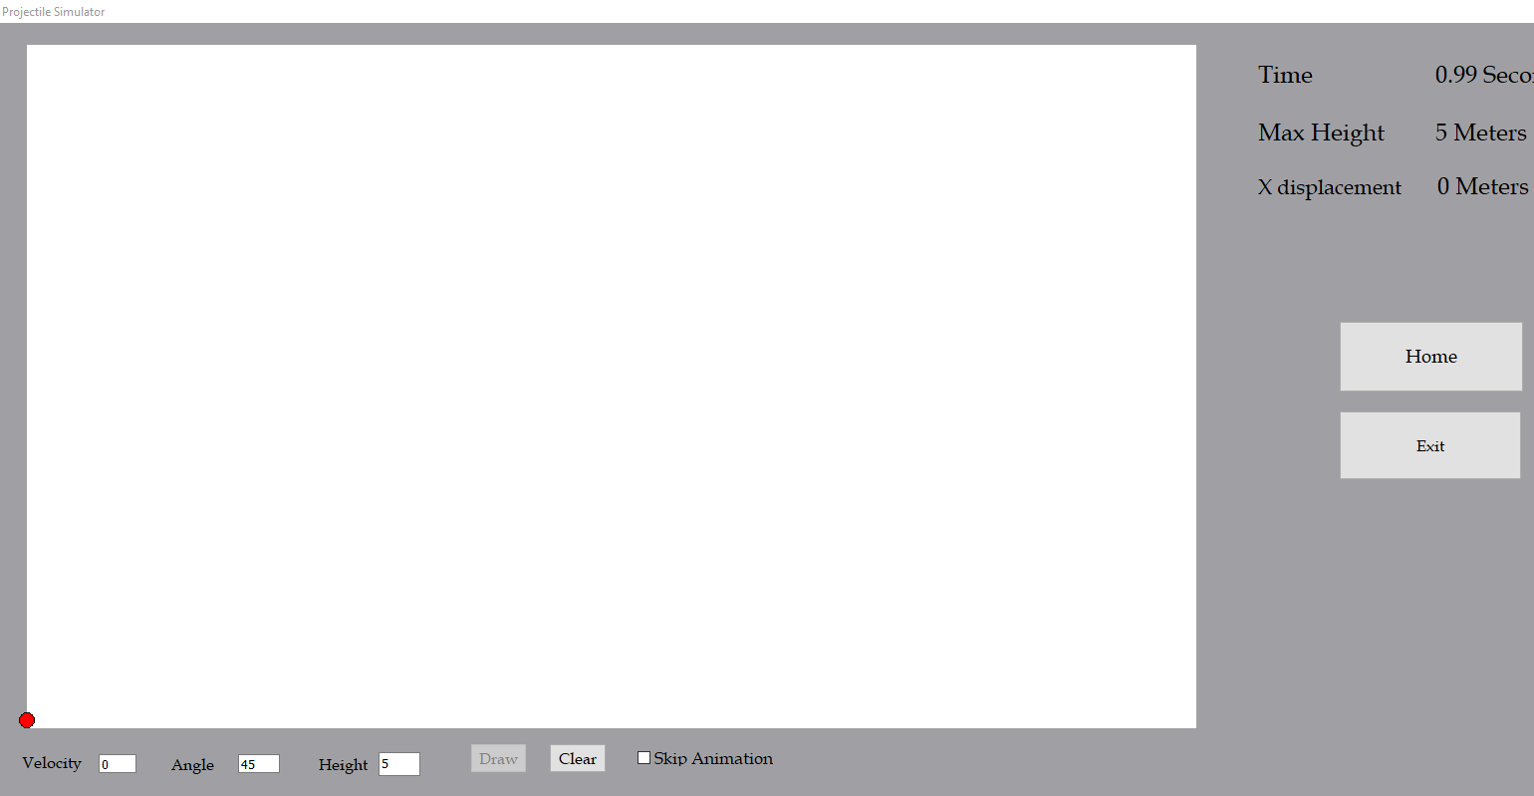

### Test 7.4.1

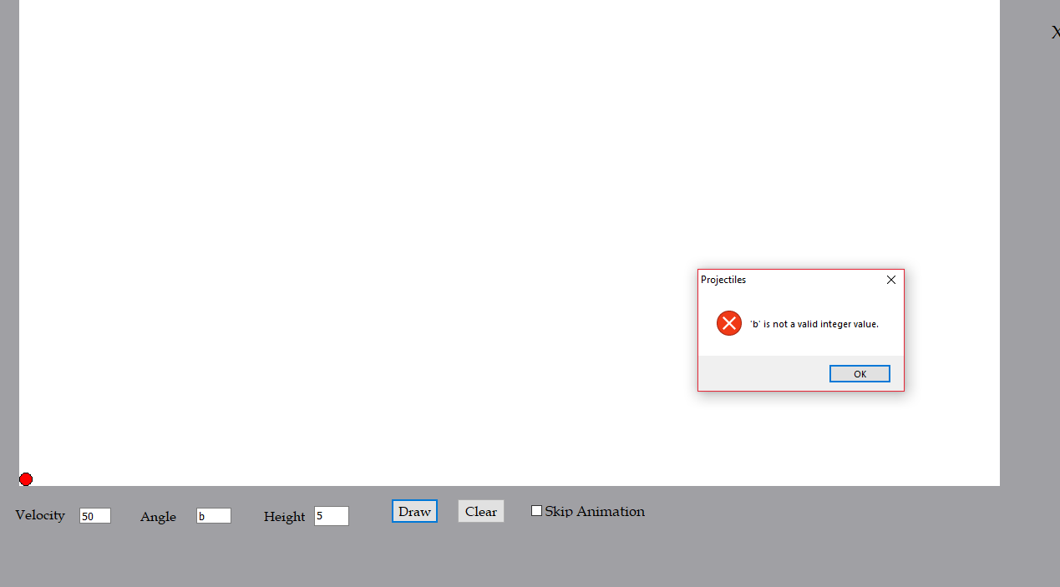

### Test 7.4.2

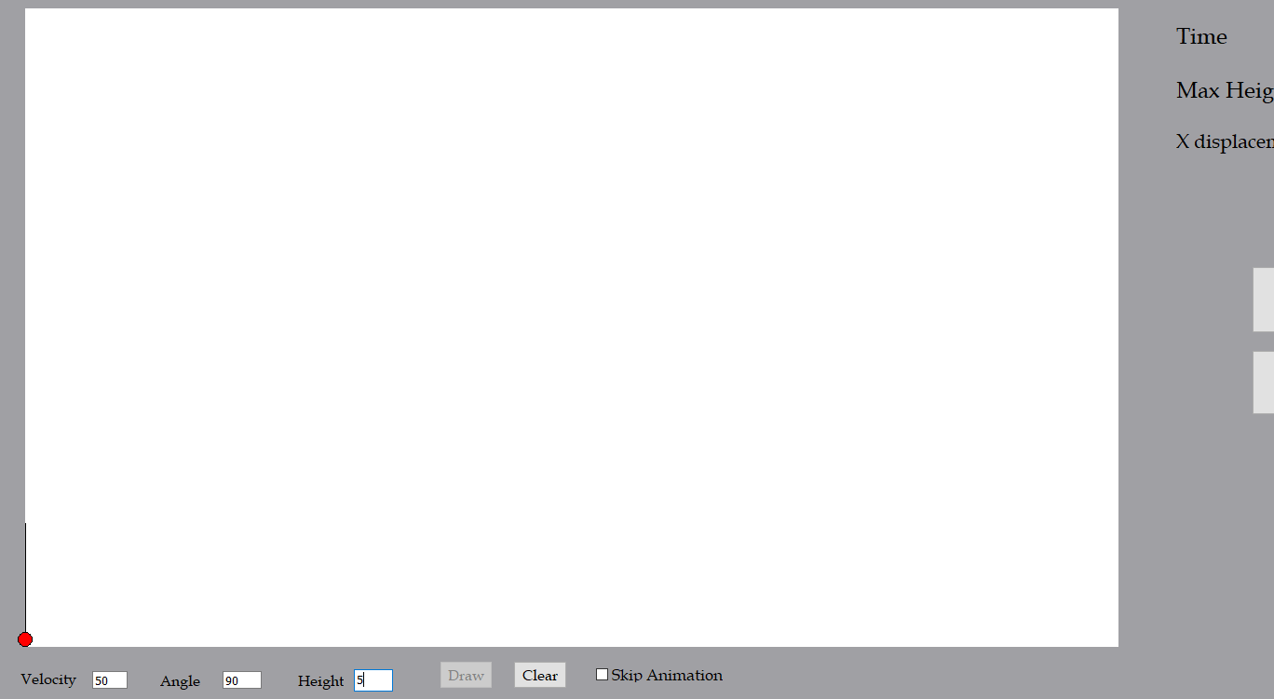

### Test 7.4.3

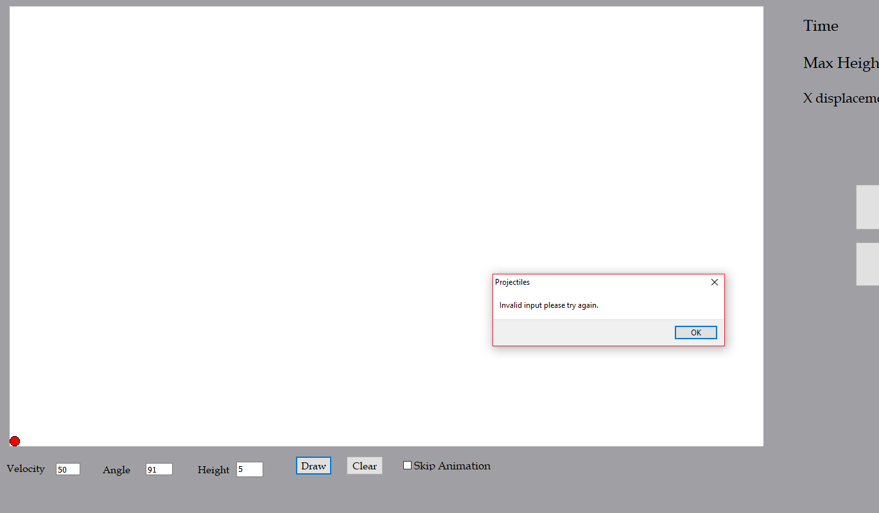

### Test 7.4.4

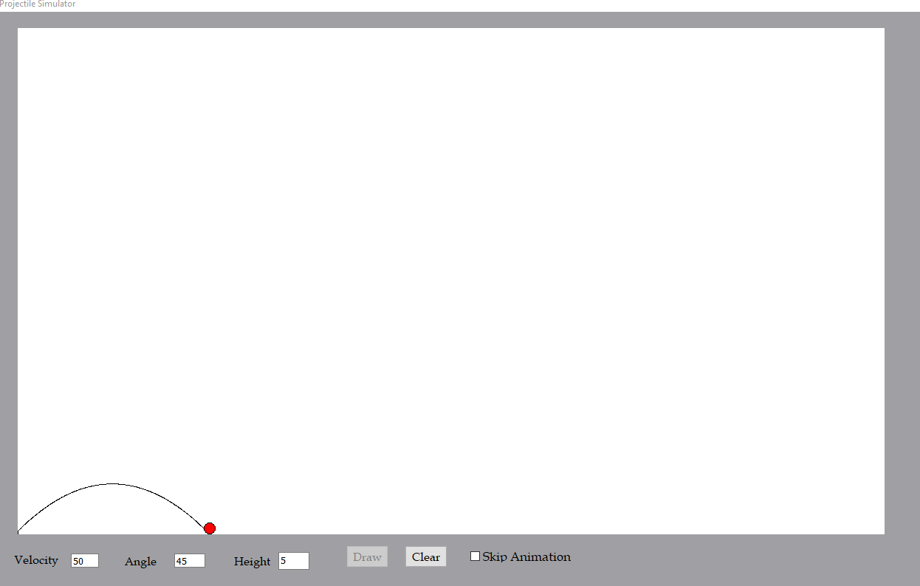

### Test 7.4.5

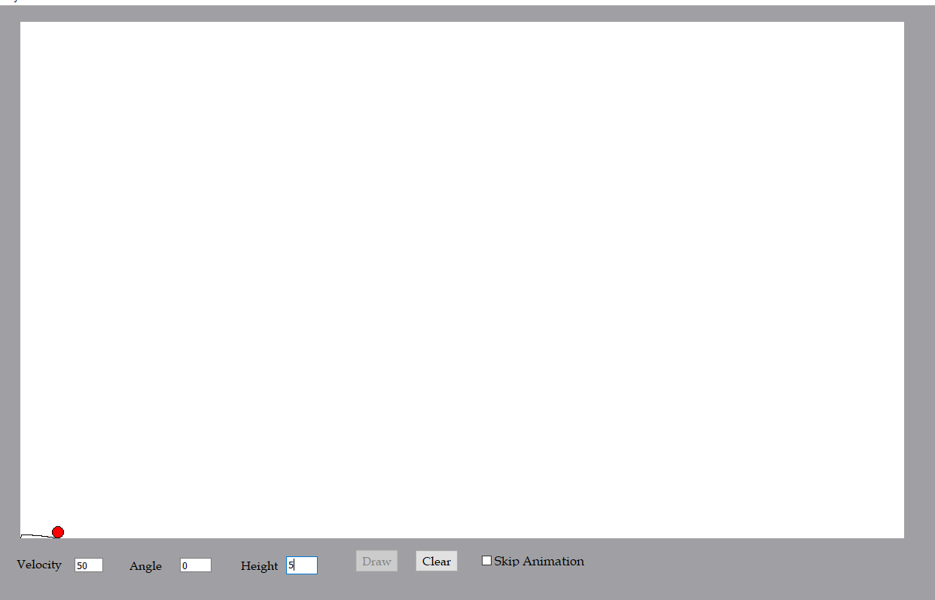

### Test 7.4.6

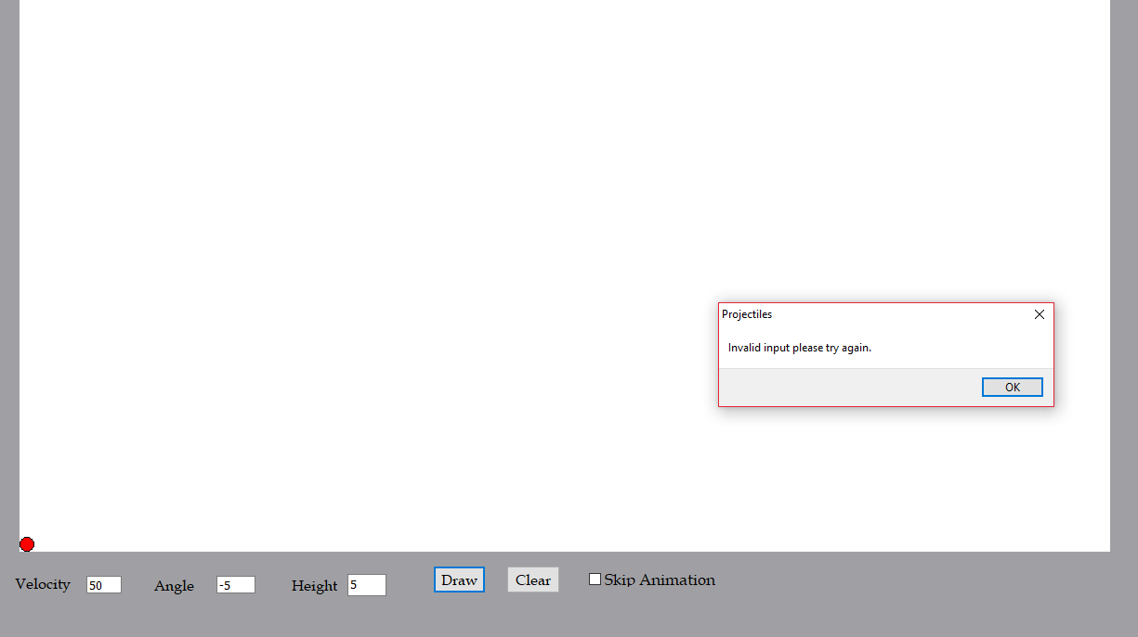

### Test 7.5.1

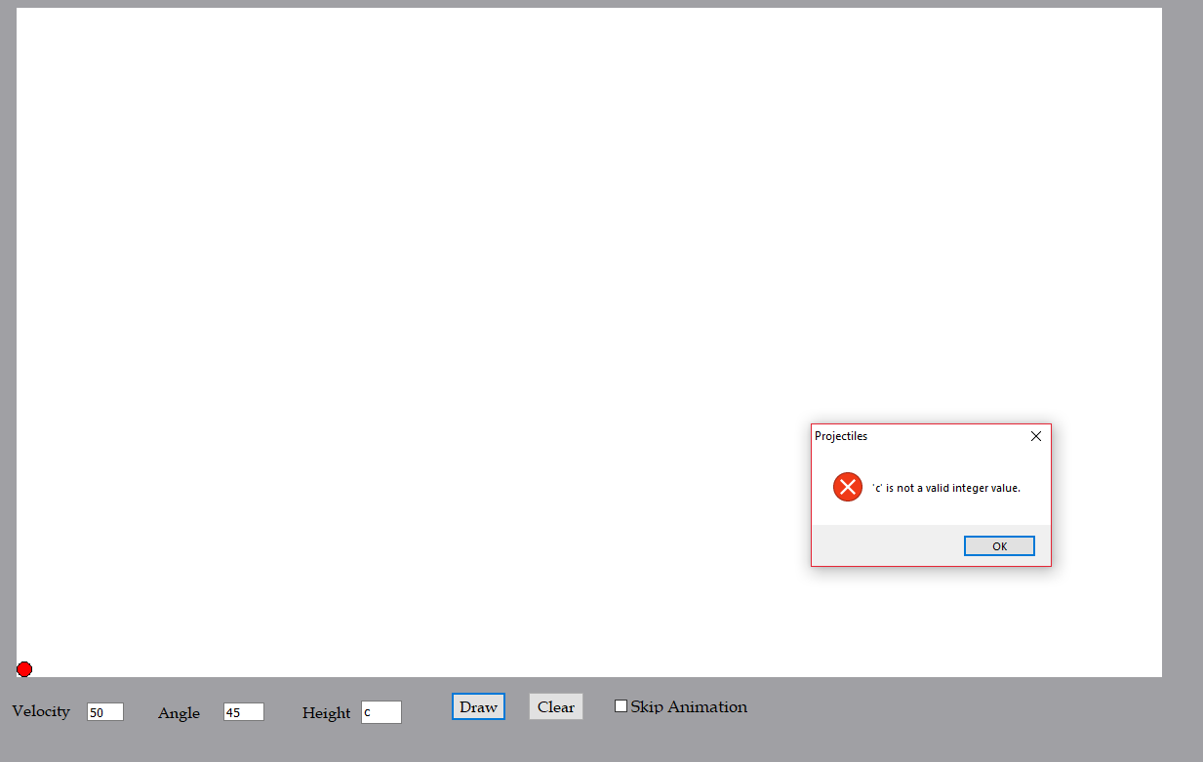

### Test 7.5.2

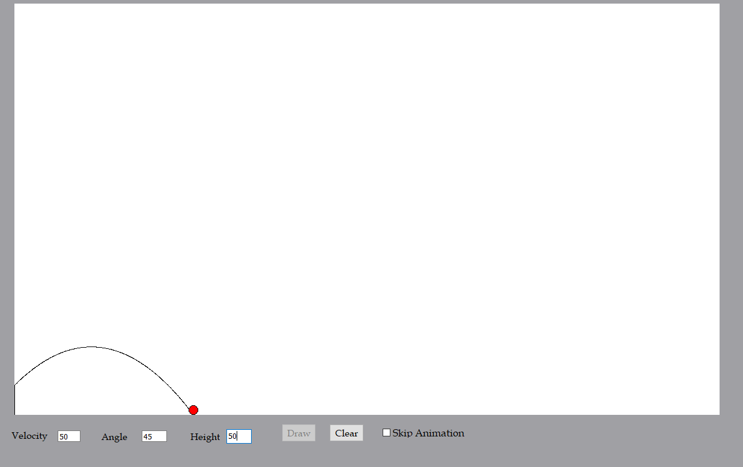

### Test 7.5.3

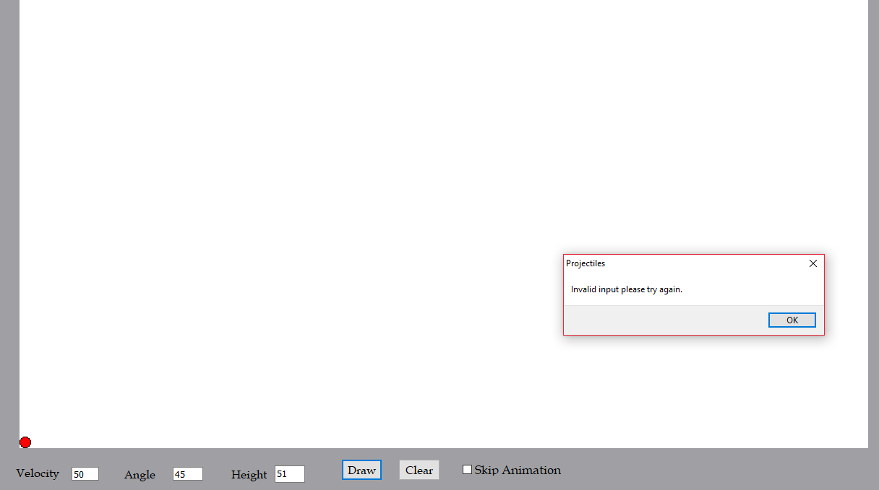

### Test 7.5.4

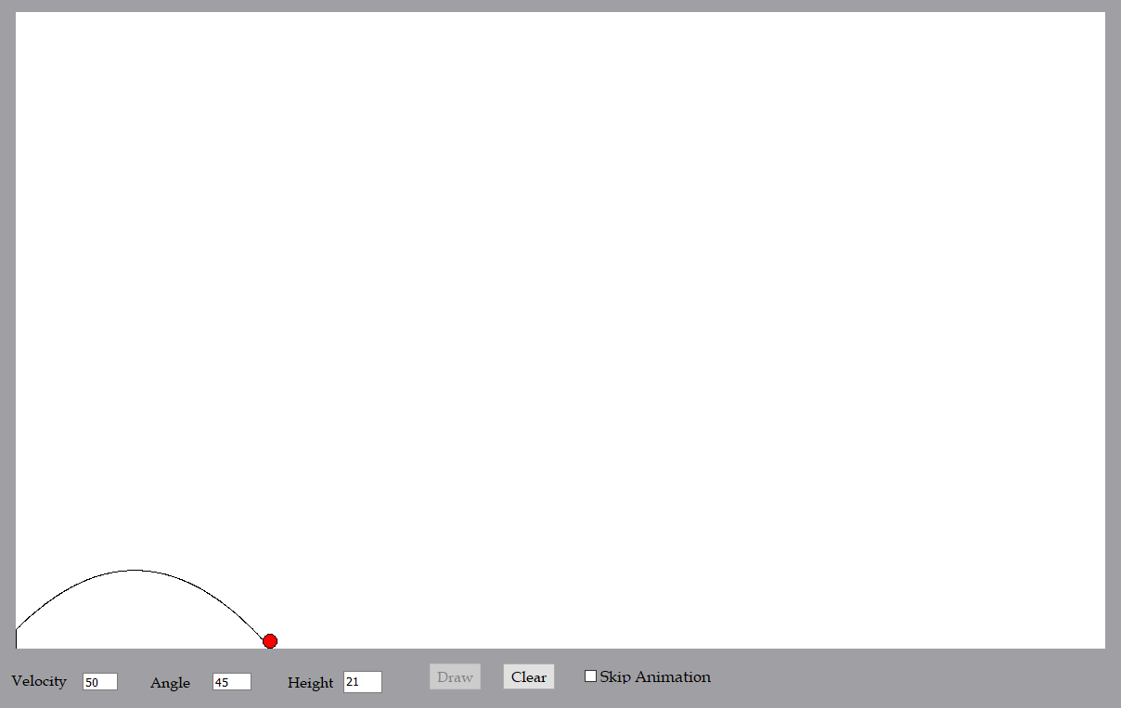

### Test 7.5.5

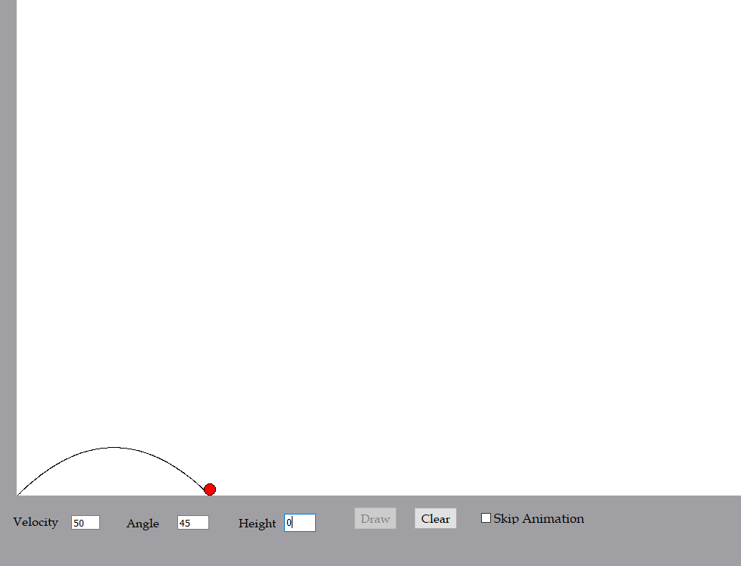

### Test 7.5.6

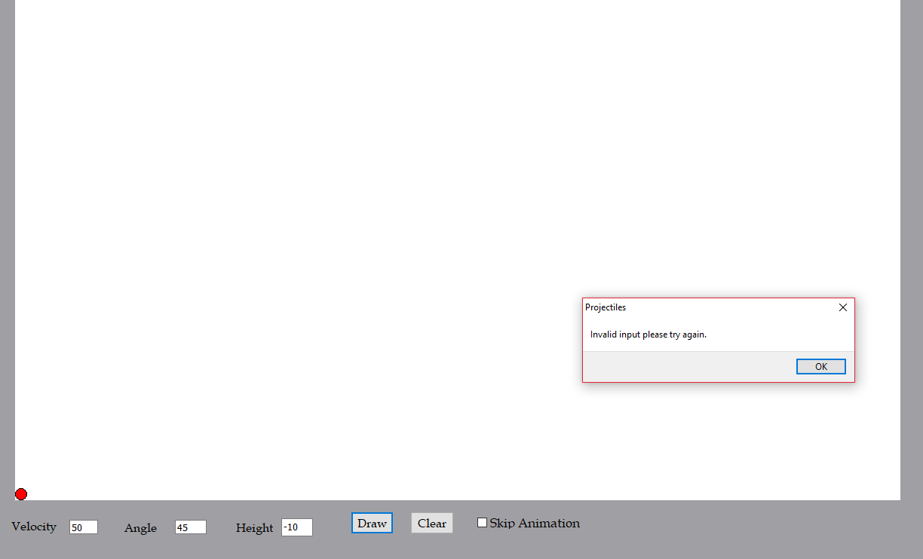

### Test 7.6.1

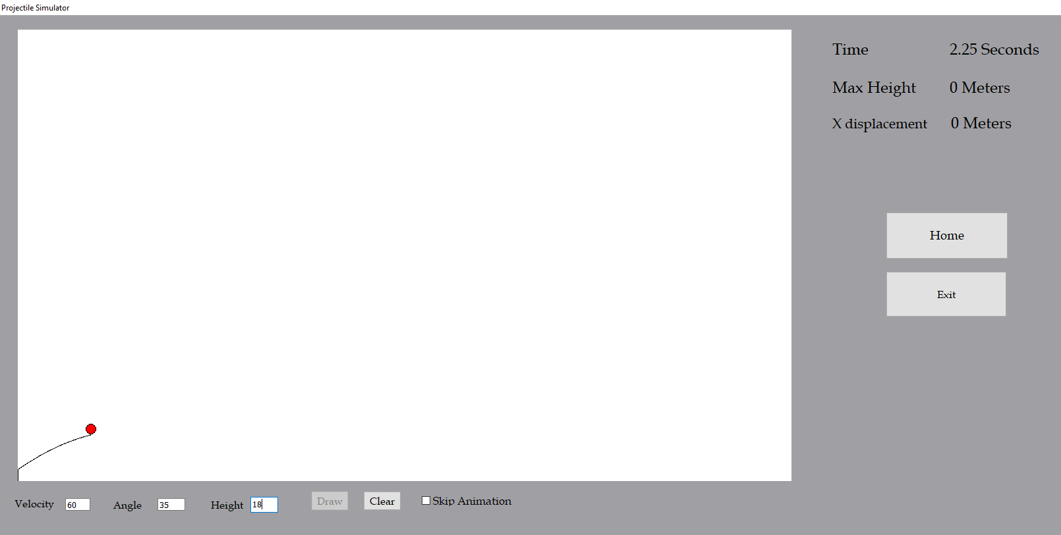

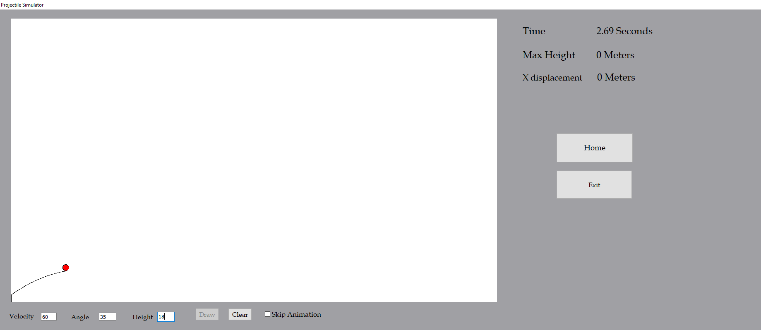

### Test 7.6.2

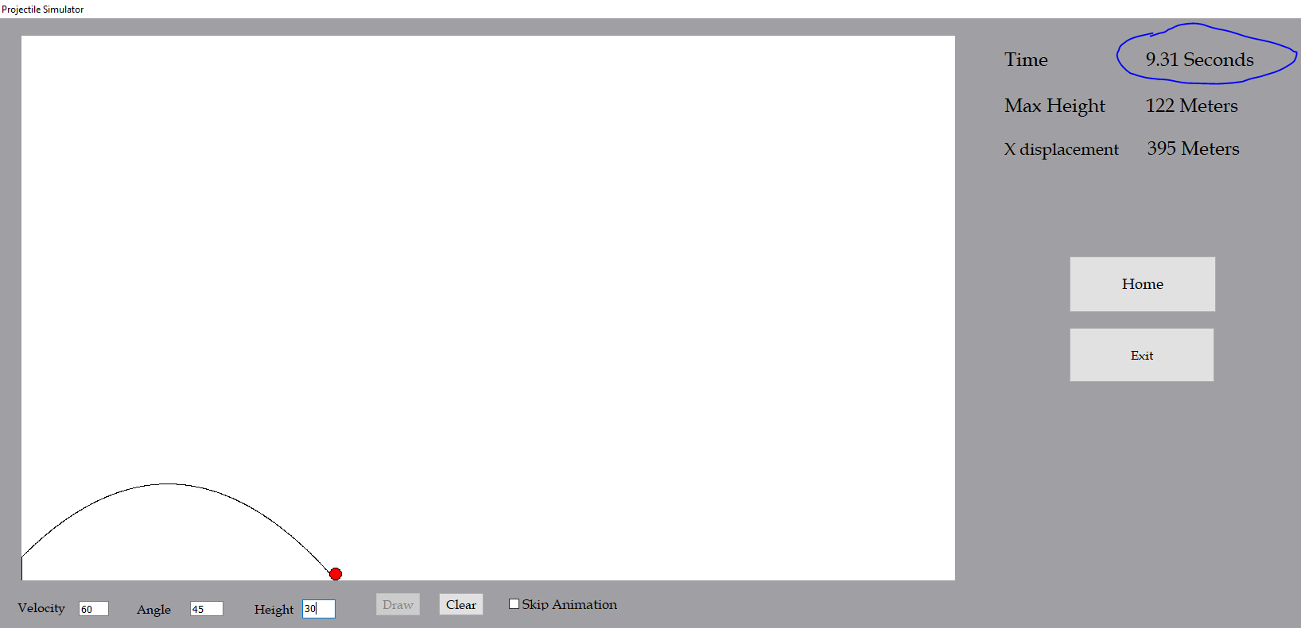

### Test 7.6.3

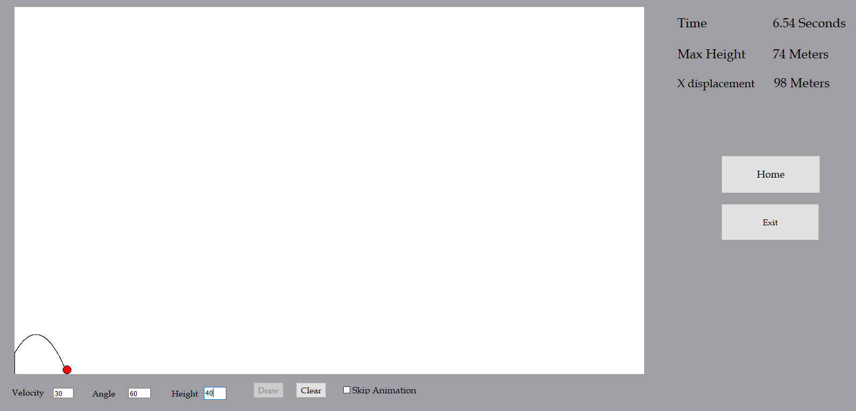

### Test 7.6.4

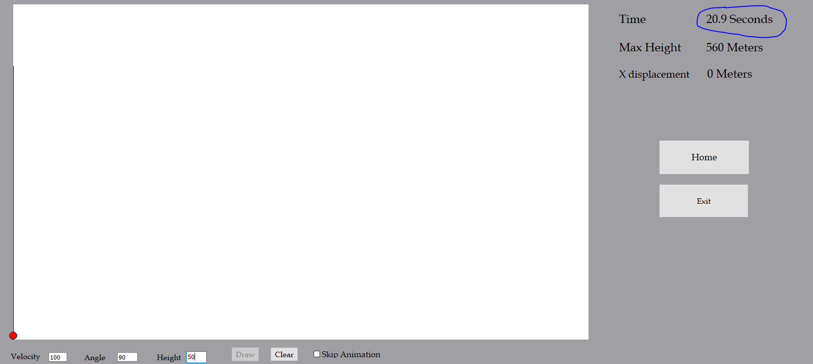

### Test 7.7.1

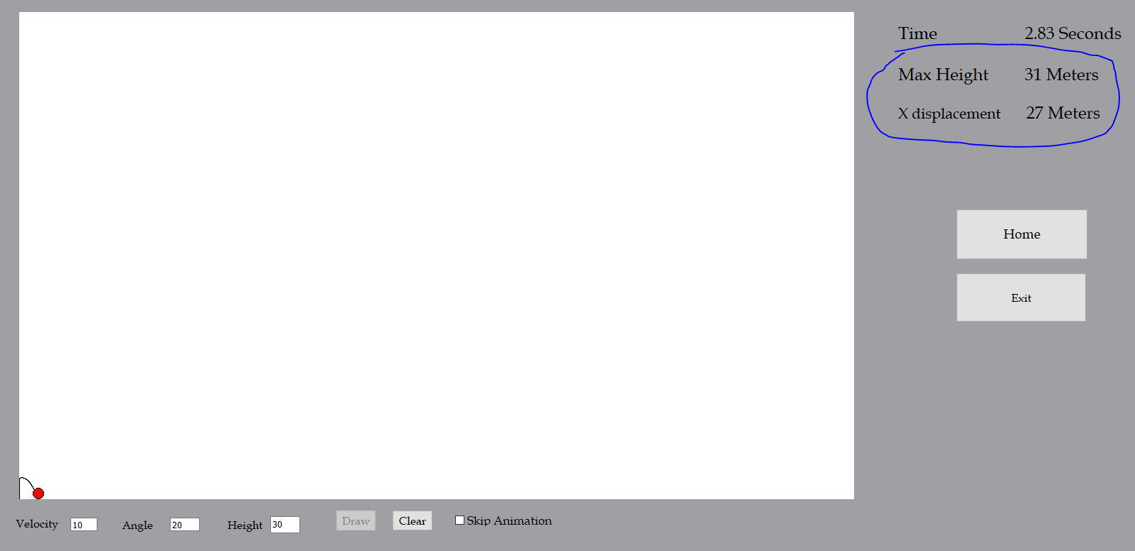

### Test 7.7.2

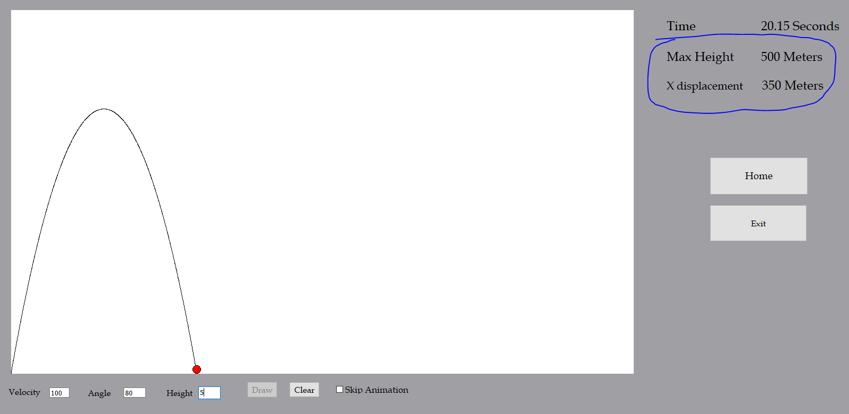

### Test 7.7.3

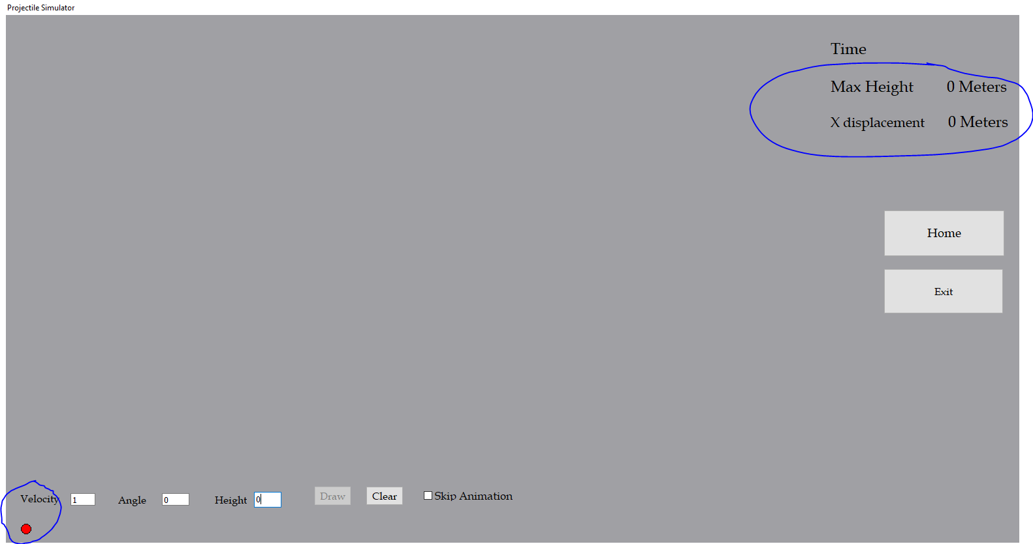

The projectile doesn’t stop running in this test suggesting that the program has found a way to break out of my loop.

### Test 7.8.1

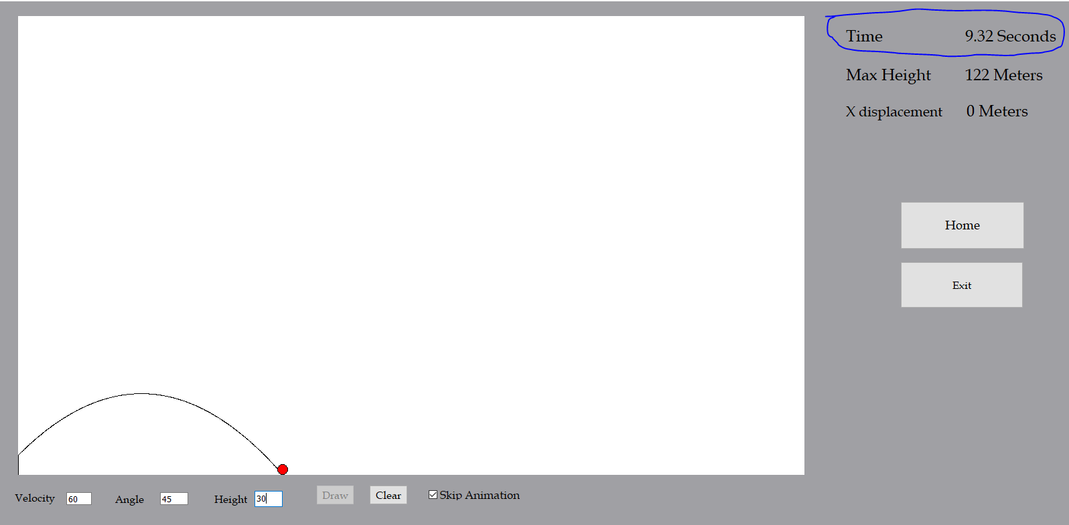

### Test 7.8.2

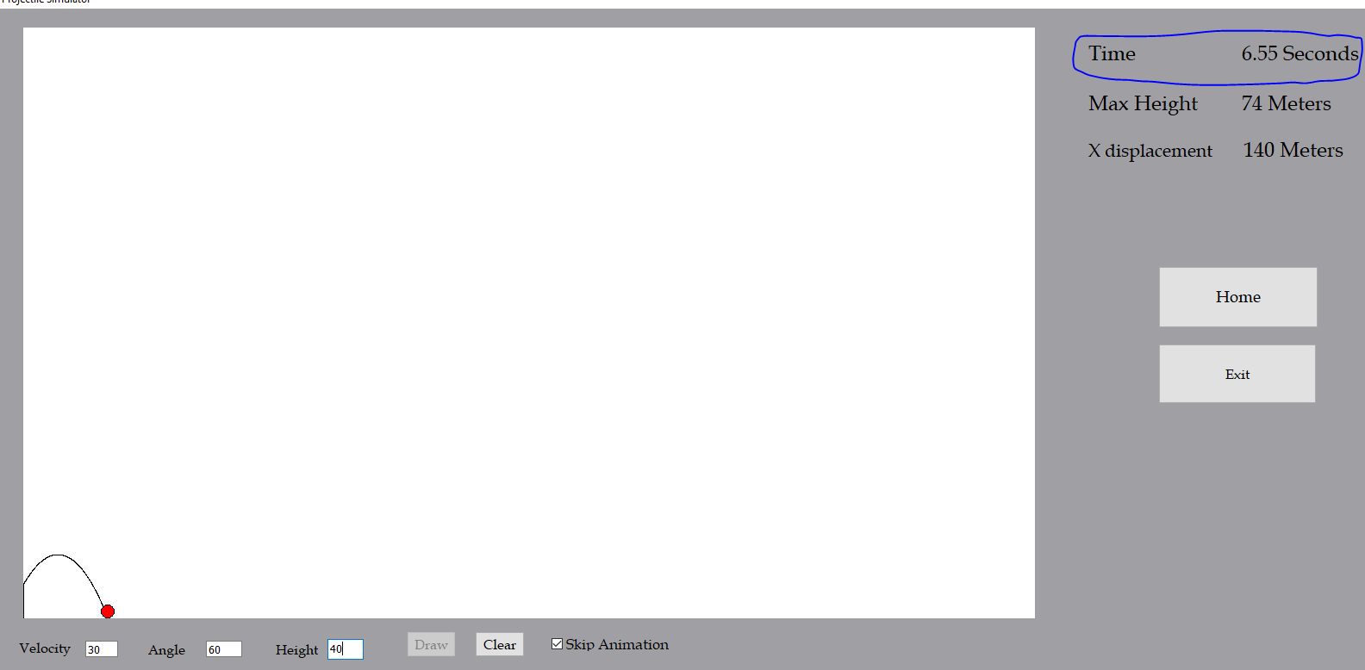

### Test 7.8.3

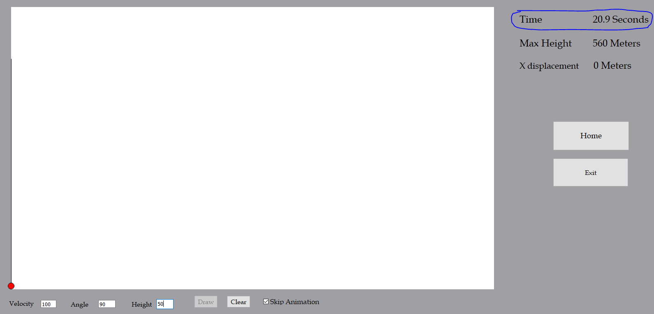

The time is slightly out the expected range, this is possible due to rounding. As the values of input increase the accuracy of the time decreases. This is happening with both skip animation on or off. The program uses a timer to calculate time (using real time), however this method can’t be used when calculating time instantly so a different is used to calculate time when skip animation is enabled, hence causing different time values when the input value are identical.

### Test 7.9.1

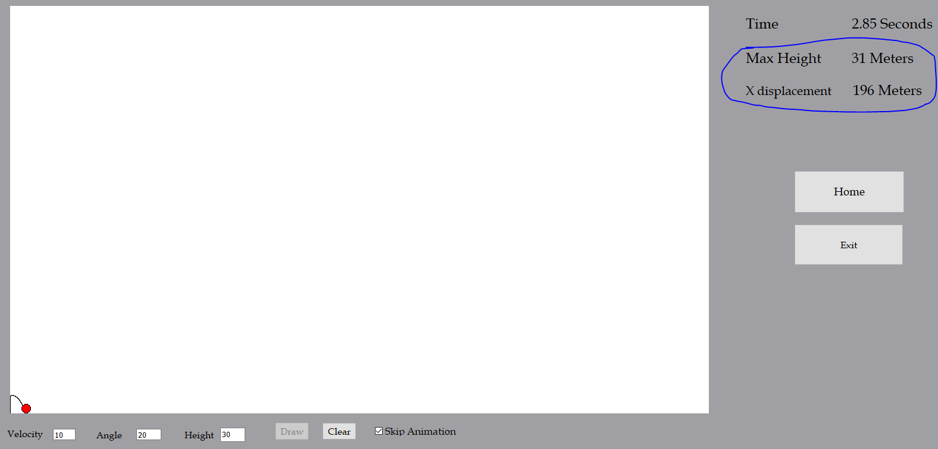

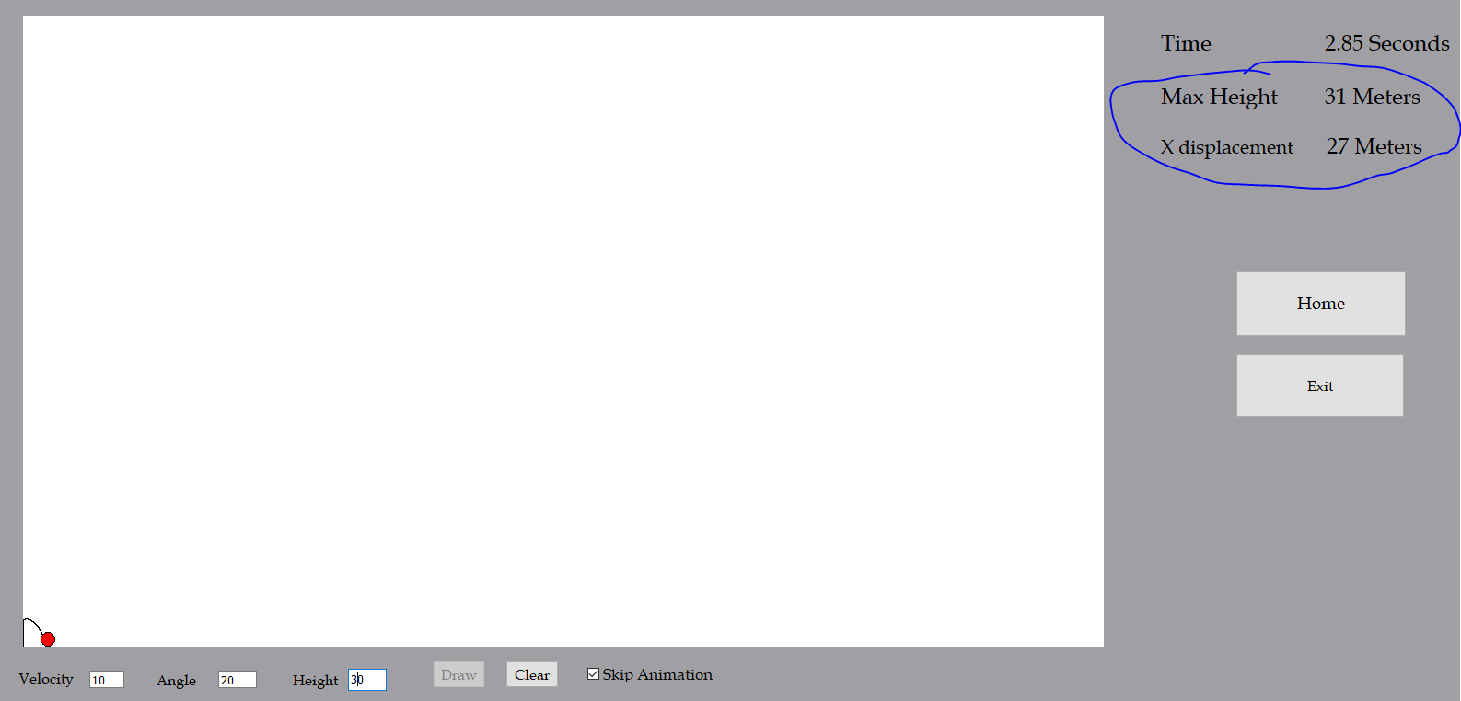

The x displacement is incorrect in the first run of these values, however it corrects itself in the next run.

### Test 7.9.2

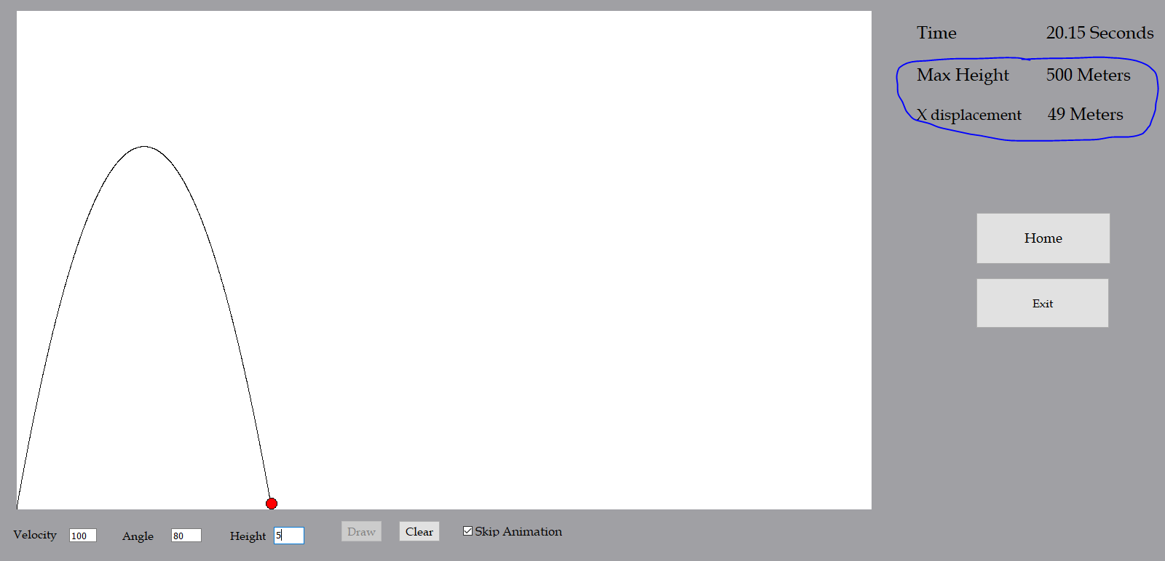

The same result in the previous test is happening for different values.

### Test 7.9.3

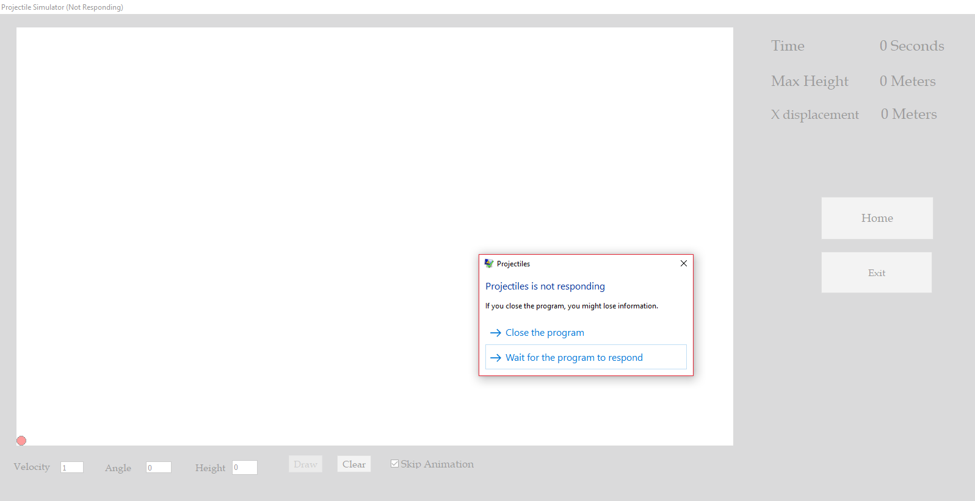

The application stops responding when the draw button is clicked

### Test 7.11.2

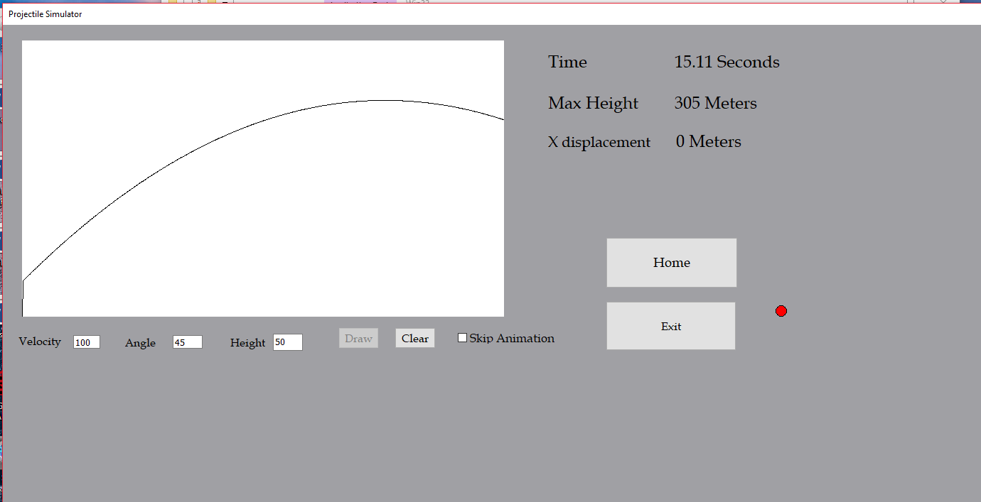

The ball and the trajectory path go of the image canvas in minimised mode using reasonably large values for input.

### Test 7.12

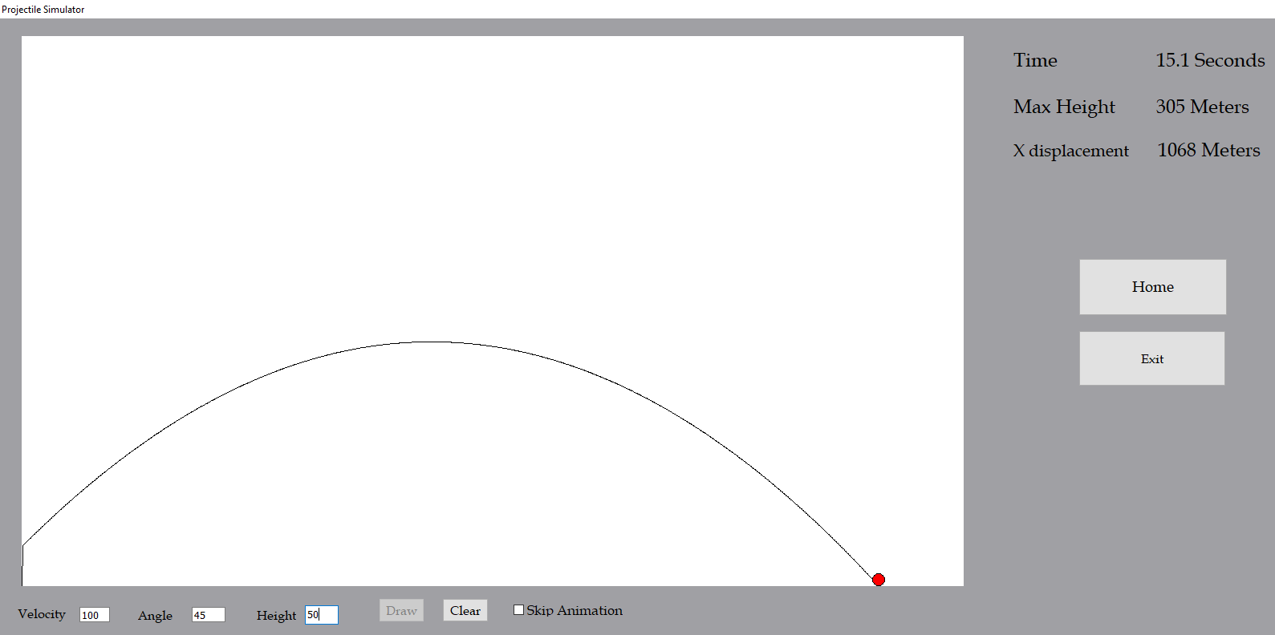

The trajectory path is drawn.

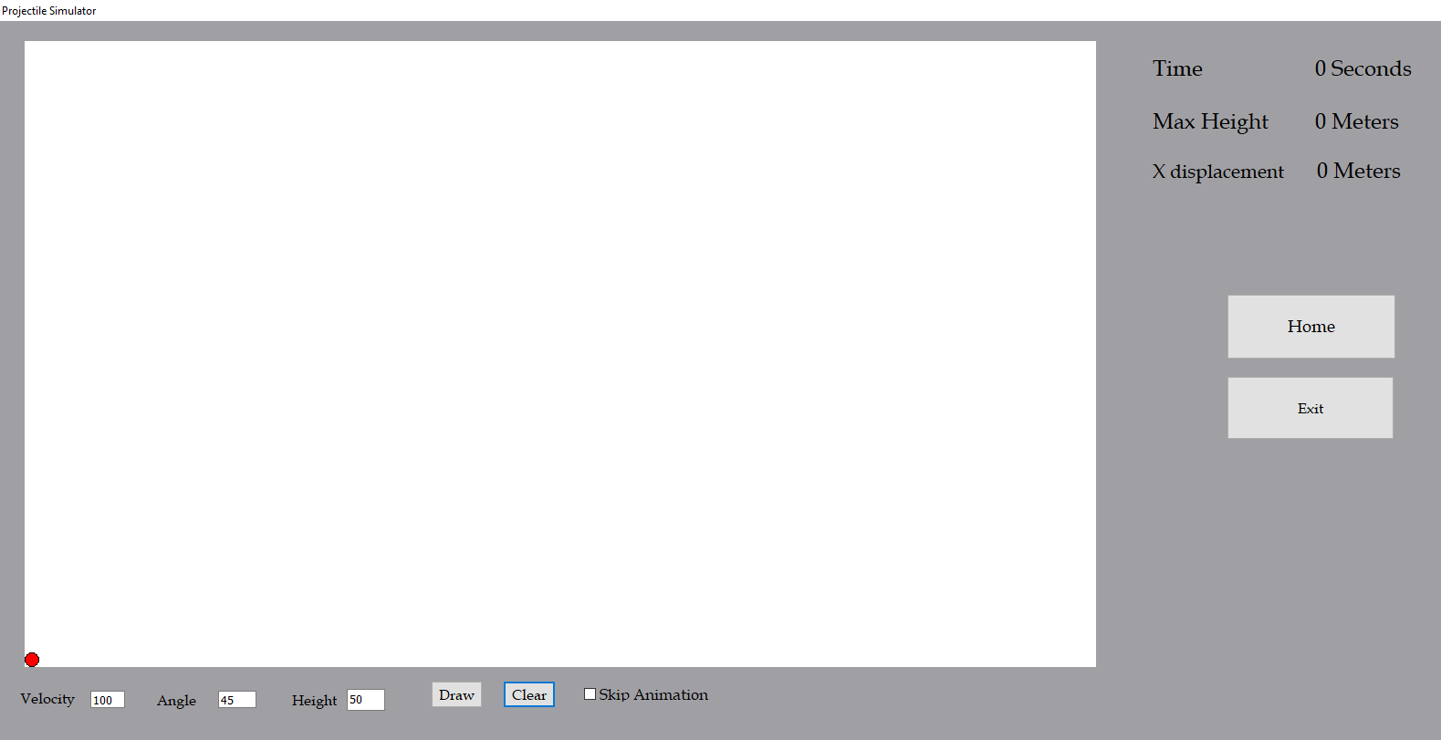

The clear button is clicked and the image canvas is cleared.

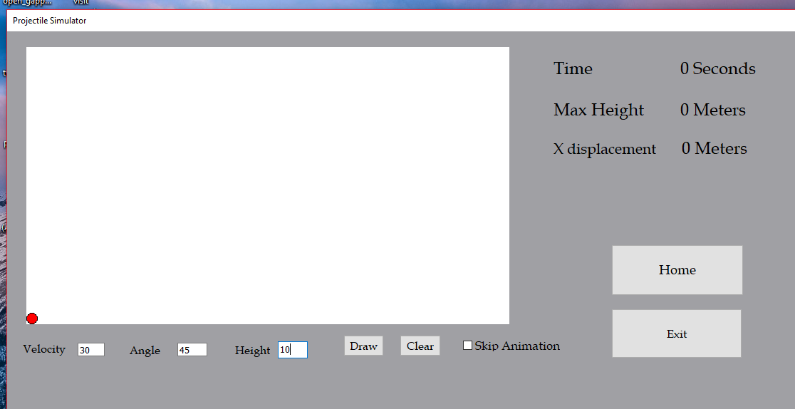

The form is then minimized.

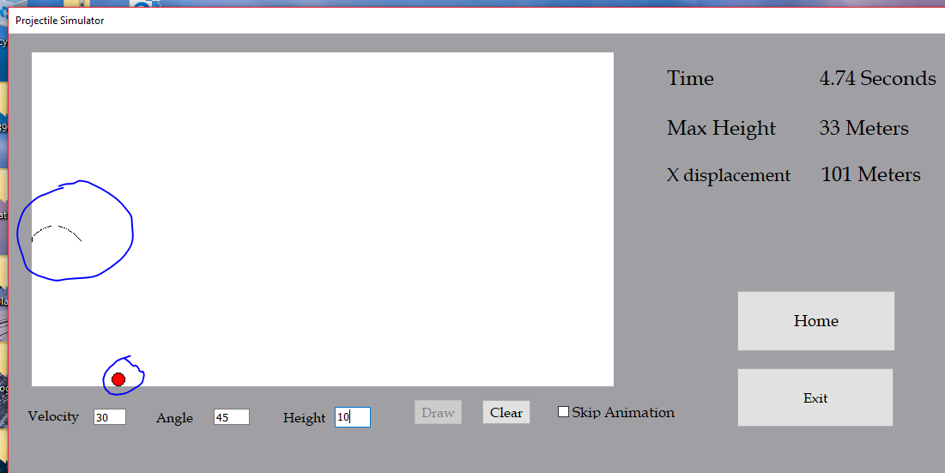

The draw button is clicked and the image canvas displays an incorrect trajectory path.

## Amendments

From the design to the actual technical solution there have many minor and major changes to allow the program to function correctly and meet objectives.

The first amendment to be made was to the database to fix an issue with generating primary keys for users, classes and questions. Using a real to represent a primary key was suitable for many unique id ‘s however there is not suitable way to generate these unique ids without the user having to enter an id to create record which would sometimes cause problems since the user may not know which ids have taken. Instead, the primary keys now use an integer with auto number implemented which automatically increments the primary key by 1 when a new record is added so the user doesn’t need to think about what primary key to use to create a record.

The second amendment was to implement a way for teachers to add worked solutions to their questions so a solutions field was added to the questions table in the database and an extra memo box was add to the questions form and the admin settings form to view the solution and a solution.

Previous version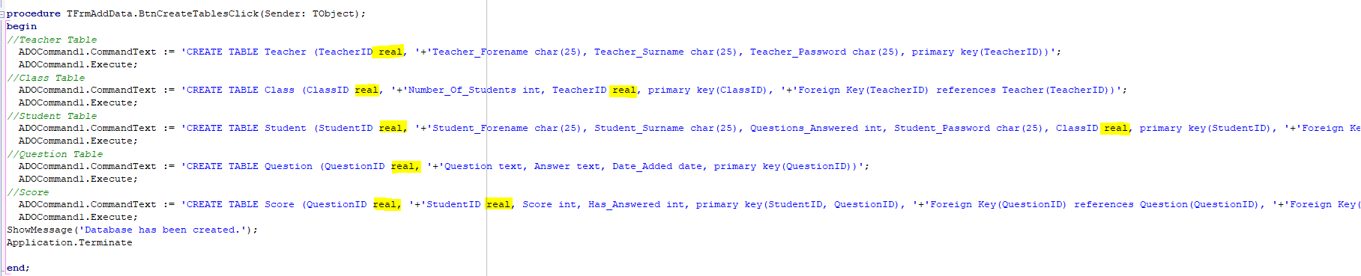

New version

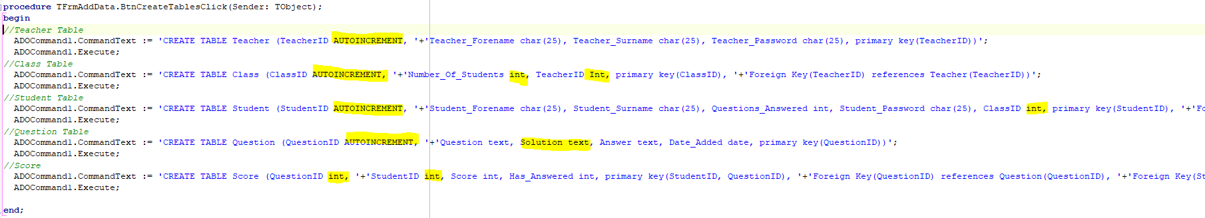

Changes made to forms

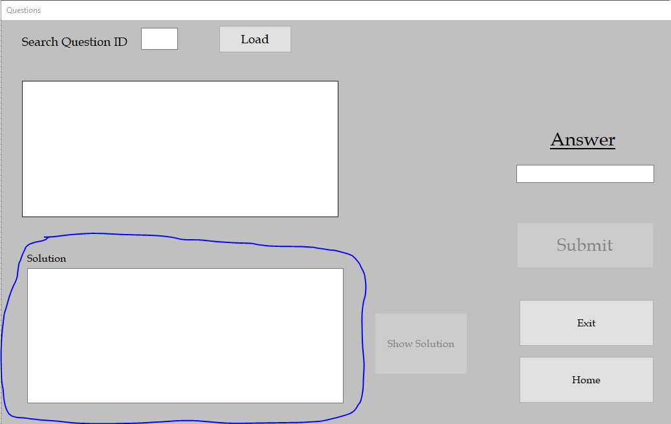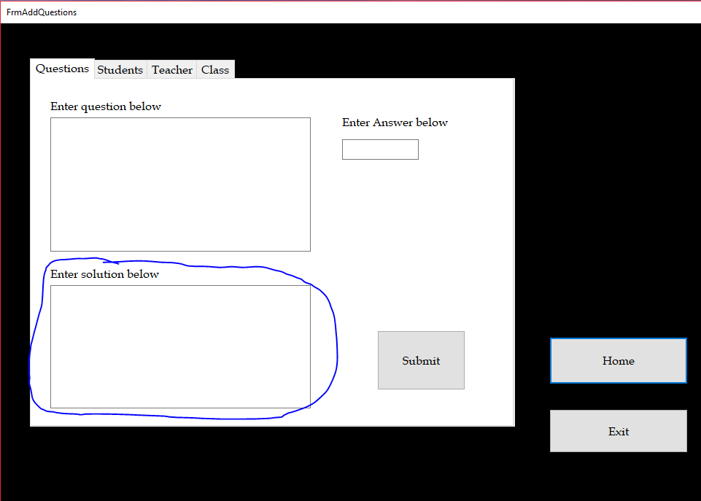

## Test review

In total there were 11 errors found in my testing, most of the errors appeared in the projectile simulator and the others were related to the database.

### Test 3.4.3 review

This test to check if the students record is updated correctly when they submit a correct answer which failed since the score was not incremented.

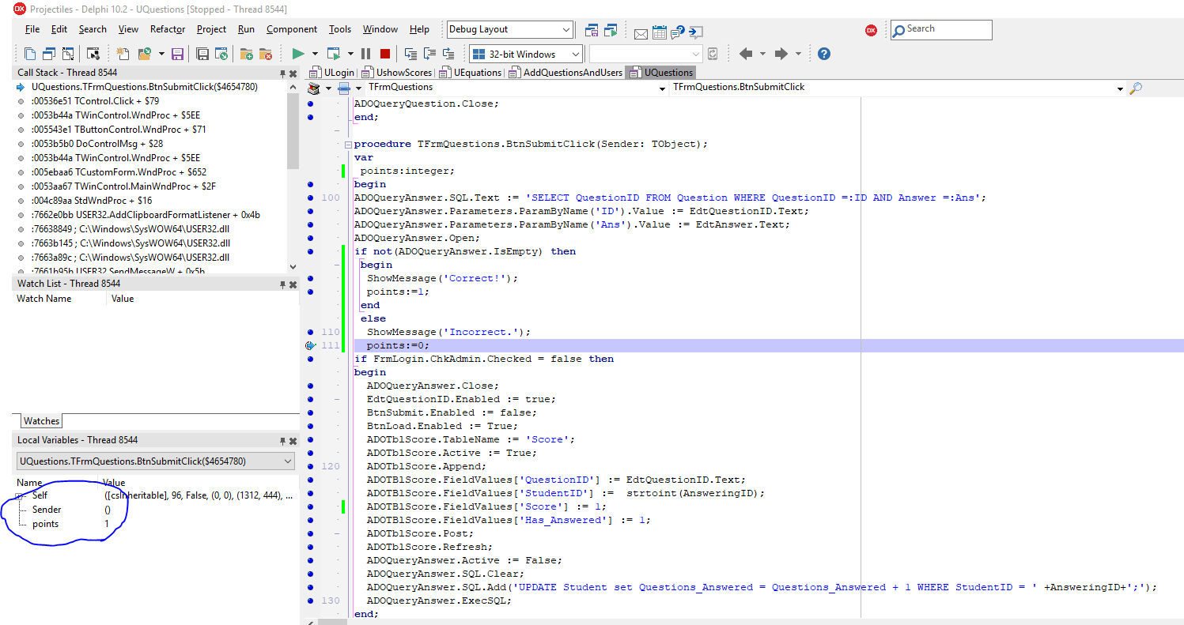

In this screenshot the program is being run with break points to determine the cause of error. The points variable is set to 1 when the answer is correct and is set to 0 when the answer is incorrect.

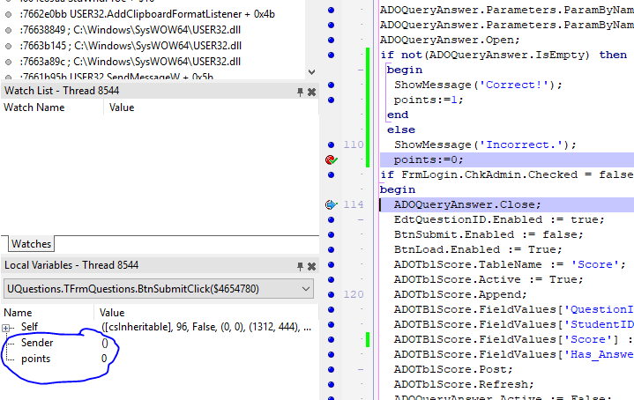

In this screenshot the 1st breakpoint is passed and points is set to 0 even though it should only be executed the else clause. This means there is an error in the if statement.

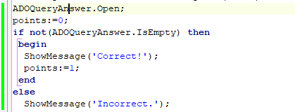My method to fix this error is to set points to 0 by default. Then set it to 1 if the answer is correct.

Re-test

|  |  |  |  |  |  |
| --- | --- | --- | --- | --- | --- |
| 3.4.3 | Test to check if the students record is updated correctly when they submit a correct answer | ‘Yes/3.76m’ then  left click btnSubmit. | Record in score table: StudentID = ‘9’, QuestionID = ‘2’, ‘Has_Answered’ = ‘1’,  Score = ‘1’.  Record in Student table: StudentID = ‘9’, Questions_Answered = ‘1’. | Record in score table: StudentID = ‘9’, QuestionID = ‘2’, ‘Has_Answered’ = ‘1’,  Score = ‘1’.  Record in Student table: StudentID = ‘9’, Questions_Answered = ‘1’. | Pass |

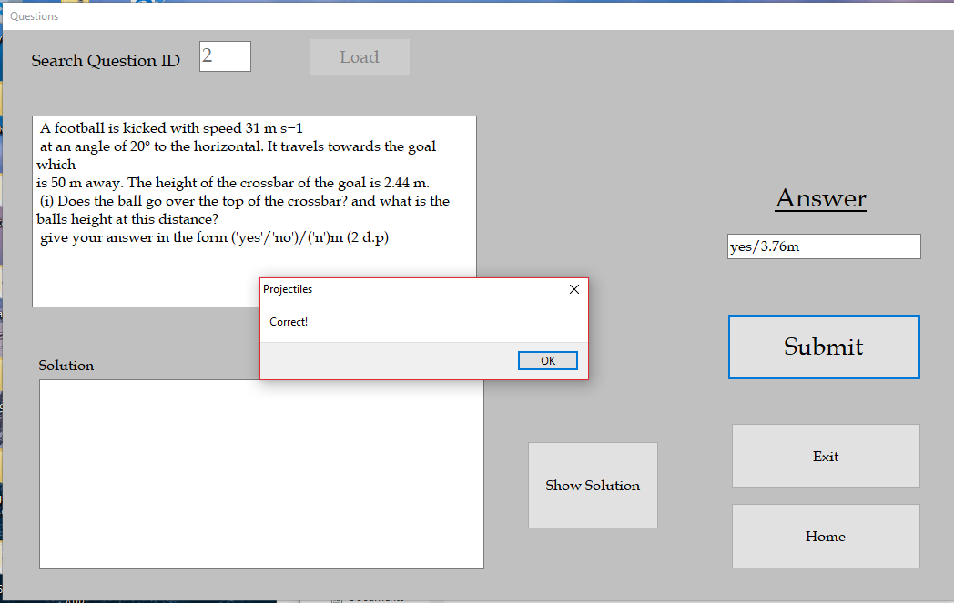

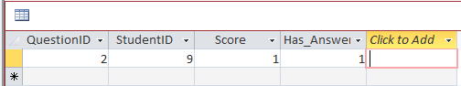

### Test 6.1.2 review

This test was to check if correct data is loaded onto the grid with index 1 selected in the table options which failed since data from students not in class 2 appeared.



This is the current line of code for obtaining class specific results, the problem is that the ‘WHERE’ statement is ignored when executing code resulting in the whole table being loaded.

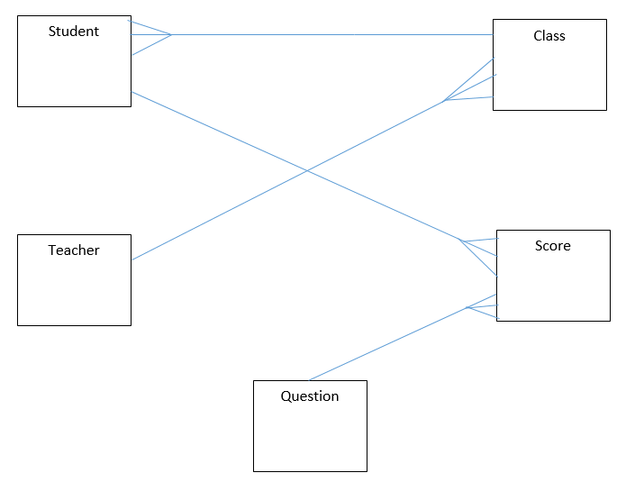

The possible cause of this problem is that there is no direct link between the Class table and the Score table for this query. This suggest there needs to be a connection from class to score (one to many (one class can have many scores but one score can only have one class)).

To fix this problem, I have added a foreign key (ClassID) to link the score table to the class table. Making this change meant other changes needed to be made to the questions form.

New code



Re-test

|  |  |  |  |  |  |
| --- | --- | --- | --- | --- | --- |
| 6.1.2 | Test to check if correct data is loaded onto the grid with index 1 selected in the table options | 1 | Only scores from students in class 1 to appear | Only scores from students in class 1 to appear | Pass |

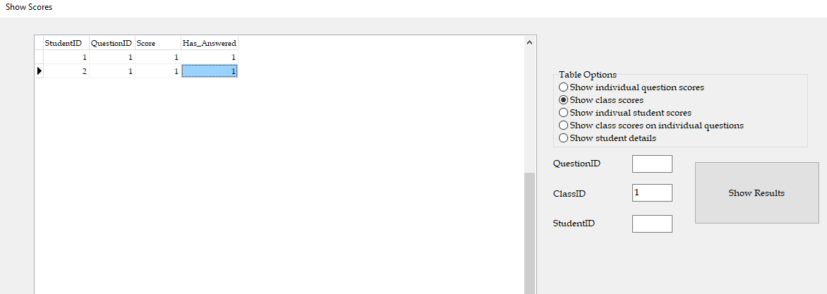

The only students in class 1 are students 1 and 2.

### Test 7.7.3 and 7.9.3 review

This test was to check the accuracy of the horizontal(x) displacement and maximum height (extreme). The test data for this test was v=1, a=0 and h =0 which caused the program crash when skip animation was enabled and loop forever when unchecked.

The loop ends when the height matches the image canvas height (when the projectile has landed) and when the time is greater than 1 which allows the projectile animation to start. The problem with this is that the projectile can land before 1 second with such low input values causing this problem.



There are 2 different approaches to fixing this bug. The first way is to change the 1 to a lower value such as 0.01 so the inputs will be acceptable in this loop. The second way would be to calculate the time of flight prior to the motion and stop the animation when the live timer value equals the calculated. Using the 2nd method will also fix the problem of having slightly different times when skip animation is checked.

New code

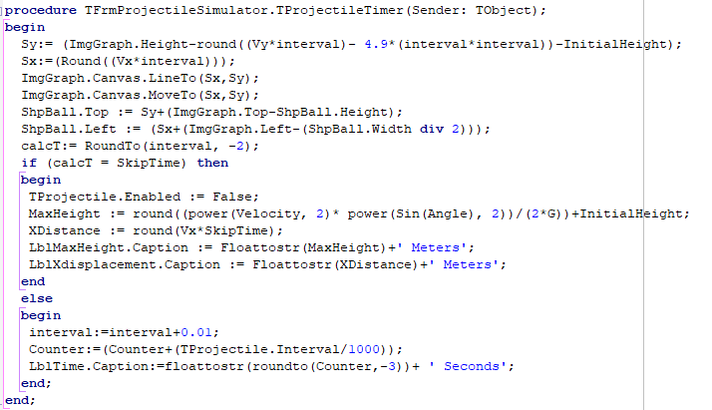

I created a variable called ’CalcT’ which is the rounded value of ‘interval’ to two decimal places. ‘Interval’ is used to draw a line every 0.01 seconds. So, this is incremented by 0.01 every pass in the loop. ‘SkipTime’ is the calculated time of flight rounded to 2 decimal places. The loop will stop once the interval value equals ‘SkipTime’. For example, if ‘SkipTime’ = 4.12, the loop will run exactly 413 times then stop (0.01*412 = 4.12 + 0.01).

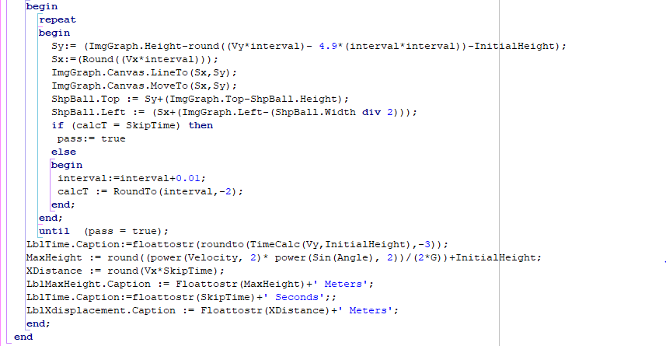

A very similar method has also been applied now when skip animation is checked.

Re-test

|  |  |  |  |  |  |
| --- | --- | --- | --- | --- | --- |
| 7.7.3 | Test to check the accuracy of the horizontal(x) displacement and maximum height (extreme) | 1,0,0 | Very short projectile animation is ran (may not be visible) with no errors. | Very short projectile animation is ran (may not be visible) with no errors. | pass |
| 7.9.3 | Test to check the accuracy of the horizontal(x) displacement and maximum height (extreme)(Skip Animation enabled) | 1,0,0 | Very short projectile animation is ran (may not be visible) with no errors. | Very short projectile animation is ran (may not be visible) with no errors. | pass |

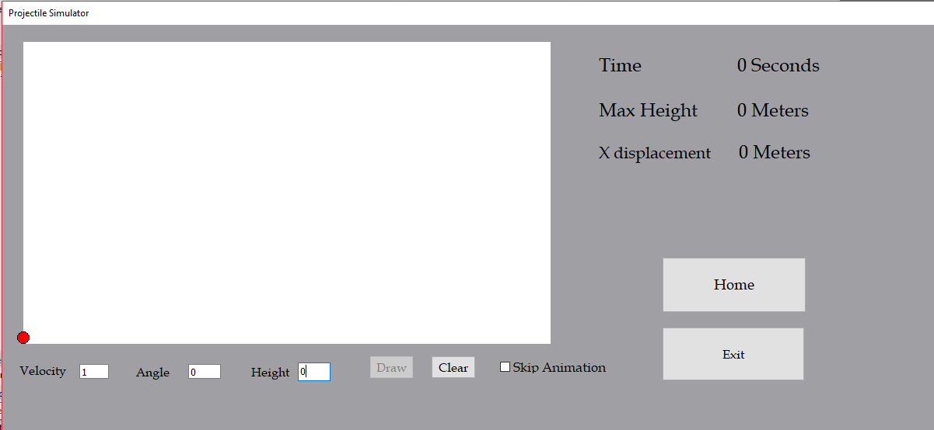

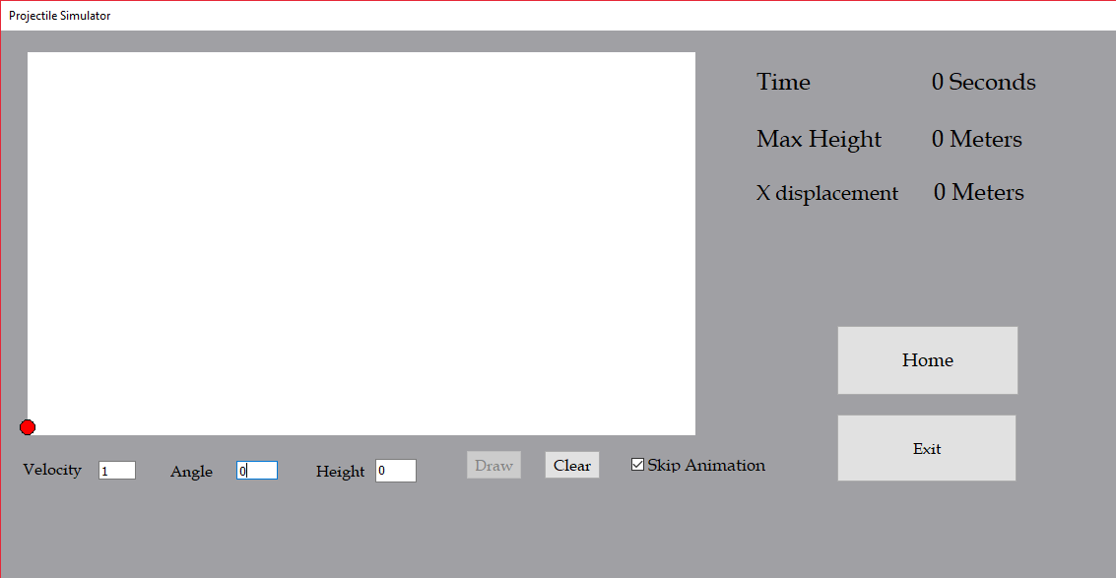

### Test 7.11.2 and 7.12 review

These tests were to the check if the projectile animation stays within the screen and image canvas (minimized mode) and to the check if the projectile animation runs as normal after switching screen modes. Both issues are to do with scaling of the image canvas.

The first problem is difficult to fix since the line.to function only accepts integers which means 1 unit on the image canvas is using 1 pixel, this means I can’t scale down the image to use half a pixel to represent 1 unit which would reduce the size which may fit the image canvas.

The 2nd problem is appearing because the height of the image canvas doesn’t change with window size if it has already been ran once therefor causing an incorrect trajectory path.

The problem is very difficult to fix so a temporary solution to these problems would be to default and lock the form on full screen mode.

Projectile form in full screen borderless mode.

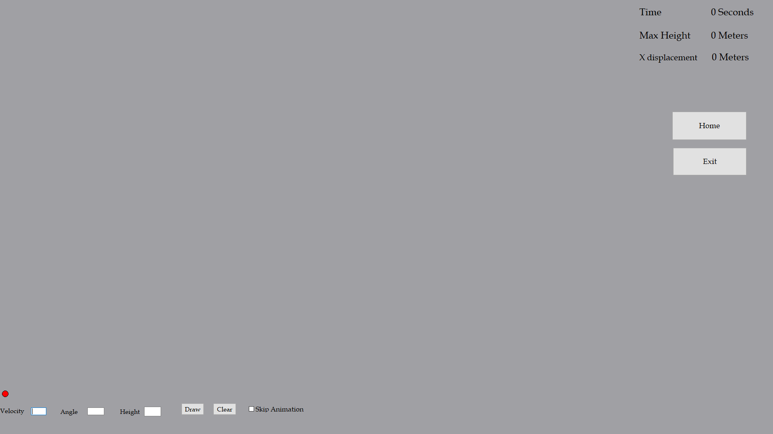

# Technical Solution

## ULogin.pas

unit ULogin;

interface

uses

Windows, Messages, SysUtils, Variants, Classes, Graphics, Controls, Forms,

Dialogs, pngimage, ExtCtrls, StdCtrls, DB, ADODB;

type

TFrmLogin = class(TForm)

BtnLogin: TButton;

EdtUsername: TEdit;

EdtPassword: TEdit;

LblUsername: TLabel;

LblPassword: TLabel;

LblTitle: TLabel;

ImgBackground: TImage;

ADOConLogin: TADOConnection;

ADOQueryLogin: TADOQuery;

ChkAdmin: TCheckBox;

LblTeacherLogin: TLabel;

BtnExit: TButton;

procedure BtnLoginClick(Sender: TObject);

procedure BtnExitClick(Sender: TObject);

private

{ Private declarations }

CurrentUser:String;

public

{ Public declarations }

end;

var

FrmLogin: TFrmLogin;

implementation

{$R *.dfm}

uses UMainMenu, UQuestions;

procedure TFrmLogin.BtnExitClick(Sender: TObject);

begin

Application.Terminate;

end;

procedure TFrmLogin.BtnLoginClick(Sender: TObject);

var

Dbase : OleVariant;

nameDatabase : string;

begin

if ADOConLogin.Connected = false then

begin

nameDatabase := 'ProjectileDB.accdb';

ADOConLogin.ConnectionString := 'Provider=Microsoft.ACE.OLEDB.12.0;Data Source =' +nameDataBase+';';

ADOConLogin.LoginPrompt := false;

ADOConLogin.Connected :=true;

ADOQueryLogin.Connection := ADOConLogin;

end;

if ChkAdmin.Checked = false then

begin

ADOQueryLogin.SQL.Text := 'SELECT StudentID, Student_Password FROM Student WHERE StudentID =:User AND Student_Password =:Password';

ADOQueryLogin.Parameters.ParamByName('User').Value := EdtUsername.Text;

ADOQueryLogin.Parameters.ParamByName('Password').Value := EdtPassword.Text;

end;

if ChkAdmin.Checked = true then

begin

ADOQueryLogin.SQL.Text := 'SELECT TeacherID, Teacher_Password FROM Teacher WHERE TeacherID =:User AND Teacher_Password =:Password';

ADOQueryLogin.Parameters.ParamByName('User').Value := EdtUsername.Text;

ADOQueryLogin.Parameters.ParamByName('Password').Value := EdtPassword.Text;

end;

ADOQueryLogin.Open;

if (not((ADOQueryLogin.IsEmpty)) or ((EdtUsername.Text = 'Admin')and (Edtpassword.Text = 'Admin') and (ChkAdmin.Checked = true))) then

begin

CurrentUser := EdtUsername.Text;

ShowMessage('Access Granted');

if ChkAdmin.Checked = true then

begin

FrmMainMenu.BtnAdminSettings.Visible := true;

FrmMainMenu.BtnDetails.Visible := true;

end;

FrmLogin.Hide;

FrmMainMenu.show;

end

else

ShowMessage('Access denied');

ADOQueryLogin.Close;

end;

end.

## UMainMenu.pas

unit UMainMenu;

interface

uses

Windows, Messages, SysUtils, Variants, Classes, Graphics, Controls, Forms,

Dialogs, StdCtrls;

type

TFrmMainMenu = class(TForm)

BtnSimulator: TButton;

BtnQuestions: TButton;

BtnEquations: TButton;

BtnAdminSettings: TButton;

LblWelcome: TLabel;

BtnExit: TButton;

BtnDetails: TButton;

procedure BtnSimulatorClick(Sender: TObject);

procedure BtnQuestionsClick(Sender: TObject);

procedure BtnEquationsClick(Sender: TObject);

procedure BtnAdminSettingsClick(Sender: TObject);

procedure BtnExitClick(Sender: TObject);

procedure BtnDetailsClick(Sender: TObject);

private

{ Private declarations }

public

{ Public declarations }

end;

var

FrmMainMenu: TFrmMainMenu;

implementation

uses UProjectileSim, UQuestions, AddQuestionsAndUsers, UEquations, UshowScores;

{$R *.dfm}

procedure TFrmMainMenu.BtnAdminSettingsClick(Sender: TObject);

begin

FrmMainMenu.Hide;

FrmAddQuestions.Show;

end;

procedure TFrmMainMenu.BtnEquationsClick(Sender: TObject);

begin

FrmMainMenu.Hide;

FrmEquations.show;

end;

procedure TFrmMainMenu.BtnExitClick(Sender: TObject);

begin

Application.Terminate;

end;

procedure TFrmMainMenu.BtnQuestionsClick(Sender: TObject);

begin

FrmMainMenu.Hide;

FrmQuestions.show;

end;

procedure TFrmMainMenu.BtnSimulatorClick(Sender: TObject);

begin

FrmMainMenu.Hide;

FrmProjectileSimulator.show;

FrmProjectileSimulator.WindowState := wsMaximized;

end;

procedure TFrmMainMenu.BtnDetailsClick(Sender: TObject);

begin

FrmMainMenu.Hide;

FrmShowScores.show;

end;

end.

## UQuestions.pas

unit UQuestions;

interface

uses

Windows, Messages, SysUtils, Variants, Classes, Graphics, Controls, Forms,

Dialogs, StdCtrls, ComCtrls, DB, ADODB;

type

TFrmQuestions = class(TForm)

MmoQuestion: TMemo;

EdtAnswer: TEdit;

BtnSubmit: TButton;

lblAnswer: TLabel;

ADOConQuestion: TADOConnection;

LblSearch: TLabel;

EdtQuestionID: TEdit;

BtnLoad: TButton;

BtnHome: TButton;

ADOQueryQuestion: TADOQuery;

ADOQueryAnswer: TADOQuery;

BtnExit: TButton;

ADOTblScore: TADOTable;

MmoSolution: TMemo;

BtnSolution: TButton;

LblSolution: TLabel;

procedure BtnHomeClick(Sender: TObject);

procedure BtnLoadClick(Sender: TObject);

procedure BtnSubmitClick(Sender: TObject);

procedure BtnExitClick(Sender: TObject);

procedure BtnSolutionClick(Sender: TObject);

private

{ Private declarations }

public

{ Public declarations }

end;

var

FrmQuestions: TFrmQuestions;

AnsweringID:string;

SclassID:integer;

implementation

uses UMainMenu, ULogin;

{$R *.dfm}

procedure TFrmQuestions.BtnExitClick(Sender: TObject);

begin

Application.Terminate;

end;

procedure TFrmQuestions.BtnHomeClick(Sender: TObject);

begin

FrmQuestions.Hide;

FrmMainMenu.Show;

EdtAnswer.Text:='';

MmoQuestion.Lines.Clear;

EdtQuestionID.text:='';

end;

procedure TFrmQuestions.BtnLoadClick(Sender: TObject);

var

nameDatabase:string;

begin

if ADOConQuestion.Connected = false then

begin

nameDatabase := 'ProjectileDB.accdb';

ADOConQuestion.ConnectionString := 'Provider=Microsoft.ACE.OLEDB.12.0;Data Source =' +nameDataBase+';';

ADOConQuestion.LoginPrompt := false;

ADOConQuestion.Connected :=true;

ADOQueryQuestion.Connection := ADOConQuestion;

ADOQueryAnswer.Connection := ADOConQuestion;

ADOTblScore.Connection := ADOConQuestion;

end;

AnsweringID := frmLogin.EdtUsername.Text;

ADOQueryQuestion.SQL.Text := 'SELECT Question FROM Question WHERE QuestionID =:ID';

ADOQueryQuestion.Parameters.ParamByName('ID').Value := EdtQuestionID.Text;

ADOQueryQuestion.Open;

if not ADOQueryQuestion.IsEmpty then

begin

EdtQuestionID.Enabled := false;

BtnSubmit.Enabled := true;

BtnLoad.Enabled := false;

BtnSolution.Enabled := true;

MmoQuestion.Text:=ADOQueryQuestion.FieldByName('Question').AsString;

end

else

ShowMessage('Question not valid, please try a different ID.');

ADOQueryQuestion.Close;

if FrmLogin.ChkAdmin.Checked = false then

begin

ADOQueryQuestion.SQL.Text := 'SELECT ClassID FROM Student WHERE StudentID =:ID';

ADOQueryQuestion.Parameters.ParamByName('ID').Value := strtoint(AnsweringID);

ADOQueryQuestion.Open;

SclassID := ADOQueryQuestion.FieldByName('ClassID').AsInteger;

ADOQueryQuestion.close

end;

end;

procedure TFrmQuestions.BtnSubmitClick(Sender: TObject);

var

points:integer;

begin

ADOQueryAnswer.SQL.Text := 'SELECT QuestionID FROM Question WHERE QuestionID =:ID AND Answer =:Ans';

ADOQueryAnswer.Parameters.ParamByName('ID').Value := EdtQuestionID.Text;

ADOQueryAnswer.Parameters.ParamByName('Ans').Value := EdtAnswer.Text;

ADOQueryAnswer.Open;

points:=0;

if not(ADOQueryAnswer.IsEmpty) then

begin

ShowMessage('Correct!');

points:=1;

end

else

ShowMessage('Incorrect.');

if FrmLogin.ChkAdmin.Checked = false then

begin

ADOQueryAnswer.Close;

EdtQuestionID.Enabled := true;

BtnSubmit.Enabled := false;

BtnLoad.Enabled := True;

ADOTblScore.TableName := 'Score';

ADOTblScore.Active := True;

ADOTblScore.Append;

ADOTBlScore.FieldValues['QuestionID'] := EdtQuestionID.Text;

ADOTBlScore.FieldValues['StudentID'] := strtoint(AnsweringID);

ADOTBlScore.FieldValues['Score'] := points;

ADOTBlScore.FieldValues['Has_Answered'] := 1;

ADOTblScore.FieldValues['ClassID'] := SclassID;

ADOTblScore.Post;

ADOTblScore.Refresh;

ADOQueryAnswer.Active := False;

ADOQueryAnswer.SQL.Clear;

ADOQueryAnswer.SQL.Add('UPDATE Student set Questions_Answered = Questions_Answered + 1 WHERE StudentID = ' +AnsweringID+';');

ADOQueryAnswer.ExecSQL;

end;

end;

procedure TFrmQuestions.BtnSolutionClick(Sender: TObject);

begin

ADOQueryQuestion.SQL.Text := 'SELECT Solution FROM Question WHERE QuestionID =:ID';

ADOQueryQuestion.Parameters.ParamByName('ID').Value := EdtQuestionID.Text;

ADOQueryQuestion.open;

MmoSolution.Text:=ADOQueryQuestion.FieldByName('Solution').AsString;

EdtQuestionID.Enabled := true;

BtnSubmit.Enabled := false;

BtnLoad.Enabled := True;

if FrmLogin.ChkAdmin.Checked = false then

begin

ADOTblScore.TableName := 'Score';

ADOTblScore.Active := True;

ADOTblScore.Append;

ADOTBlScore.FieldValues['QuestionID'] := strtoint(EdtQuestionID.Text);

ADOTBlScore.FieldValues['StudentID'] := strtoint(AnsweringID);

ADOTBlScore.FieldValues['Score'] := 0;

ADOTBlScore.FieldValues['Has_Answered'] := 1;

ADOTblScore.FieldValues['ClassID'] := SclassID;

ADOTblScore.Post;

ADOTblScore.Refresh;

ADOQueryAnswer.Active := False;

ADOQueryAnswer.SQL.Clear;

ADOQueryAnswer.SQL.Add('UPDATE Student set Questions_Answered = Questions_Answered + 1 WHERE StudentID = ' +AnsweringID+';');

ADOQueryAnswer.ExecSQL;

end;

end;

end.

## UProjectileSim.pas

unit UProjectileSim;

interface

uses

Windows, Messages, SysUtils, Variants, Classes, Graphics, Controls, Forms,

Dialogs, StdCtrls, ExtCtrls, Math;

type

TFrmProjectileSimulator = class(TForm)

LblVelocity: TLabel;

EdtVelocity: TEdit;

LblAngle: TLabel;

EdtAngle: TEdit;

BtnDraw: TButton;

ImgGraph: TImage;

TProjectile: TTimer;

BtnClear: TButton;

LblTime: TLabel;

ShpBall: TShape;

LblTTime: TLabel;

LblTMaxHeight: TLabel;

LblMaxHeight: TLabel;

BtnHome: TButton;

LblHeight: TLabel;

EdtHeight: TEdit;

BtnExit: TButton;

ChkBSkip: TCheckBox;

LblTXdisplacement: TLabel;

LblXdisplacement: TLabel;

procedure BtnDrawClick(Sender: TObject);

procedure TProjectileTimer(Sender: TObject);

procedure BtnClearClick(Sender: TObject);

procedure BtnHomeClick(Sender: TObject);

procedure BtnExitClick(Sender: TObject);

private

SkipTime:real;

Velocity:integer;

Vy,Vx :real;

Sy,Sx :integer;

Angle:real;

Ptime:real;

RTime:TTimer;

interval:real;

Counter:real;

MaxHeight:real;

XDistance:real;

InitialHeight:integer;

Valid:boolean;

public

{ Public declarations }

end;

var

FrmProjectileSimulator: TFrmProjectileSimulator;

calcT:real;

const

G=9.8;

PI=3.141592654;

implementation

uses UMainMenu;

{$R *.dfm}

{}

Function TimeCalc(b:real;c:integer):real;

var a:real;

T1, T2, n, bsquared:real;

begin

a := -4.9;

//Time factorising

bsquared := Sqr(b);

T1:= ((-b + sqrt(sqr(b)- (4*a*c)))/(2*a));

T2:= ((-b - sqrt(sqr(b)- (4*a*c)))/(2*a));

if T1>T2 then

TimeCalc := T1

else

TimeCalc := T2;

end;

Function DegreesToRadians(Degrees:integer):real;

begin

DegreesToRadians:=(Degrees*PI)/180;

end;

procedure TFrmProjectileSimulator.BtnClearClick(Sender: TObject);

begin

BtnDraw.Enabled:=True;

ImgGraph.canvas.pen.color:=clwhite;

ImgGraph.canvas.brush.color:=clwhite;

ImgGraph.canvas.rectangle(0,0,ImgGraph.width, ImgGraph.height);

TProjectile.Enabled:=False;

LblTime.Caption:='0 Seconds';

Counter:=0;

interval:=0;

CalcT:=0;

LblMaxHeight.Caption := '0 Meters';

LblXdisplacement.Caption := '0 Meters';

ShpBall.Top:=ImgGraph.Height+ImgGraph.Top-ShpBall.Height;

ShpBall.Left:=ImgGraph.Left;

end;

procedure TFrmProjectileSimulator.BtnDrawClick(Sender: TObject);

var pass:boolean;

begin

pass := false;

Valid := true;

InitialHeight :=StrToInt(EdtHeight.text);

if (InitialHeight > 50) or(InitialHeight < 0) then

Valid := false;

Angle := DegreesToRadians(strtoint(EdtAngle.Text));

if (StrToInt(EdtAngle.text)>90) or (StrToInt(EdtAngle.Text)<0) then

Valid := false;

Velocity := strtoint(EdtVelocity.Text);

if (Velocity > 100) or (Velocity < 0) then

Valid := false;

if valid then

begin

ImgGraph.canvas.pen.color:=clblack;

BtnDraw.Enabled:=false;

Vx:= (Velocity*cos(Angle));

Vy:= (Velocity*Sin(Angle));

ImgGraph.Canvas.MoveTo(0,ImgGraph.Height);

ShpBall.Top:=ImgGraph.Height+ImgGraph.Top-ShpBall.Height-InitialHeight;

ShpBall.Left:=ImgGraph.Left;

interval:=0.00;

SkipTime := RoundTo(TimeCalc(Vy,InitialHeight),-2);

if ChkBSkip.Checked = False then

begin

TProjectile.Enabled := True;

end

else

begin

repeat

begin

Sy:=(ImgGraph.Height-round((Vy*interval)- 4.9*(interval*interval))-InitialHeight);

Sx:=(Round((Vx*interval)));

ImgGraph.Canvas.LineTo(Sx,Sy);

ImgGraph.Canvas.MoveTo(Sx,Sy);

ShpBall.Top := Sy+(ImgGraph.Top-ShpBall.Height);

ShpBall.Left := (Sx+(ImgGraph.Left-(ShpBall.Width div 2)));

if (calcT = SkipTime) then

pass:= true

else

begin

interval:=interval+0.01;

calcT := RoundTo(interval,-2);

end;

end;

until (pass = true);

LblTime.Caption:=floattostr(roundto(TimeCalc(Vy,InitialHeight),-3));

MaxHeight := round((power(Velocity, 2)* power(Sin(Angle), 2))/(2*G))+InitialHeight;

XDistance := round(Vx*SkipTime);

LblMaxHeight.Caption := Floattostr(MaxHeight)+' Meters';

LblTime.Caption:=floattostr(SkipTime)+' Seconds';;

LblXdisplacement.Caption := Floattostr(XDistance)+' Meters';

end;

end

else

ShowMessage('Invalid input please try again.');

end;

procedure TFrmProjectileSimulator.BtnExitClick(Sender: TObject);

begin

Application.Terminate;

end;

procedure TFrmProjectileSimulator.BtnHomeClick(Sender: TObject);

begin

FrmProjectileSimulator.Hide;

FrmMainMenu.show;

end;

procedure TFrmProjectileSimulator.TProjectileTimer(Sender: TObject);

begin

Sy:= (ImgGraph.Height-round((Vy*interval)- 4.9*(interval*interval))-InitialHeight);

Sx:=(Round((Vx*interval)));

ImgGraph.Canvas.LineTo(Sx,Sy);

ImgGraph.Canvas.MoveTo(Sx,Sy);

ShpBall.Top := Sy+(ImgGraph.Top-ShpBall.Height);

ShpBall.Left := (Sx+(ImgGraph.Left-(ShpBall.Width div 2)));

calcT:= RoundTo(interval, -2);

if (calcT = SkipTime) then

begin

TProjectile.Enabled := False;

MaxHeight := round((power(Velocity, 2)* power(Sin(Angle), 2))/(2*G))+InitialHeight;

XDistance := round(Vx*SkipTime);

LblMaxHeight.Caption := Floattostr(MaxHeight)+' Meters';

LblXdisplacement.Caption := Floattostr(XDistance)+' Meters';

end

else

begin

interval:=interval+0.01;

Counter:=(Counter+(TProjectile.Interval/1000));

LblTime.Caption:=floattostr(roundto(Counter,-3))+ ' Seconds';

end;

end;

end.

## UEquations.pas

unit UEquations;

interface

uses

Windows, Messages, SysUtils, Variants, Classes, Graphics, Controls, Forms,

Dialogs, pngimage, ExtCtrls, Vcl.StdCtrls;

type

TFrmEquations = class(TForm)

ImgT: TImage;

ImgH: TImage;

ImgX: TImage;

ImgY: TImage;

BtnHome: TButton;

BtnExit: TButton;

procedure BtnHomeClick(Sender: TObject);

procedure BtnExitClick(Sender: TObject);

private

{ Private declarations }

public

{ Public declarations }

end;

var

FrmEquations: TFrmEquations;

implementation

{$R *.dfm}

uses UMainMenu;

procedure TFrmEquations.BtnExitClick(Sender: TObject);

begin

Application.Terminate;

end;

procedure TFrmEquations.BtnHomeClick(Sender: TObject);

begin

FrmEquations.Hide;

FrmMainmenu.show;

end;

end.

## AddQuestionsAndUsers.pas

unit AddQuestionsAndUsers;

interface

uses

Windows, Messages, SysUtils, Variants, Classes, Graphics, Controls, Forms,

Dialogs, ADODB, DB, StdCtrls, ComCtrls, ComOBj, Vcl.Grids, Vcl.DBGrids;

type

TFrmAddQuestions = class(TForm)

ADOConDB: TADOConnection;

ADOTblQuestion: TADOTable;

BtnConnect: TButton;

ADOTblStudent: TADOTable;

ADOTblTeacher: TADOTable;

ADOTblClass: TADOTable;

BtnHome: TButton;

BtnExit: TButton;

ADOQueryProjectile: TADOQuery;

TBbsAdd: TPageControl;

TbsQuestions: TTabSheet;

LblEnterQuestion: TLabel;

LblEnterAnswer: TLabel;

LblSolution: TLabel;

BtnQuestionSubmit: TButton;

MmoQuestion: TMemo;

EdtAnswer: TEdit;

MmoSolution: TMemo;

TbsStudents: TTabSheet;

LblForename: TLabel;

LblSurname: TLabel;

LblSclassID: TLabel;

LblSpassword: TLabel;

EdtForename: TEdit;

EdtSurname: TEdit;

EdtClassID: TEdit;

EdtPassword: TEdit;

BtnStudentSubmit: TButton;

TbsTeacher: TTabSheet;

LblTforename: TLabel;

LblTsurname: TLabel;

LblTpassword: TLabel;

EdtTforename: TEdit;

EdtTsurname: TEdit;

EdtTpassword: TEdit;

BtnTeacherSubmit: TButton;

TbsClass: TTabSheet;

LblCteacher: TLabel;

EdtCteacher: TEdit;

BtnClassSubmit: TButton;

procedure BtnQuestionSubmitClick(Sender: TObject);

procedure BtnStudentSubmitClick(Sender: TObject);

procedure BtnConnectClick(Sender: TObject);

procedure BtnTeacherSubmitClick(Sender: TObject);

procedure BtnClassSubmitClick(Sender: TObject);

procedure BtnHomeClick(Sender: TObject);

procedure BtnExitClick(Sender: TObject);

private

{ Private declarations }

public

{ Public declarations }

end;

var

FrmAddQuestions: TFrmAddQuestions;

implementation

{$R *.dfm}

uses UMainMenu;

procedure TFrmAddQuestions.BtnConnectClick(Sender: TObject);

var

nameDatabase:string;

begin

nameDatabase := 'ProjectileDB.accdb';

ADOConDB.ConnectionString := 'Provider=Microsoft.ACE.OLEDB.12.0;Data Source =' +nameDataBase+';';

ADOConDB.LoginPrompt := false;

ADOConDB.Connected :=true;

ADOTblQuestion.Connection := FrmAddQuestions.ADOConDB;

ADOTblStudent.Connection := FrmAddQuestions.ADOConDB;

ADOTblTeacher.Connection := FrmAddQuestions.ADOConDB;

ADOTblClass.Connection := FrmAddQuestions.ADOConDB;

ADOQueryProjectile.Connection := FrmAddQuestions.ADOConDB;

TBbsAdd.Visible:=True;

BtnConnect.Visible:=false;

end;

procedure TFrmAddQuestions.BtnExitClick(Sender: TObject);

begin

Application.Terminate;

end;

procedure TFrmAddQuestions.BtnHomeClick(Sender: TObject);

begin

FrmAddQuestions.Hide;

FrmMainmenu.show;

end;

procedure TFrmAddQuestions.BtnQuestionSubmitClick(Sender: TObject);

var

Dbase : OleVariant;

nameDatabase : string;

begin

ADOTblQuestion.TableName := 'Question';

ADOTblQuestion.Active := True;

ADOTblQuestion.Append;

ADOTblQuestion.FieldValues['Question'] := MmoQuestion.Text;

ADOTblQuestion.FieldValues['Solution'] := MmoSolution.Text;

ADOTblQuestion.FieldValues['Answer'] := EdtAnswer.Text;

ADOTblQuestion.FieldValues['Date_Added'] := Date;

ADOTblQuestion.Post;

ADOTblQuestion.Refresh;

ADOTblQuestion.Close;

ShowMessage('Question has been added.');

end;

procedure TFrmAddQuestions.BtnStudentSubmitClick(Sender: TObject);

var

Dbase : OleVariant;

nameDatabase : string;

begin

ADOTblClass.TableName := 'Class';

ADOTblClass.Open;

ADOTblStudent.TableName := 'Student';

ADOTblStudent.Active := True;

ADOTblStudent.Append;

ADOTblStudent.FieldValues['Student_Forename'] := EdtForename.Text;

ADOTblStudent.FieldValues['Student_Surname'] := EdtSurname.Text;

ADOTblStudent.FieldValues['Student_Password'] := EdtPassword.Text;

ADOTblStudent.FieldValues['ClassID'] := strtoint(EdtClassID.Text);

ADOTblStudent.FieldValues['Questions_Answered'] := 0;

ADOTblStudent.Post;

ADOTblStudent.Refresh;

ADOQueryProjectile.Active := False;

ADOQueryProjectile.SQL.Clear;

ADOQueryProjectile.SQL.Add('UPDATE Class SET Number_Of_Students = Number_Of_Students + 1 WHERE ClassID =' +EdtClassID.text+';');

ADOQueryProjectile.ExecSQL;

ShowMessage('Student has been added.');

end;

procedure TFrmAddQuestions.BtnTeacherSubmitClick(Sender: TObject);

begin

ADOTblTeacher.TableName := 'Teacher';

ADOTblTeacher.Active := True;

ADOTblTeacher.Append;

ADOTblTeacher.FieldValues['Teacher_Forename'] := EdtTForename.Text;

ADOTblTeacher.FieldValues['Teacher_Surname'] := EdtTSurname.Text;

ADOTblTeacher.FieldValues['Teacher_Password'] := EdtTPassword.Text;

ADOTblTeacher.Post;

ADOTblTeacher.Refresh;

ShowMessage('Teacher has been added.');

end;

procedure TFrmAddQuestions.BtnClassSubmitClick(Sender: TObject);

begin

ADOTblClass.TableName := 'Class';

ADOTblClass.Active := True;

ADOTblClass.Append;

ADOTblClass.FieldValues['TeacherID'] := strtoint(EdtCteacher.text);

ADOTblClass.FieldValues['Number_Of_Students'] := 0;

ADOTblClass.Post;

ADOTblClass.Refresh;

ShowMessage('Class has been added.');

end;

end.

## UshowScores.pas

unit UshowScores;

interface

uses

Winapi.Windows, Winapi.Messages, System.SysUtils, System.Variants, System.Classes, Vcl.Graphics,

Vcl.Controls, Vcl.Forms, Vcl.Dialogs, Data.DB, Vcl.StdCtrls, Data.Win.ADODB,

Vcl.Grids, Vcl.DBGrids, Vcl.ExtCtrls;

type

TFrmShowScores = class(TForm)

ADOConTable: TADOConnection;

ADOQueryResults: TADOQuery;

DataSourceResults: TDataSource;

BtnShowResults: TButton;

EdtQuestionID: TEdit;

LblQuestionID: TLabel;

RgrpTableOptions: TRadioGroup;

EdtClassID: TEdit;

ClassID: TLabel;

LblStudentID: TLabel;

EdtStudentID: TEdit;

BtnExit: TButton;

BtnHome: TButton;

DBGDetails: TDBGrid;

procedure BtnShowResultsClick(Sender: TObject);

procedure BtnHomeClick(Sender: TObject);

procedure BtnExitClick(Sender: TObject);

private

{ Private declarations }

public

{ Public declarations }

end;

var

FrmShowScores: TFrmShowScores;

nameDatabase:string;

implementation

{$R *.dfm}

uses UMainMenu;

procedure TFrmShowScores.BtnExitClick(Sender: TObject);

begin

Application.Terminate;

end;

procedure TFrmShowScores.BtnHomeClick(Sender: TObject);

begin

FrmMainMenu.show;

FrmShowScores.Hide;

end;

procedure TFrmShowScores.BtnShowResultsClick(Sender: TObject);

begin

case RgrpTableOptions.ItemIndex of

0:begin

ADOQueryResults.SQL.text:= 'SELECT StudentID, QuestionID, Score, Has_Answered FROM Score WHERE QuestionID =:QID';

ADOQueryResults.Parameters.ParamByName('QID').Value := strtoint(EdtQuestionID.Text);

end;

1:begin

ADOQueryResults.SQL.text:= 'SELECT StudentID, QuestionID, Score, Has_Answered FROM Score WHERE ClassID =:CID';

ADOQueryResults.Parameters.ParamByName('CID').Value := strtoint(EdtClassID.Text);

end;

2:begin

ADOQueryResults.SQL.text:= 'SELECT StudentID, QuestionID, Score, Class, Has_Answered FROM Score WHERE StudentID =:SID';

ADOQueryResults.Parameters.ParamByName('SID').Value := strtoint(EdtStudentID.Text);

end;

3:begin

ADOQueryResults.SQL.text:= 'SELECT StudentID, QuestionID, Score, Has_Answered FROM Score WHERE QuestionID =:QID AND ClassID =:CID';

ADOQueryResults.Parameters.ParamByName('QID').Value := strtoint(EdtQuestionID.Text);

ADOQueryResults.Parameters.ParamByName('CID').Value := strtoint(EdtClassID.Text);

end;

4:begin

ADOQueryResults.SQL.text:= 'SELECT Student_Forename, Student_Surname, Questions_Answered, ClassID FROM Student WHERE StudentID =:SID';

ADOQueryResults.Parameters.ParamByName('SID').Value := strtoint(EdtStudentID.Text);

end;

end;

ADOQueryResults.Open;

ADOQueryResults.Active;

end;

end.

# Evaluation

**1.Create a log in System for teachers and students that automatically redirects users to the correct home page.**

This objective has been met very well in my opinion. The system automatically directs the user to the main menu form after logging successfully. The main menu also shows the options available to teachers if and only if the user that logged is a teacher.

1. **Create a system that identifies if the user is a teacher or student.**

Again, this objective has been met very well since students get limited functionality in the program compared to teachers. Students cannot add questions and other data to the data base or view other student scores and details.

1. **Create a way to store the login details of each users.**

This objective has been met. Each user’s login details were stored within the projectile database.

**2.Create a home page for students which has the options to answer questions from their teacher or just use the projectile simulator.**

This objective has been met and exceeded since the main menu form gives students the option to answer questions, use the projectile simulator and view equations to for some reminders on projectiles.

**3.Home page for teachers which has the option to create projectile questions and add them to the system or just use the projectile simulator.**

This objective has been since the teacher main menu provides the 5 options including the projectile simulator and adding projectile questions

**4.Register system where teachers can create multiple accounts at once for student in their class.**

This objective has been partially met. Although the program doesn’t allow the user to create multiple accounts at once, accounts can be made 1 at time continuously.

**5.Create a way for teachers to add past paper question to system or create their own questions for students to answer.**

This objective has been partially met. The user can add questions with solutions and answers using the provided memo boxes provided, however the current system doesn’t support images so exam questions with diagrams will be difficult to add.

1. **Implement a way for teachers to add worked solution to the added question.**

The objective has been by providing a memo box to type worked solution which are stored in the database.

1. **Implement an option for teachers to add questions with or without worked solutions.**

This objective has been since the user can leave the solution meme box blank if they wish to.

**6.Create a way for students to view and answer questions on the system.**

This objective has been met and exceeded since the system provides a way for students to answer questions and view solutions in the UQuestions form. This system also has a scoring system too.

**a) Allow the user to enter answers to each question with an edit box.**

The objective has been met. The UQuestions form provides an edit box for students to enter their answers.

**7. Create a system that calculates the distance travelled, maximum height and time using inputs from the user which are the angle of projection, initial velocity and height.**

This objective has been met in the projectile simulator. The simulator takes these 3 specified inputs and outputs the horizontal displacement, maximum height and the time of the flight.

1. **Create a way for the user to input the initial velocity.**

An edit box is provided in the projectile simulator to input a velocity; therefore, the objective has been met.

1. **Limit the users input to any integer number greater than 0.**

An error message occurs when a user enters any integer below 0; therefore, this objective has been met.

**b) Create a way for the user to input the angle of projection.**

An edit box is provided in the projectile simulator to input an angle; therefore, the objective has been met.

1. **Limit the users input to a maximum of 90 degrees.**

An error message occurs when a user enters an angle above 90 degrees; therefore, this objective has been met.

**c) Create a way for the user to input the initial height.**

An edit box is provided in the projectile simulator to input an initial height; therefore, the objective has been met.

1. **Limit the users input to any integer greater than 0.**

The user can enter an initial height between 0 and 50 to prevent to projectile going off the screen so the objective has been partially met.

**8. Create a button labelled ‘Draw’ that shows a live animation of a projectile motion and starts the calculation of the projectile.**

The objective has been met and exceeded. The draw button is in the projectile simulator. When it has 3 valid inputs the trajectory path is drawn on the image canvas. To draw this trajectory many calculations are mad such as the horizontal and vertical velocity which are then used to calculate x and y coordinates to accurately draw the projectile path. A ball also follows the trajectory path the user can visualise an actual object.

1. **Create a live timer which starts once the projectile animation is started and stops once the projectile animation ends**

This objective has been met. The program calculates the time of flight for the projectile initially. A live timer displayed in the right-hand side of the projectile simulator which starts when the draw button has been clicked and stops when it is equal to the calculated time of flight value.

1. **Create an option for the user to skip animations.**

A check box is used to complete this objective. When the Skip Animation check box is enabled and the user clicks draw, the projectile trajectory is shown instantly with the time and many other calculated values.

**9. Create a GUI that looks and feels responsive**

**a) Add sounds to button clicks.**

This objective has not been met since it is not highly prioritised and doesn’t affect the main purpose of the program. This feature could possibly be implemented in future updates.

**b) Add animations for screen transitions.**

Again, this objective has not been met since it is not highly prioritised and doesn’t affect the main purpose of the program. This feature could possibly be implemented in future updates.

**10. Create a normalised database that stores the past paper questions and questions created by teachers. This should store…**

**a) The question**

**b) The answer**

**c) Worked solution if available.**

**d) Students who have answered the question with their score**

This objective has been met since the database has 5 tables fully normalised which hold scores, questions, students, teachers and classes. Again, the question table can hold any sort of text format question with a worked solution too. The score table holds the scores of each student on each question and indicates if they have answered the question(1 = has answered an 0= has not answered.)

**11. Create a way for teachers to view the scores of each student on each question using a table to show this data.**

The objective has been met and exceeded since the UshowScores form gives teachers the option to view student scores on all or a specific question, view class scores on all or a specific question and view scores on specific question. This is all displayed on a database grid which uses queries to create a table.

**12. Create a way for students to view which questions they have answered and their score on each question using a table to show this data.**